UNITED STATES
SECURITIES AND EXCHANGE COMMISSION
Washington, D.C. 20549
FORM 10-Q
(Mark One)
☒ |  |  | QUARTERLY REPORT PURSUANT TO SECTION 13 OR 15(d) OF THE SECURITIES EXCHANGE ACT OF 1934
For the quarterly period ended March 31, 2026
OR
☐ |  |  | TRANSITION REPORT PURSUANT TO SECTION 13 OR 15(d) OF THE SECURITIES EXCHANGE ACT OF 1934
Commission file number 001-40282
LanzaTech Global, Inc.
(Exact name of registrant as specified in its charter)
Delaware |  |  |  |  |  | 92-2018969
(State or other jurisdiction of incorporation or organization) |  |  |  |  |  | (I.R.S. Employer Identification No.)
8045 Lamon Avenue, Suite 400
Skokie, IL 60077
(847) 324-2400
(Registrant's telephone number, including area code)
Securities registered pursuant to Section 12(b) of the Act:
Title of each class |  |  |  |  |  | Trading Symbol(s) |  |  |  |  |  | Name of each exchange on which registered
Common Stock, $0.0000001 par value |  |  |  |  |  | LNZA |  |  |  |  |  | The Nasdaq Stock Market LLC
Warrants to purchase common stock |  |  |  |  |  | LNZAW |  |  |  |  |  | The Nasdaq Stock Market LLC

Indicate by check mark whether the registrant: (1) has filed all reports required to be filed by Section 13 or 15(d) of the Securities Exchange Act of 1934 during the preceding 12 months (or for such shorter period that the registrant was required to file such reports); and (2) has been subject to such filing requirements for the past 90 days. Yes ☒ No ☐
Indicate by check mark whether the registrant has submitted electronically every Interactive Data File required to be submitted and posted pursuant to Rule 405 of Regulation S-T (§232.405 of this chapter) during the preceding 12 months (or for such shorter period that the registrant was required to submit). Yes ☒ No ☐
Indicate by check mark whether the registrant is a large accelerated filer, an accelerated filer, a non-accelerated filer, a smaller reporting company, or an emerging growth company. See the definitions of “large accelerated filer,” “accelerated filer,” “smaller reporting company,” and “emerging growth company” in Rule 12b-2 of the Exchange Act.
Large accelerated filer |  |  | ☐ |  |  | Accelerated filer |  |  | ☐
Non-accelerated filer |  |  | ☒ |  |  | Smaller reporting company |  |  | ☒
 |  |  |  |  |  | Emerging growth company |  |  | ☐
If an emerging growth company, indicate by check mark if the registrant has elected not to use the extended transition period for complying with any new or revised financial accounting standards provided pursuant to Section 13(a) of the Exchange Act. ☐
Indicate by check mark whether the registrant is a shell company (as defined in Rule 12b-2 of the Exchange Act). Yes ☐ No ☒
The registrant had outstanding 10,089,163 shares of common stock as of May 8, 2026

1

LANZATECH GLOBAL, INC.
FORM 10-Q
FOR THE QUARTERLY PERIOD ENDED MARCH 31, 2026
TABLE OF CONTENTS
 |  |  |  |  |  | Page
 |  |  | Part I - Financial Information
Item 1. |  |  | Financial Statements (unaudited) |  |  | 4
 |  |  | Consolidated Balance Sheets as of March 31, 2026 and December 31, 2025 |  |  | 4
 |  |  | Consolidated Statements of Operations and Comprehensive Loss for the three months ended March 31, 2026 and 2025 |  |  | 5
 |  |  | Consolidated Statements of Changes in Mezzanine Equity and Shareholders’ Equity/(Deficit) for the three months ended March 31, 2026 and 2025 |  |  | 6
 |  |  | Consolidated Statements of Cash Flows for the three months ended March 31, 2026 and 2025 |  |  | 8
 |  |  | Notes to the Consolidated Financial Statements |  |  | 9
Item 2. |  |  | Management’s Discussion and Analysis of Financial Condition and Results of Operations |  |  | 40
Item 3. |  |  | Quantitative and Qualitative Disclosures About Market Risk |  |  | 52
Item 4. |  |  | Controls and Procedures |  |  | 52
 |  |  | Part II - Other Information
Item 1. |  |  | Legal Proceedings |  |  | 53
Item 1A. |  |  | Risk Factors |  |  | 53
Item 2. |  |  | Unregistered Sales of Equity Securities and Use of Proceeds |  |  | 53
Item 3. |  |  | Defaults Upon Senior Securities |  |  | 53
Item 4. |  |  | Mine Safety Disclosures |  |  | 53
Item 5. |  |  | Other Information |  |  | 53
Item 6. |  |  | Exhibits |  |  | 55
 |  |  | Signatures |  |  | 57

1

CAUTIONARY NOTE REGARDING FORWARD-LOOKING STATEMENTS
This Quarterly Report on Form 10-Q (the “Form 10-Q” or “Quarterly Report”) contains “forward-looking statements” within the meaning of Section 27A of the Securities Act of 1933, as amended (the “Securities Act”), and Section 21E of the Securities Exchange Act of 1934, as amended (the “Exchange Act”), which are subject to the “safe harbor” created by those sections. This includes, without limitation, statements regarding the financial position, business strategy and the plans and objectives of management for future operations. These statements constitute projections, forecasts and forward-looking statements, and are not guarantees of performance. Such statements can be identified by the fact that they do not relate strictly to historical or current facts. When used in this Quarterly Report, words such as “anticipate,” “believe,” “continue,” “could,” “estimate,” “expect,” “intend,” “may,” “might,” “plan,” “possible,” “potential,” “predict,” “project,” “should,” “strive,” “would” and similar expressions may identify forward-looking statements, but the absence of these words does not mean that a statement is not forward-looking. When we discuss our strategies or plans, we are making projections, forecasts or forward-looking statements.
Forward-looking statements may include, for example, statements about:
•our ability to continue operations as a going concern;
•our ability to attract new investors and raise substantial additional financing to fund our operations and/or execute on our other strategic options;
•delays or interruptions in government contract awards, funding cycles or agency operations (including due to a government shutdown) that could postpone project milestones and defer related revenue recognition;
•our ability to maintain the listing of our securities on the Nasdaq Stock Market LLC (“Nasdaq”);
•our ability to execute on our business strategy and achieve profitability;
•our ability to attract, retain and motivate qualified personnel;
•our anticipated growth rate and market opportunities;
•the potential liquidity and trading of our securities;
•our future financial performance and capital requirements;
•our assessment of the competitive landscape;
•our ability to comply with laws and regulations applicable to our business;
•our ability to enter into, successfully maintain and manage relationships with industry partners;
•the availability of governmental programs designed to incentivize the production and consumption of low-carbon fuels and carbon capture and utilization;
•our ability to adequately protect our intellectual property rights;
•our ability to manage our growth effectively;
•our ability to increase our revenue from engineering services, sales of equipment packages and sales of CarbonSmart products and to improve our operating results; and
•our ability to remediate the material weaknesses in our internal control over financial reporting and to maintain effective internal controls.
We caution you that the foregoing list may not contain all of the forward-looking statements made in this Quarterly Report.
These forward-looking statements are based on our current expectations and projections about future events and are subject to a number of risks, uncertainties and assumptions, including those described in Part I, “Item 1A- Risk
2

Factors” of the Company’s Annual Report on Form 10-K for the year ended December 31, 2025 filed with the SEC on March 31, 2026 (the “2025 Annual Report”), in addition to those discussed elsewhere in this Quarterly Report. Moreover, we operate in a competitive industry, and new risks emerge from time to time. It is not possible for management to predict all risks, nor can we assess the impact of all factors on our business or the extent to which any factor, or combination of factors, may cause actual results to differ materially from those contained in any forward-looking statements we may make. In light of these risks, uncertainties and assumptions, the forward-looking events and circumstances discussed in this Quarterly Report may not occur, and actual results could differ materially and adversely from those anticipated or implied in the forward-looking statements in this Quarterly Report.
The forward-looking statements included in this Quarterly Report are made only as of the date hereof. You should not rely upon forward-looking statements as predictions of future events. Although we believe that the expectations reflected in our forward-looking statements are reasonable, we cannot guarantee that the future results, levels of activity, performance or events and circumstances reflected in the forward-looking statements will be achieved or occur. LanzaTech Global, Inc. (collectively referred to herein as “the Company”, “LanzaTech”, “we”, “us”, “our”) does not undertake any obligation to update publicly any forward-looking statements for any reason after the date of this Quarterly Report to conform these statements to actual results or to changes in expectations, except as required by law.
You should read this Quarterly Report and the documents that have been filed as exhibits to the Quarterly Report with the understanding that the actual future results, levels of activity, performance, events and circumstances of LanzaTech may be materially different from what is expected.

3
LANZATECH GLOBAL, INC.
CONSOLIDATED BALANCE SHEETS
(Unaudited, in thousands, except share and per share data)

Item 1. Financial Statements

 |  |  | March 31,  2026 |  |  |  |  |  | December 31,  2025
Assets
Current assets:
Cash and cash equivalents |  |  | $ | 19,861 |  |  |  |  | $ | 13,164
Trade and other receivables, net of allowance |  |  | 10,557 |  |  |  |  |  | 9,527
Contract assets, net of allowance |  |  | 6,683 |  |  |  |  |  | 6,541
Other current assets |  |  | 10,860 |  |  |  |  |  | 10,456
Total current assets |  |  | 47,961 |  |  |  |  |  | 39,688
Property, plant and equipment, net |  |  | 16,153 |  |  |  |  |  | 17,128
Right-of-use assets |  |  | 14,116 |  |  |  |  |  | 14,378
Equity method investment |  |  | 11,318 |  |  |  |  |  | 13,272
Equity security investment |  |  | 14,990 |  |  |  |  |  | 14,990
Other non-current assets |  |  | 671 |  |  |  |  |  | 751
Total assets |  |  | $ | 105,209 |  |  |  |  | $ | 100,207
Liabilities, Mezzanine Equity and Shareholders’ Equity
Current liabilities:
Accounts payable |  |  | $ | 10,443 |  |  |  |  | $ | 10,869
Other accrued liabilities |  |  | 11,138 |  |  |  |  |  | 10,278
Warrants |  |  | 6 |  |  |  |  |  | 11
Fixed Maturity Consideration and current FPA Put Option liability |  |  | — |  |  |  |  |  | 4,123
Contract liabilities |  |  | 740 |  |  |  |  |  | 423
Accrued salaries and wages |  |  | 1,732 |  |  |  |  |  | 1,843
Current lease liabilities |  |  | 354 |  |  |  |  |  | 176
Total current liabilities |  |  | 24,413 |  |  |  |  |  | 27,723
Non-current lease liabilities |  |  | 15,973 |  |  |  |  |  | 16,388
Non-current contract liabilities |  |  | 5,760 |  |  |  |  |  | 5,896
FPA Put Option liability |  |  | — |  |  |  |  |  | 30,015
Brookfield Loan liability |  |  | 11,000 |  |  |  |  |  | 10,900
Other long-term liabilities |  |  | 4 |  |  |  |  |  | 8
Total liabilities |  |  | 57,150 |  |  |  |  |  | 90,930
Commitments and Contingencies (Note 15)
Mezzanine Equity
Convertible preferred stock, $0.0001 par value; 20,000,000 shares authorized as of March 31, 2026 and December 31, 2025; 0 and 20,000,000 shares issued as of March 31, 2026 and December 31, 2025, respectively; and 0 and 20,000,000 shares outstanding as of March 31, 2026 and December 31, 2025, respectively |  |  | — |  |  |  |  |  | 2
Preferred stock - additional paid-in capital |  |  | — |  |  |  |  |  | 13,167
Total mezzanine equity |  |  | — |  |  |  |  |  | 13,169
Shareholders’ Equity/(Deficit)
Common stock, $0.0000001 par value, 25,800,000 shares authorized as of March 31, 2026 and December 31, 2025; 10,089,163 and 2,320,511 shares issued and outstanding as of March 31, 2026 and December 31, 2025, respectively |  |  | 23 |  |  |  |  |  | 23
Additional paid-in capital |  |  | 1,079,833 |  |  |  |  |  | 1,013,195
Accumulated other comprehensive income |  |  | 1,436 |  |  |  |  |  | 1,444
Accumulated deficit |  |  | (1,033,233) |  |  |  |  |  | (1,018,554)
Total shareholders’ equity/(deficit) |  |  | 48,059 |  |  |  |  |  | (3,892)
Total liabilities, mezzanine equity and shareholders' equity |  |  | $ | 105,209 |  |  |  |  | $ | 100,207

See the accompanying Notes to the Consolidated Financial Statements

4
LANZATECH GLOBAL, INC.
CONSOLIDATED STATEMENTS OF OPERATIONS AND COMPREHENSIVE LOSS
(Unaudited, in thousands, except share and per share data)

 |  |  |  |  | Three Months Ended March 31,
 |  |  |  |  |  |  | 2026 |  |  |  |  |  | 2025
Revenues:
Contracts with customers and grants |  |  |  |  |  |  | $ | 7,279 |  |  |  |  | $ | 3,057
CarbonSmart product sales |  |  |  |  |  |  | 4,050 |  |  |  |  |  | 4,204
Collaborative arrangements |  |  |  |  |  |  | — |  |  |  |  |  | 1,050
Related party transactions |  |  |  |  |  |  | 691 |  |  |  |  |  | 1,172
Total revenues |  |  |  |  |  |  | 12,020 |  |  |  |  |  | 9,483
Costs and operating expenses:
Contracts with customers and grants(1) |  |  |  |  |  |  | 4,209 |  |  |  |  |  | 2,902
CarbonSmart product sales(1) |  |  |  |  |  |  | 4,059 |  |  |  |  |  | 4,136
Collaborative arrangements(1) |  |  |  |  |  |  | — |  |  |  |  |  | 461
Related party transactions(1) |  |  |  |  |  |  | 23 |  |  |  |  |  | 14
Research and development expense |  |  |  |  |  |  | 4,008 |  |  |  |  |  | 16,494
Depreciation expense |  |  |  |  |  |  | 939 |  |  |  |  |  | 781
Selling, general and administrative expense |  |  |  |  |  |  | 8,593 |  |  |  |  |  | 15,748
Total cost and operating expenses |  |  |  |  |  |  | 21,831 |  |  |  |  |  | 40,536
Loss from operations |  |  |  |  |  |  | (9,811) |  |  |  |  |  | (31,053)
Other income (expense):
Interest income, net |  |  |  |  |  |  | 104 |  |  |  |  |  | 438
Other income (expense), net |  |  |  |  |  |  | (423) |  |  |  |  |  | 17,918
Total other income (expense), net |  |  |  |  |  |  | (319) |  |  |  |  |  | 18,356
Loss from equity method investees, net |  |  |  |  |  |  | (4,549) |  |  |  |  |  | (6,532)
Net loss |  |  |  |  |  |  | $ | (14,679) |  |  |  |  | $ | (19,229)
Other comprehensive loss:
Changes in credit risk of fair value instruments |  |  |  |  |  |  | — |  |  |  |  |  | 2,696
Foreign currency translation adjustments |  |  |  |  |  |  | (8) |  |  |  |  |  | (441)
Comprehensive loss |  |  |  |  |  |  | $ | (14,687) |  |  |  |  | $ | (16,974)
Net loss per common share - basic |  |  |  |  |  |  | $ | (1.77) |  |  |  |  | $ | (9.79)
Net loss per common share - diluted |  |  |  |  |  |  | $ | (1.77) |  |  |  |  | $ | (9.79)
Weighted-average number of common shares outstanding - basic(2) |  |  |  |  |  |  | 8,272,551 |  |  |  |  |  | 1,965,143
Weighted-average number of common shares outstanding - diluted(2) |  |  |  |  |  |  | 8,272,551 |  |  |  |  |  | 1,965,143
(1)Exclusive of depreciation
(2)All common stock share and per share data for all periods prior to the quarterly period ending September 30, 2025 have been retroactively adjusted to reflect the 1-for-100 reverse stock split of the Company’s common stock and the decrease in the par value of the Company’s common stock from $0.0001 to $0.0000001 per share which became effective on August 18, 2025. See Note 2, “Summary of Significant Accounting Policies” for further information.

See the accompanying Notes to the Consolidated Financial Statements

5
LANZATECH GLOBAL, INC.
CONSOLIDATED STATEMENTS OF CHANGES IN MEZZANINE EQUITY AND SHAREHOLDERS’ EQUITY/(DEFICIT)
(Unaudited, in thousands, except share data)

 |  |  | Mezzanine Equity Preferred Stock |  |  |  |  |  |  |  |  |  |  |  | Additional Paid-in Capital |  |  |  |  |  | Total Mezzanine Equity |  |  |  |  |  |  |  |  | Common Stock Outstanding |  |  |  |  |  |  |  |  |  |  |  | Additional Paid-in Capital |  |  |  |  |  | Accumulated Deficit |  |  |  |  |  | Accumulated Other Comprehensive Income |  |  |  |  |  | Total Shareholders' Equity/(Deficit)
 |  |  | Shares |  |  |  |  |  | Amount |  |  |  |  |  |  |  |  |  |  |  |  |  |  |  |  |  |  |  |  | Shares |  |  |  |  |  | Amount
Balance at December 31, 2025 |  |  | 20,000,000 |  |  |  |  |  | $ | 2 |  |  |  |  | $ | 13,167 |  |  |  |  | $ | 13,169 |  |  |  |  |  |  |  | 2,320,511 |  |  |  |  |  | $ | 23 |  |  |  |  | $ | 1,013,195 |  |  |  |  | $ | (1,018,554) |  |  |  |  | $ | 1,444 |  |  |  |  | $ | (3,892)
Stock-based compensation expense |  |  | — |  |  |  |  |  | — |  |  |  |  |  | — |  |  |  |  |  | — |  |  |  |  |  |  |  |  | — |  |  |  |  |  | — |  |  |  |  |  | 1,330 |  |  |  |  |  | — |  |  |  |  |  | — |  |  |  |  |  | 1,330
Net loss |  |  | — |  |  |  |  |  | — |  |  |  |  |  | — |  |  |  |  |  | — |  |  |  |  |  |  |  |  | — |  |  |  |  |  | — |  |  |  |  |  | — |  |  |  |  |  | (14,679) |  |  |  |  |  | — |  |  |  |  |  | (14,679)
Issuance of common stock upon vesting of RSUs |  |  | — |  |  |  |  |  | — |  |  |  |  |  | — |  |  |  |  |  | — |  |  |  |  |  |  |  |  | 7,362 |  |  |  |  |  | — |  |  |  |  |  | — |  |  |  |  |  | — |  |  |  |  |  | — |  |  |  |  |  | —
Forward Purchase Agreement settlement |  |  | — |  |  |  |  |  | — |  |  |  |  |  | — |  |  |  |  |  | — |  |  |  |  |  |  |  |  | — |  |  |  |  |  | — |  |  |  |  |  | 32,139 |  |  |  |  |  | — |  |  |  |  |  | — |  |  |  |  |  | 32,139
Conversion of preferred stock into common stock |  |  | (20,000,000) |  |  |  |  |  | (2) |  |  |  |  |  | (13,167) |  |  |  |  |  | (13,169) |  |  |  |  |  |  |  |  | 3,250,322 |  |  |  |  |  | — |  |  |  |  |  | 13,169 |  |  |  |  |  | — |  |  |  |  |  | — |  |  |  |  |  | 13,169
Issuance of common stock in private placement |  |  | — |  |  |  |  |  | — |  |  |  |  |  | — |  |  |  |  |  | — |  |  |  |  |  |  |  |  | 4,510,968 |  |  |  |  |  | — |  |  |  |  |  | 20,000 |  |  |  |  |  | — |  |  |  |  |  | — |  |  |  |  |  | 20,000
Foreign currency translation |  |  | — |  |  |  |  |  | — |  |  |  |  |  | — |  |  |  |  |  | — |  |  |  |  |  |  |  |  | — |  |  |  |  |  | — |  |  |  |  |  | — |  |  |  |  |  | — |  |  |  |  |  | (8) |  |  |  |  |  | (8)
Balance at March 31, 2026 |  |  | — |  |  |  |  |  | $ | — |  |  |  |  | $ | — |  |  |  |  | $ | — |  |  |  |  |  |  |  | 10,089,163 |  |  |  |  |  | $ | 23 |  |  |  |  | $ | 1,079,833 |  |  |  |  | $ | (1,033,233) |  |  |  |  | $ | 1,436 |  |  |  |  | $ | 48,059

See the accompanying Notes to the Consolidated Financial Statements

6
LANZATECH GLOBAL, INC.
CONSOLIDATED STATEMENTS OF CHANGES IN MEZZANINE EQUITY AND SHAREHOLDERS’ EQUITY/(DEFICIT)
(Unaudited, in thousands, except share data)

 |  |  |  |  |  |  |  | Common Stock Outstanding |  |  |  |  |  |  |  |  |  |  |  | Additional Paid-in Capital |  |  |  |  |  | Accumulated Deficit |  |  |  |  |  | Accumulated Other Comprehensive Income |  |  |  |  |  | Total Shareholders' Equity
 |  |  |  |  |  |  |  | Shares(1) |  |  |  |  |  | Amount
Balance at December 31, 2024 |  |  |  |  |  |  |  | 1,949,157 |  |  |  |  |  | $ | 19 |  |  |  |  | $ | 981,638 |  |  |  |  | $ | (969,603) |  |  |  |  | $ | 1,393 |  |  |  |  | $ | 13,447
Stock-based compensation expense |  |  |  |  |  |  |  | — |  |  |  |  |  | — |  |  |  |  |  | 2,353 |  |  |  |  |  | — |  |  |  |  |  | — |  |  |  |  |  | 2,353
Net loss |  |  |  |  |  |  |  | — |  |  |  |  |  | — |  |  |  |  |  | — |  |  |  |  |  | (19,229) |  |  |  |  |  | — |  |  |  |  |  | (19,229)
Issuance of common stock upon exercise of warrants and vesting of RSUs |  |  |  |  |  |  |  | 29,819 |  |  |  |  |  | — |  |  |  |  |  | — |  |  |  |  |  | — |  |  |  |  |  | — |  |  |  |  |  | —
Other comprehensive income, net |  |  |  |  |  |  |  | — |  |  |  |  |  | — |  |  |  |  |  | — |  |  |  |  |  | — |  |  |  |  |  | 2,696 |  |  |  |  |  | 2,696
Foreign currency translation |  |  |  |  |  |  |  | — |  |  |  |  |  | — |  |  |  |  |  | — |  |  |  |  |  | — |  |  |  |  |  | (441) |  |  |  |  |  | (441)
Balance at March 31, 2025 |  |  |  |  |  |  |  | 1,978,976 |  |  |  |  |  | $ | 19 |  |  |  |  | $ | 983,991 |  |  |  |  | $ | (988,832) |  |  |  |  | $ | 3,648 |  |  |  |  | $ | (1,174)
(1) All common stock share and per share data for all periods prior to the quarterly period ending September 30, 2025 have been retroactively adjusted to reflect the 1-for-100 reverse stock split of the Company’s common stock and the decrease in the par value of the Company’s common stock from $0.0001 to $0.0000001 per share which became effective on August 18, 2025. See Note 2 —Summary of Significant Accounting Policies for further information.
See the accompanying Notes to the Consolidated Financial Statements

7
LANZATECH GLOBAL, INC.
CONSOLIDATED STATEMENTS OF CASH FLOWS
(Unaudited, in thousands)

 |  |  | Three Months Ended March 31,
 |  |  | 2026 |  |  |  |  |  | 2025
Cash Flows From Operating Activities:
Net loss |  |  | $ | (14,679) |  |  |  |  | $ | (19,229)
Adjustments to reconcile net loss to net cash used in operating activities:
Share-based compensation expense |  |  | 1,327 |  |  |  |  |  | 2,280
Gain on change in fair value of SAFE and warrant liabilities |  |  | (4) |  |  |  |  |  | (2,932)
Loss on change in fair value of the Amended Brookfield Loan |  |  | 100 |  |  |  |  |  | 11,426
Loss on Brookfield SAFE extinguishment |  |  | — |  |  |  |  |  | 6,216
Change in fair value of Convertible Note |  |  | — |  |  |  |  |  | (35,143)
Provisions for losses on trade and other receivables and contract assets, net of recoveries |  |  | — |  |  |  |  |  | 126
Depreciation of property, plant and equipment |  |  | 939 |  |  |  |  |  | 781
Amortization of discount on debt security investment |  |  | — |  |  |  |  |  | (37)
Non-cash lease expense |  |  | 262 |  |  |  |  |  | 490
Non-cash recognition of licensing revenue |  |  | (498) |  |  |  |  |  | (1,108)
Loss from equity method investees, net |  |  | 4,549 |  |  |  |  |  | 6,532
Unrealized (Gain)/Loss on net foreign exchange |  |  | (244) |  |  |  |  |  | 275
Changes in operating assets and liabilities:
Accounts receivable, net |  |  | (1,030) |  |  |  |  |  | 240
Contract assets |  |  | (221) |  |  |  |  |  | 5,837
Accrued interest on debt investment |  |  | — |  |  |  |  |  | 32
Other assets |  |  | (394) |  |  |  |  |  | 895
Accounts payable and accrued salaries and wages |  |  | (558) |  |  |  |  |  | 1,171
Contract liabilities |  |  | 317 |  |  |  |  |  | 463
Operating lease liabilities |  |  | (237) |  |  |  |  |  | (467)
Other liabilities |  |  | 1,103 |  |  |  |  |  | 1,051
Net cash used in operating activities |  |  | (9,268) |  |  |  |  |  | (21,101)
Cash Flows From Investing Activities:
Purchase of property, plant and equipment |  |  | (55) |  |  |  |  |  | (713)
Proceeds from disposal of property, plant and equipment |  |  | 42 |  |  |  |  |  | —
Purchase of additional LanzaJet equity method investment |  |  | (2,000) |  |  |  |  |  | —
Proceeds from maturity of debt securities |  |  | — |  |  |  |  |  | 5,000
Net cash (used in) provided by investing activities |  |  | (2,013) |  |  |  |  |  | 4,287
Cash Flows From Financing Activities:
Proceeds from issuance of common stock |  |  | 20,000 |  |  |  |  |  | —
Settlement of Forward Purchase Agreement |  |  | (2,000) |  |  |  |  |  | —
Partial settlement of the Brookfield Loan |  |  | — |  |  |  |  |  | (12,500)
Net cash provided by (used in) financing activities |  |  | 18,000 |  |  |  |  |  | (12,500)
Effects of currency translation on cash, cash equivalents and restricted cash |  |  | (4) |  |  |  |  |  | (389)
Net decrease in cash, cash equivalents and restricted cash |  |  | 6,715 |  |  |  |  |  | (29,703)
Cash, cash equivalents and restricted cash at beginning of period |  |  | 17,051 |  |  |  |  |  | 45,737
Cash, cash equivalents and restricted cash at end of period |  |  | $ | 23,766 |  |  |  |  | $ | 16,034
Supplemental disclosure of non-cash investing and financing activities:
Acquisition of property, plant and equipment under accounts payable |  |  | $ | 21 |  |  |  |  | $ | 255
Extinguishment of the Brookfield SAFE |  |  | — |  |  |  |  |  | 13,274
Issuance of the Brookfield Loan |  |  | — |  |  |  |  |  | (19,490)

8
LANZATECH GLOBAL, INC.
NOTES TO CONSOLIDATED FINANCIAL STATEMENTS

Note 1 — Description of the Business
LanzaTech Global, Inc., formerly known as AMCI Acquisition Corp. II (“AMCI”) prior to February 8, 2023, was incorporated as a Delaware corporation on January 28, 2021. On March 8, 2022, LanzaTech NZ, Inc. (“Legacy LanzaTech”) entered into an Agreement and Plan of Merger with AMCI and AMCI Merger Sub, Inc. a Delaware corporation and a wholly owned subsidiary of AMCI (“Merger Sub”). On February 8, 2023, Legacy LanzaTech completed its business combination with AMCI by which Merger Sub merged with and into Legacy LanzaTech, with Legacy LanzaTech continuing as the surviving corporation and as a wholly owned subsidiary of AMCI (the “Business Combination”).
The reporting entity is LanzaTech Global, Inc. and its subsidiaries (collectively referred to herein as “the Company”, “LanzaTech” “we”, “us”, “our”). The Company’s common stock trades under the ticker symbol “LNZA” and its Public Warrants trade under the ticker symbol “LNZAW” on the Nasdaq Stock Market.
The Company is headquartered in Skokie, Illinois, USA. The Company is a nature-based carbon refining company that transforms waste carbon into the chemical building blocks for consumer goods such as fuels, fabrics, and packaging that people use in their daily lives. The Company’s customers leverage its proven proprietary gas fermentation technology platform to convert certain feedstocks, including waste carbon gases, into fuels and chemicals such as ethanol. The Company performs related services such as feasibility studies, engineering services, and research and development (“R&D”) in biotechnology for commercial and government entities. The Company also purchases chemicals produced at customer facilities employing the Company’s technology and sells them under the brand name CarbonSmart. The Company has also been developing the capabilities to produce single cell protein as a primary product from its gas fermentation platform.
As of March 31, 2026, the Company’s technology was operated by licensees at four commercial-scale ethanol plants in China, one plant in Belgium, one in the commissioning phase in India, with others currently in development in various countries.
Unless otherwise indicated, amounts in these unaudited interim financial statements are presented in thousands, except for share and per share amounts.

Note 2 — Summary of Significant Accounting Policies
Basis of Presentation and Principles of Consolidation
The accompanying unaudited interim consolidated financial statements of the Company have been prepared pursuant to Securities and Exchange Commission (“SEC”) rules and regulations for quarterly reports on Form 10-Q. Accordingly, they do not include all of the information and note disclosures required by U.S. Generally Accepted Accounting Principles (“GAAP”) for complete financial statements and should be read in conjunction with the consolidated financial statements and notes thereto included in our Annual Report on Form 10-K for the year ended December 31, 2025. Intercompany transactions and balances have been eliminated in consolidation. All adjustments to the unaudited interim consolidated financial statements are of a normal, recurring nature and, in the opinion of management, are necessary for a fair presentation of results for these interim periods. Revenues and expenses are subject to fluctuations and accordingly, quarterly interim results may not be indicative of full year results.
Going Concern
The accompanying unaudited consolidated financial statements of the Company have been prepared in accordance with GAAP and assume the Company will continue as a going concern. The going concern basis of presentation assumes that the Company will continue in operation one year after the date these financial statements are issued and will be able to realize its assets and discharge its liabilities and commitments in the normal course of business.
The Company has recurring net losses and anticipates continuing to incur losses. The Company had cash and cash equivalents of $19,861 and accumulated deficit of $(1,033,233) as of March 31, 2026, along with cash outflows from operations of $(9,268) and net loss of $(14,679) for the three months ended March 31, 2026. The Company has historically funded its operations through the Business Combination, issuances of equity securities, and debt financing, as well as from revenue generating activities with commercial and governmental entities.
9
LANZATECH GLOBAL, INC.
NOTES TO CONSOLIDATED FINANCIAL STATEMENTS

The Company is focusing on streamlining its business priorities, taking actions to reduce its cost structure and evaluating other liquidity enhancing initiatives, including pursuing capital raising, partnership or asset-related opportunities, and other strategic options. In accordance with Accounting Standards Update ("ASU") No. 2014-15, “Disclosure of Uncertainties about an Entity’s Ability to Continue as a Going Concern (Subtopic 205-40),” management has evaluated in aggregate the conditions and events that raise substantial doubt regarding the Company’s ability to continue as a going concern through the next twelve months from the date of issuance of these unaudited consolidated financial statements. In making its assessment, management has considered the progress the Company has made on executing on its business plan and reducing its costs, as well as capital raised.
On January 21, 2026, the Company completed a private placement of its common stock, par value $0.0000001 per share (“Common Stock”), to certain existing and new institutional investors pursuant to subscription agreements, issuing 4,000,000 shares of Common Stock (the “January Subscribed Shares”) at $5.00 per share for gross proceeds of $20.0 million, and 510,968 bonus shares to such investors in consideration for funding their purchase price no later than January 21, 2026 (the “January 2026 Financing”). Concurrently with the January 2026 Financing, the Company issued to LT Global the PIPE Warrant (as defined below). Additionally, on May 10, 2026, the Company entered into a subscription agreement (“Subscription Agreement”) with LanzaTech Global SPV, LLC (“LT Global”), pursuant to which LT Global purchased on May 13, 2026, in a private placement, 1,000,000 shares of Common Stock (the “May Subscribed Shares”) at a per share purchase price of $10.00 (the “Purchase Price”), resulting in gross proceeds to the Company of $10,000,000. The Subscription Agreement also provides that each of LT Global and the Company shall have the right from time to time, upon written notice to the other, to require the issuance and purchase of a number of additional shares of Common Stock at the Purchase Price for an aggregate purchase price of up to $20,000,000 at any time and from time to time prior to May 13, 2027, subject to the terms and conditions set forth in the Subscription Agreement, including that no Liquidation Event (as defined in the Subscription Agreement and including certain bankruptcy and insolvency related events) shall have occurred and be continuing and a bring down of customary representations and warranties. In addition, in order for the Company to require the issuance and sale of additional shares with a value in excess of $10,000,000, the Company must establish that it had less than $40,000,000 of cash on its balance sheet as of the last day of the most recently ended calendar month. See Note 16 – Subsequent Events below.
Management has concluded that these financing transactions completed in 2026 will provide the Company with sufficient liquidity to meet its current and future obligations through the next twelve months from the date of issuance of this Quarterly Report on Form 10-Q.
Reverse Stock Split and Reduction in Authorized Shares
On August 15, 2025, the Company filed with the Secretary of State of the State of Delaware (the “Delaware Secretary of State”) two Certificates of Amendment to the Company’s Second Amended and Restated Articles of Incorporation to (1) decrease the par value of the Company’s Common Stock from $0.0001 to $0.0000001 per share (the “Par Value Change”) and increase the number of authorized shares of Common Stock from 600,000,000 to 2,580,000,000 (the “Authorized Share Increase”), effective 4:59 p.m. Eastern Time on August 18, 2025, and (2) effect a 1-for-100 reverse stock split (the “Reverse Stock Split”) of the Company’s issued and outstanding Common Stock and proportionately decrease the number of authorized shares of Common Stock to 25,800,000 (the “Proportionate Authorized Share Decrease” and, together with the Par Value Change, Authorized Share Increase and Reverse Stock Split, the “Charter Amendments”), effective 5:00 p.m. Eastern Time on August 18, 2025 (the “Reverse Split Effective Time”). The Charter Amendments were approved by the Board of Directors of the Company and by stockholders of the Company at the Company’s 2025 Annual Meeting of Stockholders held on July 28, 2025, as detailed in the Company’s definitive proxy statement for such annual meeting, filed with the SEC on June 18, 2025 (as supplemented by the proxy supplement filed with the SEC on July 17, 2025).

At the Reverse Split Effective Time, every 100 shares of the Company’s issued and outstanding Common Stock were automatically reclassified and combined into one share of Common Stock. No fractional shares were issued in connection with the Reverse Stock Split. Instead, any fractional shares resulting from the Reverse Stock Split were rounded up to the nearest whole share at the registered holder and participant level with The Depository Trust Company. Proportionate adjustments were made to the number of shares of the Company’s Common Stock underlying the Company’s outstanding equity awards. With respect to the Company’s warrants, every 100 shares of Common Stock that may be purchased pursuant to the exercise of warrants prior to the Reverse Split Effective Time represent one share of Common Stock that may be purchased pursuant to such warrants following the Reverse Split Effective Time. Correspondingly, the exercise price per share of such warrants has been proportionately increased, such that the exercise
10
LANZATECH GLOBAL, INC.
NOTES TO CONSOLIDATED FINANCIAL STATEMENTS

price per share of such warrants immediately following the Reverse Stock Split is $1,150, which equals the product of 100 multiplied by $11.50, the exercise price per share immediately prior to the Reverse Stock Split.

The Reverse Stock Split affected all stockholders uniformly and did not alter any stockholder’s percentage interest in the Company’s equity (other than as a result of the rounding of shares to the nearest whole share in lieu of issuing fractional shares).
Unless otherwise indicated, all Common Stock share and per share data for all periods presented herein have been retroactively adjusted to reflect the Reverse Stock Split and the Par Value Change.
Significant Accounting Policies
The Company’s significant accounting policies are included in Note 2 of the Notes to the Company’s Audited Consolidated Financial Statements included in the Company’s Annual Report on Form 10-K for the year ended December 31, 2025.
Use of Estimates
The preparation of financial statements in conformity with GAAP requires management to make estimates and assumptions that affect the reported amounts of assets and liabilities, the disclosure of contingent assets and liabilities at the date of the consolidated financial statements, and the reported amounts of revenues and expenses during the reporting period. Significant estimates include revenue recognized over time, the Simple Agreement for Future Equity with Brookfield (the “Brookfield SAFE”), the Brookfield Loan (as defined below), Convertible Note, the Series A Preferred Stock and the Private Placement Warrants (as defined below).
The Company uses the input method where revenue is recognized on the basis of the Company’s efforts or inputs to the satisfaction of a performance obligation (for example, resources consumed, labor hours expended, costs incurred, time elapsed, or machine hours used) relative to the total expected inputs to the satisfaction of that performance obligation. Under the input method, the Company exercises judgment and estimation when selecting the most indicative measure of such performance.
Most of our arrangements provide fixed consideration, however, when there are variable consideration elements, the Company estimates the transaction price and whether revenue should be constrained. Refer to “Revenue Recognition” below.
Changes in facts and circumstances or additional information may result in revised estimates, and actual results may differ from these estimates.
Cash and Cash Equivalents
The Company considers all highly liquid investments with an original maturity of three months or less at the time of purchase to be cash equivalents. As of March 31, 2026 and December 31, 2025, the Company had $19,861 and $13,164 of cash and cash equivalents, respectively.
Restricted Cash
The Company is required to maintain a cash deposit with a bank which consists of collateral on certain travel and expense programs maintained by the bank. The following represents a reconciliation of cash and cash equivalents in the consolidated balance sheets to total cash, cash equivalents and restricted cash in the consolidated statements of cash flows as of March 31, 2026 and December 31, 2025.
 |  |  | As of
 |  |  | March 31, 2026 |  |  |  |  |  | December 31, 2025
Cash and cash equivalents |  |  | $ | 19,861 |  |  |  |  | $ | 13,164
Restricted cash (presented within Other current assets) |  |  | 3,905 |  |  |  |  |  | 3,887
Cash, cash equivalents and restricted cash |  |  | $ | 23,766 |  |  |  |  | $ | 17,051
Forward Purchase Agreement
11
LANZATECH GLOBAL, INC.
NOTES TO CONSOLIDATED FINANCIAL STATEMENTS

On February 3, 2023, the Company entered into the Forward Purchase Agreement (the “FPA”) with ACM ARRT H LLC (“ACM”). On the same date, ACM partially assigned its rights under the FPA to Vellar Opportunity Fund SPV LLC - Series 10 (“Vellar”). ACM and Vellar are together referred to as the “Purchasers.” Pursuant to the FPA, the Purchasers obtained 5,916,514 common shares (at such date, prior to the Reverse Stock Split) (“Recycled Shares”) on the open market for approximately $10.16 per share (at such date, prior to the Reverse Stock Split) (“Redemption Price”), and the purchase price of $60,096 was funded by the use of AMCI trust account proceeds as a partial prepayment (“Prepayment Amount”) for the FPA redemption three years from the date of the Business Combination (the “ FPA Maturity Date”). The FPA Maturity Date may be accelerated, at the Purchasers’ discretion, if the Company’s volume-weighted average share price is below $3.00 per share for any 50 trading days during a 60 consecutive trading-day period (the “VWAP Condition”) or if the Company is delisted. The Purchasers have the option to early terminate the arrangement in whole or in part by providing optional early termination notice to the Company (the “Optional Early Termination”). For those shares early terminated (the “Terminated Shares”), the Purchasers will owe the Company an amount equal to the Terminated Shares times the Redemption Price, which may be reduced in the case of certain dilutive events (“Reset Price”).

At the FPA Maturity Date, the Company is obligated to pay the Purchasers an amount equal to (prior to the Reverse Stock Split) the product of (1) 7,500,000 less the number of Terminated Shares multiplied by (2) $2.00 (the “Maturity Consideration”), which under the FPA is payable at the Company’s option in cash or shares of Common Stock valued at the average daily VWAP Price (as defined in the FPA) over the 30 scheduled trading days ending on the FPA Maturity Date. In addition to the Maturity Consideration, on the FPA Maturity Date, the Company is obligated to pay the Purchasers an amount equal to the product of (x) 500,000 and (y) the Redemption Price, totaling $5,079 (the “Share Consideration”), which under the FPA is payable in cash. If the Purchasers were to utilize their Optional Early Termination to terminate the FPA early in its entirety, neither the Maturity Consideration nor the Share Consideration would be due to the Purchasers.

The Purchasers’ Optional Early Termination economically results in the prepaid forward contract being akin to a written put option with the Purchasers’ right to sell all or a portion of the 5,916,514 common shares (prior to the Reverse Stock Split) to the Company. The Company is entitled over the 36-month maturity period to either a return of the prepayment or the underlying shares, which the Purchasers will determine at their sole discretion.
The FPA consists of three freestanding financial instruments, which are accounted for (prior to the Reverse Stock Split) as follows:
1) The total prepayment of $60,547 (“Prepayment Amount”), which is accounted for as a reduction to equity to reflect the substance of the overall arrangement as a net repurchase of the Recycled Shares and sale of shares to the Purchasers pursuant to a subscription agreement.
2) The “FPA Put Option”, which includes both the in-substance written put option and the portion of the Maturity Consideration in excess of the Minimum Maturity Consideration (as defined below) (the “Variable Maturity Consideration”). The FPA Put Option is a derivative instrument the Company has recorded as a liability and measured at fair value. The initial fair value of the FPA Put Option and subsequent changes in fair value of the FPA Put Option are recorded within other income (expense), net on the consolidated statements of operations and comprehensive loss.
3) The “Fixed Maturity Consideration,” which includes the minimum portion of the Maturity Consideration (the “Minimum Maturity Consideration”), calculated as (1) 7,500,000 less 5,916,514 multiplied by (2) $2.00 or $3,167, and the Share Consideration. Both the Minimum Maturity Consideration and the Share Consideration are considered to be free-standing debt instruments and as both will be paid on the same terms and at the same time, these are accounted for together. The Company has elected to measure these using the FVO under ASC 825, Financial Instruments (“ASC 825”). The Fixed Maturity Consideration was recorded as a long-term liability on the consolidated balance sheets as of December 31, 2023, and was reclassified as described below as of September 30, 2024. The initial fair value of the Fixed Maturity Consideration and subsequent changes in fair value of the Fixed Maturity Consideration are recorded within other income (expense), net on the consolidated statements of operations and comprehensive loss.
In relation to the FPA, the Company’s volume-weighted average share price was below $3.00 per share for 50 trading days during the 60-day consecutive trading period ended on July 1, 2024 (the “VWAP Trigger Event”). On July 22, 2024, Vellar notified the Company of a VWAP Trigger Event, purporting to accelerate the FPA Maturity Date of its portion of the Recycled Shares (i.e., 2,999,000 shares at such date, prior to the Reverse Stock Split) to July 22, 2024. It subsequently delivered to the Company a notice of default under the FPA. On July 24, 2024, the Company filed suit against Vellar under the FPA, primarily in connection with Vellar’s sale of Recycled Shares (see Note 8 — Forward Purchase
12
LANZATECH GLOBAL, INC.
NOTES TO CONSOLIDATED FINANCIAL STATEMENTS

Agreement). As a result, the Company reclassified the Maturity Consideration and the Share Consideration to current liabilities on the consolidated balance sheets and the FPA Put Option excluding the Variable Maturity Consideration portion remained in long-term liabilities.
In October 2024, ACM accelerated the FPA Maturity Date with respect to its portion of the FPA in connection with the VWAP Trigger Event, and the Company fully satisfied its obligation to ACM in accordance with the FPA’s provisions. In February 2026, the Company entered into a settlement arrangement with Vellar with respect to its portion of the FPA and satisfied its related obligations. See Note 8 — Forward Purchase Agreement for further details on the FPA.
Convertible Note
On August 5, 2024, the Company entered into a Convertible Note Purchase Agreement (the “Convertible Note Purchase Agreement”) with Carbon Direct Fund II Blocker I LLC (“Carbon Direct Capital”) pursuant to which the Company agreed to sell and issue to Carbon Direct Capital and other purchasers in a private placement transaction (the “Private Placement”) in one or more closings up to an aggregate principal amount of $150,000 of convertible notes. On August 6, 2024, the Company issued and sold a principal amount of $40,150 of convertible notes to Carbon Direct Capital pursuant to the Convertible Note Purchase Agreement (the “Convertible Note”). The Company had elected the fair value option for the Convertible Note at issuance, under ASC 825.
On May 7, 2025, the Company consummated a Qualified Equity Financing with the Series A Preferred Stock Issuance, resulting in the conversion of the Convertible Note into 340,543 shares of Common Stock (34,054,337 shares prior to the Reverse Stock Split) pursuant to the mandatory conversion provision of the Convertible Note.
Fair Value of Financial Instruments
Fair value is defined as the exchange price that would be received for an asset or an exit price paid to transfer a liability in the principal or most advantageous market for the asset or liability in an orderly transaction between market participants on the Measurement Date. Valuation techniques used to measure fair value must maximize the use of observable inputs and minimize the use of unobservable inputs. The fair value hierarchy defines a three-level valuation hierarchy for disclosure of fair value measurements as follows:
Level 1 — Valuations based on quoted prices in active markets for identical assets or liabilities that an entity has the ability to access;
Level 2 — Valuations based on quoted prices for similar assets or liabilities, quoted prices for identical assets or liabilities in markets that are not active, or other inputs that are observable or can be corroborated by observable data for substantially the full term of the assets or liabilities; and
Level 3 — Valuations based on inputs that are supported by little or no market activity and that are significant to the fair value of the assets or liabilities.
The categorization of a financial instrument within the valuation hierarchy is based upon the lowest level of input that is significant to the fair value measurement.
The fair value of the Company’s assets and liabilities, which qualify as financial instruments under ASC 820, Fair Value Measurement, approximates the carrying amounts represented in the accompanying consolidated balance sheets, primarily due to their short-term nature, except for the warrant liability.
Revenue Recognition
The Company recognizes revenue from exchange transactions in accordance with ASC 606, Revenue from Contracts with Customers (“ASC 606”) and grants from non-customers. The Company primarily earns revenue from services related to biorefining (formerly known as carbon capture and transformation) which includes techno-economic feasibility studies and basic engineering design of commercial plants, licensing of technologies and sales of biocatalysts (microbes and media). The other two revenue streams are: (1) joint development and contract research activities to develop and optimize novel biocatalysts, related processes and technologies, and (2) supply of chemical building blocks, such as ethanol, made using the Company’s proprietary technologies (referred to as CarbonSmart).
Revenue is measured based on the consideration specified in a contract with a customer. The Company records taxes collected from customers and remitted to governmental authorities on a net basis. The Company’s payment terms are
13
LANZATECH GLOBAL, INC.
NOTES TO CONSOLIDATED FINANCIAL STATEMENTS

generally between 30-60 days and can vary by customer type and products offered. Management has evaluated the terms of the Company’s arrangements and determined that they do not contain significant financing components.
Biorefining
The Company provides feasibility studies and basic design and engineering services used for detailed design, procurement, and construction of commercial plants that utilize the Company’s technologies, along with the sale of microbes and media. The services provided are recognized as a performance obligation satisfied over time. Revenue is recognized as services are rendered using the cost-to-cost input method for certain engineering services, or the labor hours input method as performance obligations are satisfied. Revenue for the sale of microbes and media is at a point in time, depending on when control transfers to the customer.
The Company licenses intellectual property to generate recurring revenue, in the case of running royalties, or one-time revenue, in the case of fixed consideration royalties, when its customers deploy the Company’s technology in their biorefining plants. When licenses are considered to be distinct performance obligations, the recognition of revenue is dependent on the terms of the contract, which may include fixed consideration or royalties based on sales or usage, in which case the revenue is recognized when the subsequent sale or usage occurs or when the performance obligation to which some or all of the sales or usage-based royalty is allocated has been satisfied, whichever is later.
Joint Development and Contract Research
The Company performs R&D services related to novel technologies and development of biocatalysts for commercial applications, mainly to produce fuels and chemicals. The Company engages in two main types of R&D services – joint development agreements (“JDA”), and contract research, including projects with the U.S. Department of Energy and other U.S. or foreign government agencies. Such services are recognized as a performance obligation satisfied over time. Revenue is recognized based on milestone completion, when payments are contingent upon the achievement of such milestones, or based on percentage-completion method when enforceable rights to payment exist. When no milestones or phases are clearly defined, management has determined that the cost incurred, input method, is an appropriate measure of progress because services are rendered to satisfy the performance obligations. The Company estimates its variable consideration under the expected value method.
Revenue is not recognized in advance of customer acceptance of a milestone when such acceptance is contractually required. Payments for R&D services are typically due from customers when a milestone is completed or a technical report is submitted; therefore, a contract asset is recognized at milestone completion but prior to the submission of a technical report. The contract asset represents the Company’s right to consideration for the services performed at milestone completion. Occasionally, customers provide payments in advance of the Company providing services which creates a contract liability for the Company. The contract liability represents the Company's obligation to provide services to a customer.
Grants
Grants received to perform services related to biorefining or joint development and contract research, including cost reimbursement agreements, are assessed to determine if the agreement should be accounted for as an exchange transaction or a contribution. An agreement is accounted for as a contribution if the resource provider does not receive commensurate value in return for the assets transferred. Contributions are recognized as grant revenue as the qualifying costs related to the grant are incurred.
CarbonSmart
The Company purchases ethanol from the customers who have deployed the Company’s proprietary technologies in their biorefining plants and sells it and its derivatives as CarbonSmart products. Revenue is recognized at a point in time when control transfers to the Company’s end customer, which varies depending on the shipping terms. The Company acts as the principal in such transactions and accordingly, recognizes revenue and cost of revenues on a gross basis. Amounts received for sales of CarbonSmart products are classified as revenue from sales of CarbonSmart products in the consolidated statements of operations and comprehensive loss.
Collaboration Arrangements
The Company has certain partnership agreements that are within the scope of ASC 808, Collaborative Arrangements, which provides guidance on the presentation and disclosure of collaborative arrangements. Generally, the
14
LANZATECH GLOBAL, INC.
NOTES TO CONSOLIDATED FINANCIAL STATEMENTS

classification of the transaction under the collaborative arrangements is determined based on the nature of the contractual terms of the arrangement, along with the nature of the operations of the participants. The Company’s collaborative agreements generally include a provision of R&D services related to novel technologies and biocatalysts. Amounts received for these services are classified as Revenue from collaborative arrangements in the consolidated statements of operations and comprehensive loss. The Company's R&D services are a major part of the Company's ongoing operations and therefore ASC 606 is applied to recognize revenue.
Cost of Revenues
The Company’s R&D, engineering, and other direct costs of services and goods related to revenue agreements with customers, related parties, and collaborative partners represent cost of revenues. Costs include both internal and third-party fixed and variable costs and include materials, supplies, labor, and fringe benefits.
Research and Development
The Company expenses as incurred costs associated with R&D activities other than those related to revenue agreements or those eligible for capitalization under applicable guidance.
Concentration of Credit Risk and Other Risks and Uncertainties
Revenue generated from the Company’s customers and grant providers from outside of the United States was approximately 79% and 69%, for the three months ended March 31, 2026 and 2025, respectively.
As of March 31, 2026 and December 31, 2025, approximately 65% and 73%, respectively, of trade accounts receivable and unbilled accounts receivable were due from customers and grant providers located outside the United States. As of March 31, 2026 and December 31, 2025, the value of property, plant, and equipment outside the United States was immaterial.
The Company’s revenue by geographic region based on the contracting entities’ location is presented in Note 4 — Revenues.
Our largest contracting entities represent 10% or greater of revenue and were as follows for the three months ended March 31, 2026 and 2025:
 |  |  |  |  | Three Months Ended March 31,
 |  |  |  |  |  |  | 2026 |  |  |  |  |  | 2025
Customer A |  |  |  |  |  |  | 24 |  | % |  |  |  | — |  | %
Customer B |  |  |  |  |  |  | 23 |  | % |  |  |  | 31 |  | %
Customer C |  |  |  |  |  |  | 8 |  | % |  |  |  | 10 |  | %
Customer D |  |  |  |  |  |  | 1 |  | % |  |  |  | 11 |  | %

Recently Adopted Accounting Pronouncements
ASU 2023-09, Improvements to Income Tax Disclosures (“ASU 2023-09”)
In December 2023, the FASB issued ASU No. 2023-09, which requires disaggregated information about a reporting entity’s effective tax rate reconciliation as well as information on income taxes paid. The standard is intended to help investors better assess how a company’s operations and related tax risks and tax planning and operational opportunities affect the Company’s tax rate and prospects for future cash flows. ASU 2023-09 improves disclosures by requiring (1) consistent categories and greater disaggregation of information in the rate reconciliation and (2) income taxes paid disaggregated by jurisdiction. It also includes certain other amendments to improve the effectiveness of income tax disclosures. This ASU is effective for public companies with annual periods beginning after December 15, 2024, with early adoption permitted. The Company adopted this ASU on January 1, 2025, using a prospective approach. The adoption did not have an impact on the Company’s consolidated financial position, results of operations, or cash flows and resulted only in enhanced income tax disclosures included in the 2025 Annual Report.
Recently Issued Accounting Pronouncements
15
LANZATECH GLOBAL, INC.
NOTES TO CONSOLIDATED FINANCIAL STATEMENTS

ASU 2025-11, Interim Reporting (“Topic 270”)
In December 2025, the FASB issued ASU No. 2025-11, which improves the navigability of the required interim disclosures and clarifying when that guidance is applicable. The amendments also provide additional guidance on what disclosures should be provided in interim reporting periods. The amendments add to Topic 270 a principle that requires entities to disclose events since the end of the last annual reporting period that have a material impact on the entity. This ASU is effective for public companies with annual periods beginning after December 15, 2027, and for interim periods within annual periods beginning after December 15, 2028. The Company is currently evaluating the impact of this new guidance on its related disclosures.
ASU 2025-10, Government Grants (“Topic 832”)
In December 2025, the FASB issued ASU No. 2025-10, which establish the accounting for a government grant received by a business entity, including guidance for (1) a grant related to an asset and (2) a grant related to income. Among other things, the amendment requires that a government grant received not be recognized until it is probable that the business will comply with the conditions of the grant and will receive the grant, and meet the recognition guidance for a grant. For grants related to income, the new standard requires entities to present the resulting income either within other income or as a reduction of the related expense, consistent with the nature of the grant. This ASU is effective for public companies with annual periods beginning after December 15, 2028, and for interim periods within those annual reporting periods. The Company is currently evaluating the impact of this new guidance on its consolidated financial statements and related disclosures.
ASU 2025-05, Financial Instruments — Credit Losses (“Topic 326”)
In September 2025, the FASB issued ASU No. 2024-05, which allows entities to elect a practical expedient that assumes that current conditions as of the balance sheet date do not change for the remaining life of the asset. The standard aims to reduce the time and effort necessary to analyze and estimate credit losses for current accounts receivable and current contract assets. This ASU is effective for public companies with annual periods beginning after December 15, 2027, and for interim periods within those annual reporting periods. The Company is currently evaluating the impact of this new guidance on its consolidated financial statements and related disclosures.
ASU 2024-03, Disaggregation of Income Statement Expenses (“ASU 2024-03”)
In November 2024, the FASB issued ASU No. 2024-03, which introduces new disclosure requirements for reporting entities to provide disaggregated information on specific expense categories within relevant income statement captions. The standard aims to enhance transparency by requiring a breakdown of expenses such as purchases of inventory, employee compensation, depreciation, intangible asset amortization, and depletion. Additionally, the ASU mandates that certain gains, losses, and reconciling items that align with existing GAAP disclosures be presented in a tabular format, allowing for a more detailed understanding of a company’s expense structure. The standard also requires narrative disclosure for selling expenses, including a description defined by management. This ASU is effective for public companies with annual periods beginning after December 15, 2026, and for interim periods within fiscal years beginning after December 15, 2027. The Company is currently evaluating the impact of this new guidance on its consolidated financial statements and related disclosures.

16
LANZATECH GLOBAL, INC.
NOTES TO CONSOLIDATED FINANCIAL STATEMENTS

Note 3 — Net Loss Per Share
Basic net loss per share is computed by dividing net loss by the weighted-average number of common shares of the Company outstanding during the period. Diluted net loss per share is computed by giving effect to all Common Stock equivalents of the Company, including equity-classified share-based compensation and warrants, to the extent they are dilutive.
The following table presents (in thousands, except share and per share amounts) the calculation of basic and diluted net loss per share for the Company’s Common Stock (all amounts are presented on a post-Reverse Stock Split basis). See Note 2 — Summary of Significant Accounting Policies.
 |  |  |  |  | Three Months Ended March 31,
 |  |  |  |  |  |  | 2026 |  |  |  |  |  | 2025
Numerator:
Net loss |  |  |  |  |  |  | $ | (14,679) |  |  |  |  | $ | (19,229)
Denominator:
Weighted-average number of common shares outstanding - basic |  |  |  |  |  |  | 8,272,551 |  |  |  |  |  | 1,965,143
Weighted-average number of common shares outstanding - diluted(1) |  |  |  |  |  |  | 8,272,551 |  |  |  |  |  | 1,965,143
Earnings per share:
Net loss per common share - basic |  |  |  |  |  |  | $ | (1.77) |  |  |  |  | $ | (9.79)
Net loss per common share - diluted |  |  |  |  |  |  | $ | (1.77) |  |  |  |  | $ | (9.79)
__________________
(1)In periods in which the Company reports a net loss, all Common Stock equivalents are excluded from the calculation of diluted weighted average shares outstanding because of their anti-dilutive effect on loss per share.
As of March 31, 2026 and 2025, Common Stock equivalents not included in the computation of loss per share because their effect would be antidilutive included the following (all amounts are presented on a post-Reverse Stock Split basis).
 |  |  | As of March 31,
 |  |  | 2026 |  |  |  |  |  | 2025
Options |  |  | 124,242 |  |  |  |  |  | 181,949
RSUs |  |  | 40,205 |  |  |  |  |  | 59,130
Convertible Note |  |  | — |  |  |  |  |  | 340,543
Warrants |  |  | 443,477 |  |  |  |  |  | 447,055
Total |  |  | 607,924 |  |  |  |  |  | 1,028,677

17
LANZATECH GLOBAL, INC.
NOTES TO CONSOLIDATED FINANCIAL STATEMENTS

Note 4 — Revenues
Disaggregated Revenue
The following table presents disaggregated revenue in the following categories (in thousands):
 |  |  |  |  | Three Months Ended March 31,
 |  |  |  |  |  |  | 2026 |  |  |  |  |  | 2025
Contract Types:
Licensing |  |  |  |  |  |  | $ | 595 |  |  |  |  | $ | 1,051
Engineering and other services |  |  |  |  |  |  | 6,386 |  |  |  |  |  | 1,802
Biorefining revenue |  |  |  |  |  |  | $ | 6,981 |  |  |  |  | $ | 2,853
Joint development agreements |  |  |  |  |  |  | — |  |  |  |  |  | 1,050
Contract research |  |  |  |  |  |  | 989 |  |  |  |  |  | 1,376
Joint development and contract research revenue |  |  |  |  |  |  | $ | 989 |  |  |  |  | $ | 2,426
CarbonSmart product |  |  |  |  |  |  | 4,050 |  |  |  |  |  | 4,204
Total Revenue |  |  |  |  |  |  | $ | 12,020 |  |  |  |  | $ | 9,483
The following table presents revenue from partners in collaborative arrangements and from grant contributions which are included in the table above as follows (in thousands):
 |  |  |  |  | Three Months Ended March 31,
 |  |  |  |  |  |  | 2026 |  |  |  |  |  | 2025
Revenue from partners in collaborative agreements included in the Joint development agreements above |  |  |  |  |  |  | $ | — |  |  |  |  | $ | 1,050
Revenue from grant contributions included in Engineering and other services above |  |  |  |  |  |  | 2,875 |  |  |  |  |  | 55
Revenue by Geographic Location
The following table presents disaggregation of the Company’s revenues by customer location for the three months ended March 31, 2026 and 2025 (in thousands):
 |  |  |  |  | Three Months Ended March 31,
 |  |  |  |  |  |  | 2026 |  |  |  |  |  | 2025
North America |  |  |  |  |  |  | $ | 2,585 |  |  |  |  | $ | 2,965
Europe, Middle East, Africa (EMEA) |  |  |  |  |  |  | 5,018 |  |  |  |  |  | 2,510
Asia |  |  |  |  |  |  | 4,417 |  |  |  |  |  | 4,008
Total Revenue |  |  |  |  |  |  | $ | 12,020 |  |  |  |  | $ | 9,483
18
LANZATECH GLOBAL, INC.
NOTES TO CONSOLIDATED FINANCIAL STATEMENTS

Contract balances
The following table provides changes in contract assets and liabilities (in thousands):
 |  |  | Current Contract Assets |  |  |  |  |  | Current Contract Liabilities |  |  |  |  |  | Non-current Contract Liabilities
Balance as of December 31, 2025 |  |  | $ | 6,541 |  |  |  |  | $ | 423 |  |  |  |  | $ | 5,896
Additions to unbilled accounts receivable |  |  | 13,179 |  |  |  |  |  | — |  |  |  |  |  | —
Increases due to consideration received |  |  | — |  |  |  |  |  | 260 |  |  |  |  |  | —
Increase due to pre-billing |  |  | — |  |  |  |  |  | 57 |  |  |  |  |  | —
Unbilled accounts receivable recognized in trade receivables |  |  | (12,958) |  |  |  |  |  | — |  |  |  |  |  | —
Increase on revaluation on currency |  |  | (79) |  |  |  |  |  | — |  |  |  |  |  | (136)
Balance as of March 31, 2026 |  |  | $ | 6,683 |  |  |  |  | $ | 740 |  |  |  |  | $ | 5,760
The increase in contract assets was due to unbilled services during the quarter exceeding billed services previously recorded as contract assets. As of March 31, 2026 and December 31, 2025, the Company had $10,557 and $9,527, respectively, of billed accounts receivable, net of allowance.
The increase in current contract liabilities was primarily due to advance payments and billings during the quarter.
Remaining performance obligations
Transaction price allocated to the remaining performance obligations represents contracted revenue that has not yet been recognized, including unearned revenue to be recognized in future periods. Transaction price allocated to remaining performance obligations is influenced by factors such as project size, duration, contract modifications, and customer-specific acceptance rights. As of March 31, 2026, the Company had approximately $48,066 in contracted revenue remaining to be recognized, of which $20,544 is expected to be recognized in the next twelve months.

19
LANZATECH GLOBAL, INC.
NOTES TO CONSOLIDATED FINANCIAL STATEMENTS

Note 5 — Investments
HTM Debt Securities
Held to maturity (“HTM”) debt securities are comprised of corporate debt securities. HTM debt securities are classified as short-term or long-term based upon the contractual maturity of the underlying investment. The Company liquidated its HTM debt securities during 2025.
Equity investments
As of March 31, 2026 and December 31, 2025, the Company’s equity investments consisted of the following (in thousands):
 |  |  |  |  |  | As of
 |  |  |  |  |  | March 31,  2026 |  |  |  |  |  | December 31,  2025
Equity Method Investment in LanzaJet |  |  |  |  |  | $ | 11,318 |  |  |  |  | $ | 13,272
Equity Security Investment in SGLT |  |  |  |  |  | 14,990 |  |  |  |  |  | 14,990
Total Investment |  |  |  |  |  | $ | 26,308 |  |  |  |  | $ | 28,262
LanzaJet
On May 13, 2020, the Company contributed $15,000 in intellectual property in exchange for a 37.5% interest (“Original Interest”) of LanzaJet in connection with an investment agreement (“Original Investment Agreement”). The Company accounts for the transaction as a revenue transaction with a customer under ASC 606. The licensing and technical support services provided are recognized as a single combined performance obligation satisfied over the expected period of those services, beginning May 2020 through December 2025.
Under the Original Investment Agreement, LanzaTech had a right to receive up to an aggregate of 45,000,000 additional LanzaJet shares for no additional consideration if (i) certain other LanzaJet shareholders made additional investments for the funding of the development and operation of commercial facilities that would sublicense the relevant fuel production technology from LanzaJet, or (ii) a non-LanzaJet shareholder sublicensed the Company’s technology through collaboration with LanzaJet, and LanzaTech and the LanzaJet board of directors waived the requirement on a pro-rata basis (the “SPE Investment Condition”).
On June 18, 2024, LanzaJet issued to LanzaTech 15,000,000 shares related to the sublicensing of the Company’s technology to a non-LanzaJet shareholder, as the first tranche of the additional consideration per the Original Investment Agreement. This was accounted for as revenue from contract modification with a cumulative catch-up, net of intra-entity profit elimination, and as an increase in the Company’s equity method investment in LanzaJet. As a result, LanzaTech’s ownership in LanzaJet increased to 37.01% as of June 30, 2024.
On October 16, 2025, the Company and other investment parties entered into (i) a Second Amended and Restated Investment Agreement (the “Second A&R LanzaJet Investment Agreement”), (ii) a Second Amended and Restated Stockholders’ Agreement, and (iii) an amendment to the LanzaJet License Agreement (collectively, the “LanzaJet Amendments”). These amendments updated the structure of the LanzaJet agreements and reflected other modifications agreed to by the LanzaJet investment parties. Among other changes, the Second A&R LanzaJet Investment Agreement eliminated the SPE Investment Condition and provided that LanzaJet would issue to the Company (1) a second tranche of 15,000,000 LanzaJet shares on a date promptly following the execution of the Second A&R LanzaJet Investment Agreement and (2) a third tranche of 15,000,000 LanzaJet shares no later than December 31, 2025, subject to achieving a certain development milestone.
On December 16, 2025, LanzaTech received its final tranches of LanzaJet common stock, which increases the Company’s ownership percentage and non-controlling interest in LanzaJet to 53.16%. These issuances were made pursuant to the Second A&R LanzaJet Investment Agreement and represent the final equity tranches under that agreement. The shares were issued in accordance with pre-agreed terms and do not reflect any new capital investment by LanzaTech.
On February 11, 2026, LanzaTech, Inc., a wholly owned subsidiary of the Company, entered into a Series A Preferred Stock Purchase and Exchange Agreement (the “LanzaJet Series A Stock Purchase Agreement”) with LanzaJet
20
LANZATECH GLOBAL, INC.
NOTES TO CONSOLIDATED FINANCIAL STATEMENTS

and certain investors (the “Series A Investors”). The Series A Stock Purchase Agreement provides for (i) the issuance and sale by LanzaJet of its Series A Preferred Stock, (ii) the exchange by certain holders of LanzaJet common stock and warrants for newly created Class C common stock and corresponding warrants on a 1:1 basis, and (iii) the exchange or conversion of certain LanzaJet convertible securities into newly created preferred stock of LanzaJet (collectively, the “Series A Transaction”). The Series A Transaction may occur in one or more closings, including an initial closing that occurred effective February 11, 2026 (the “Initial Closing”).
Effective February 11, 2026, LanzaJet, the Company, and certain other stockholders of LanzaJet, including certain of the Series A Investors, entered into a Third Amended and Restated Stockholders’ Agreement (the “Third A&R LanzaJet Stockholders’ Agreement”), which amended and restated that certain Second Amended and Restated Stockholders’ Agreement to reflect the issuance of the Series A Preferred Stock and the admission of additional stockholders as parties thereto, and to modify certain governance, transfer and other provisions in connection with the Series A Transaction.
At the Initial Closing, the Company purchased 455,522 shares of Series A Preferred Stock for an aggregate purchase price of $2.0 million and exchanged 60,316,250 shares of LanzaJet common stock for 60,316,250 shares of newly issued Class C Common Stock.
In connection with the Series A Transaction, LanzaJet filed a Fifth Amended and Restated Certificate of Incorporation with the Secretary of State of the State of Delaware to authorize the Series A Preferred Stock and Class C Common Stock and to establish the rights and preferences of these securities. LanzaJet, the Company and certain other stockholders also entered into a Third Amended and Restated Stockholders’ Agreement, which, among other matters, updates governance, transfer and other provisions and provides the Company with the right to designate one member of the seven-member LanzaJet board of directors so long as the Company and its affiliates beneficially own at least 5% of LanzaJet’s fully diluted common shares.
As a result of the Series A Transaction, the Company’s ownership interest in LanzaJet decreased from approximately 53.16% as of December 31, 2025 to approximately 46% on a fully diluted basis as of February 11, 2026. In March of 2026, LanzaJet issued additional Series A Preferred Stock to a third party, reducing the Company’s ownership percentage to 45.6%. The Company continues to account for its investment in LanzaJet under the equity method of accounting. Changes to the Company’s ownership interest generated a dilution gain of $8,851, which was applied to its off-balance sheet losses, described below.
During the three months ended March 31, 2026 and 2025, the Company recognized revenue from the sub-license arrangement of $595 and $1,051, respectively, and had associated unrecognized intra-entity profits of $14,964 and $15,559 as of March 31, 2026 and December 31, 2025, respectively. Intra-entity profits are amortized over a 15-year period through 2034.
In connection with the LanzaJet Note Purchase Agreement (see Note 13 — Related Party Transactions), LanzaJet issued warrants to its lenders that became exercisable at an exercise price of $0.01 (at such time, prior to the Reverse Stock Split) upon the drawdown of the related funding commitments. The warrants are considered in-substance common stock under U.S. GAAP once the associated funding is drawn and the warrants become exercisable. The Company committed a proportionally smaller amount of funding relative to other participating investors and, as a result, received fewer warrants. Accordingly, when warrants held by other investors become exercisable and meet the criteria for in-substance common stock, the Company’s ownership interest in LanzaJet would be diluted. All such warrants became exercisable during the year ended December 31, 2024.
The carrying value of the Company’s equity method investment in LanzaJet as of March 31, 2026 and December 31, 2025 was $11,318 and $13,272, respectively. The carrying value balance went to zero during the first fiscal quarter of 2025 as a result of recording losses against the balance. Additional losses recorded in the second fiscal quarter were taken against the loans receivable balance bringing it to zero. The increase in equity method investment in 2025 was a result of LanzaJet sublicensing the Company’s technology to two of their customers in the fourth quarter of 2025. Any future losses will be first applied to this investment balance in accordance with equity method accounting. The Company will continue to monitor LanzaJet’s financial results and track its share of any future profits or losses off-balance sheet until profits exceed off-balance sheet losses in which those profits will be recorded to Income (loss) from equity method investees, net in our consolidated statements of operations and comprehensive loss.
See Note 13 — Related Party Transactions for information regarding the February 11, 2026 amendment to the LanzaJet Note Purchase Agreement.
21
LANZATECH GLOBAL, INC.
NOTES TO CONSOLIDATED FINANCIAL STATEMENTS

In connection with a sublicense agreement to LanzaJet (the “LanzaJet License Agreement”) under the Company’s license agreement (the “Battelle License”) with Battelle Memorial Institute (“Battelle”), LanzaTech remains responsible for any failure by LanzaJet to pay royalties due to Battelle. The fair value of LanzaTech’s obligation under this guarantee was immaterial as of March 31, 2026 and 2025.
The following table presents summarized aggregated financial information of our LanzaJet equity method investment (in thousands):
 |  |  | Three Months Ended March 31,
 |  |  | 2026 |  |  |  |  |  | 2025
Selected Statement of Operations Information:
Revenues |  |  | $ | 5,691 |  |  |  |  | $ | 2,327
Gross profit |  |  | 4,302 |  |  |  |  |  | 928
Net loss |  |  | (9,246) |  |  |  |  |  | (17,980)
Net loss attributable to the Company(1) |  |  | $ | (4,549) |  |  |  |  | $ | (6,532)
 |  |  | As of
 |  |  | March 31,  2026 |  |  |  |  |  | December 31,  2025
Selected Balance Sheet Information:
Current assets |  |  | $ | 23,083 |  |  |  |  | $ | 17,695
Non-current assets |  |  | 308,047 |  |  |  |  |  | 268,358
Current liabilities |  |  | 21,525 |  |  |  |  |  | 29,970
Non-current liabilities |  |  | $ | 256,090 |  |  |  |  | $ | 329,235
__________________
1) Net loss attributable to the Company as of March 31, 2026 includes off balance sheet losses of $12.7 million. See Note 13 — Related Party Transactions, for information on our off balance sheet losses.
SGLT
On September 28, 2011, the Company contributed RMB 25,800 (approx. $4,000) in intellectual property in exchange for 30% of the registered capital of Beijing Shougang LanzaTech Technology Co., LTD (“SGLT”). Since then, the Company’s interest in SGLT’s registered capital has decreased to approximately 9.31% as a result of investment by new investors. The Company accounts for its investment in equity securities of SGLT using the alternative measurement principles as permitted under ASC 321, Investments — Equity Securities, because SGLT's fair value is not readily determinable. For the three months ended March 31, 2026 and 2025, there was no change in the recorded amount of the investment in SGLT.
As of March 31, 2026 and 2025, there were no impairments of equity investments. During the three months ended March 31, 2026 and 2025, the Company received no dividends from equity investments. See Note 13 — Related Party Transactions, for information on revenues, accounts receivable, contract assets and purchases and open accounts payable with the Company’s equity investments.

Note 6 — Brookfield Instruments
On October 2, 2022, the Company entered into the Brookfield SAFE under which the Company agreed to issue to Brookfield the right to certain shares of its capital stock, in exchange for the payment of $50,000 (the “Initial Purchase Amount”). The Brookfield SAFE was legal form debt, however it could be converted into a maximum number of shares of 5,000,000. Management elected to apply the Fair Value Option ("FVO") under ASC 825, Financial Instruments. As the Brookfield SAFE was accounted for under the FVO, the Brookfield SAFE was classified as a mark-to-market liability.
On the fifth anniversary of the Brookfield SAFE, LanzaTech was required to repay in cash the Initial Purchase Amount less any Non-Repayable Amount (the “Remaining Amount”), as well as interest on such Remaining Amount of 8.0%, compounded annually.
22
LANZATECH GLOBAL, INC.
NOTES TO CONSOLIDATED FINANCIAL STATEMENTS

For each $50,000 of aggregate equity funding required for qualifying projects presented to Brookfield in accordance with the Brookfield Framework Agreement (discussed below), the Remaining Amount would be reduced by $5,000 (such cumulative reductions the “Non-Repayable Amount”) and converted into LanzaTech Shares at $10.00 per share. Interest on the corresponding amount would be forgiven. Each project presented must have met certain criteria in order to be considered a qualifying project.
On February 14, 2025, the Company and Brookfield terminated the Brookfield SAFE and all rights and obligations, and concurrently entered into the Brookfield Loan (as defined below). As of that date, the Brookfield SAFE had not converted as a qualifying financing had not occurred and no qualified project investments had been presented to Brookfield. The Framework Agreement, as described below, remains in full effect. Management considered the terms of the Brookfield SAFE and the Brookfield Loan to be substantially different per ASC 470-50 – Debt: Modifications and Extinguishments. As such, the exchange of instruments was accounted for as the extinguishment of the Brookfield SAFE and the recognition of a new debt instrument, “the Brookfield Loan”. As of February 14, 2025, the Company recognized a loss of $6,216 on extinguishment of the Brookfield SAFE in other expenses/income on the consolidated statements of operations and comprehensive loss.
Brookfield Framework Agreement
On October 2, 2022, LanzaTech entered into a framework agreement with Brookfield (as amended by Amendment No. 1 to the Brookfield Framework Agreement, dated July 10, 2025, the “Brookfield Framework Agreement”) for an initial term ending December 3, 2028. Under such agreement, LanzaTech agreed to exclusively offer Brookfield the opportunity to acquire or invest in certain projects to construct commercial production facilities employing carbon capture and transformation technology in the U.S., the European Union, the United Kingdom, Canada or Mexico for which LanzaTech is solely or jointly responsible for obtaining or providing equity financing, subject to certain exceptions. LanzaTech agreed to present Brookfield with projects that over the term of the agreement require equity funding of at least $500,000 in the aggregate. With respect to projects acquired by Brookfield, LanzaTech is entitled to a percentage of free cash flow generated by such projects determined in accordance with a hurdle-based return waterfall. Brookfield has no obligation under the Brookfield Framework Agreement to invest in any of the projects. There have been no investments in projects as of March 31, 2026.
Brookfield Loan
On February 14, 2025, LanzaTech and Brookfield entered into a Loan Agreement (the “Original Brookfield Loan Agreement”), and concurrently terminated the Brookfield SAFE.
Under the Original Brookfield Loan Agreement and effective as of the termination of the Brookfield SAFE, Brookfield was deemed to have loaned to LanzaTech, and LanzaTech was deemed to have borrowed from Brookfield $60,031 (the “Brookfield Loan”), representing the $50,000 initial amount under the Brookfield SAFE plus accrued interest at a rate of 8.00% per annum, compounded annually from October 2, 2022 to and including February 14, 2025. The initial principal payment of $12,500 to Brookfield was due on or prior to February 21, 2025 and has been paid. For each $50,000 of aggregate equity funding required for qualifying projects presented to Brookfield in accordance with the Framework Agreement, $5,000 of the remaining outstanding principal amount (the “Remaining Amount”) under the Original Brookfield Loan Agreement would be deemed to be repaid.
On July 10, 2025, the Company and Brookfield entered into Amendment No. 1 to the Original Brookfield Loan Agreement (the “Amended Brookfield Loan Agreement”). Under the Amended Brookfield Loan Agreement, (i) the maturity date of the Brookfield Loan is extended from October 3, 2027 to December 3, 2029 (the period from October 4, 2027 to December 3, 2029, the “extension period”), (ii) interest will accrue on a daily basis on the Remaining Amount at (a) 8.00% per annum, compounded annually, through and including October 3, 2027, (b) 8.00% per annum, payable quarterly in cash, from October 4, 2027 through and including December 3, 2028 and (c) 12.00% per annum, payable quarterly in cash, from December 4, 2028 through and including December 3, 2029 and (iii) during the extension period, the deemed repayment provisions set forth in the Original Brookfield Loan Agreement associated with equity funding required for qualifying projects will not apply to eligible projects under the Amended Brookfield Framework Agreement with respect to which Brookfield has (or is deemed to have) delivered a rejection notice. The Remaining Amount, plus accrued interest will be repayable in cash upon the earlier of (i) December 3, 2029, (ii) the occurrence of certain change of control events or (iii) a breach of the Amended Brookfield Loan Agreement.
23
LANZATECH GLOBAL, INC.
NOTES TO CONSOLIDATED FINANCIAL STATEMENTS

The Brookfield Loan is legal form debt and management has elected to apply the FVO with the Brookfield Loan classified as a mark-to-market liability. As of March 31, 2026, no qualifying financing had yet occurred and no qualified project investments had been presented to Brookfield, therefore no portion of the Brookfield Loan was deemed repaid. As of March 31, 2026, the fair value of the Brookfield Loan was $11,000 and was recorded within the Brookfield Loan liability on the consolidated balance sheets.
Refer to Note 10 — Fair Value Measurement for further details on the Brookfield SAFE and the Brookfield Loan’s fair value measurement and liabilities recorded as of March 31, 2026 and associated changes to their respective fair value for the three months ended March 31, 2026.

Note 7 — Convertible Note
On August 5, 2024, the Company entered into the Convertible Note Purchase Agreement pursuant to which the Company agreed to sell and issue to Carbon Direct Capital and other purchasers in a private placement transaction in one or more closings up to an aggregate principal amount of $150,000 of convertible notes. On August 6, 2024, the Company issued and sold $40,150 principal amount of convertible notes to Carbon Direct Capital pursuant to the Convertible Note Purchase Agreement. The gross proceeds from the initial closing were approximately $40,000 before deducting estimated offering expenses.
On May 7, 2025, the Company consummated a Qualified Equity Financing with the preferred stock issuance, resulting in conversion of the Convertible Note into 340,543 shares of Common Stock (34,054,337 prior to the Reverse Stock Split) pursuant to the mandatory conversion provision of the Convertible Note. The fair value adjustment upon conversion was $8,132 of which $4 was booked to Common Stock at a par value of $0.0000001 and the remaining was recorded in additional paid-in capital in the Company’s consolidated balance sheets. The change in fair value for the three months ended March 31, 2025 was a gain of $34,325, included within other income (expense), net and $818 was the change in fair value attributable to the instrument specific credit risk included within changes in credit risk of fair value instruments in the Company’s consolidated statements of operations and comprehensive loss, during the period.

24
LANZATECH GLOBAL, INC.
NOTES TO CONSOLIDATED FINANCIAL STATEMENTS

Note 8 — Forward Purchase Agreement
The FPA consisted of the Prepayment Amount, the FPA Put Option and the Fixed Maturity Consideration. The Prepayment Amount of $60,547 was recorded as a reduction to additional paid-in capital in the Company’s consolidated balance sheets at inception. The FPA Put Option and the Fixed Maturity Consideration are recorded as liabilities in the consolidated balance sheets.
On July 22, 2024, Vellar purported to accelerate the FPA Maturity Date with respect to its portion of the Recycled Shares (i.e., 2,999,000 shares at such date, prior to the Reverse Stock Split) to July 22, 2024 in connection with the VWAP Trigger Event. It subsequently delivered to the Company a notice of default under the FPA. On July 24, 2024, the Company filed suit against Vellar under the FPA, primarily in connection with Vellar’s sale of Recycled Shares.
As of December 31, 2025, the Company had Fixed Maturity Consideration valued at $4,123 which represented the fair value of the fixed portion of the Share Consideration and the Minimum Maturity Consideration and was classified as current in the consolidated balance sheets and FPA Put Option was valued at $30,015 classified as non-current liability in the consolidated balance sheets.
During the three months ended March 31, 2026, the Company entered into a settlement agreement with Vellar to resolve all outstanding matters related to the FPA and related litigation. Under the terms of the agreement, the Company paid a settlement amount in cash, and the parties mutually released all claims.
As a result of the settlement, the Company extinguished and derecognized all remaining liabilities associated with the FPA against additional paid in capital reflecting the in-substance share repurchase accounting treatment applied at inception of the FPA. Accordingly, no amounts related to the FPA remained on the Company’s consolidated balance sheet as of March 31, 2026.

Note 9 — Preferred Stock and PIPE Warrant
Series A Convertible Senior Preferred Stock - Mezzanine Equity
On May 7, 2025 (the “Preferred Stock Closing Date”), the Company and the LanzaTech Global SPV, LLC, an entity controlled by a large existing investor (the “Preferred Stockholder”) entered into a Series A Convertible Senior Preferred Stock Purchase Agreement (as amended by Amendment No. 1 to the Series A Convertible Senior Preferred Stock Purchase Agreement, dated June 2, 2025, and Amendment No. 2 to the Series A Convertible Senior Preferred Stock Purchase Agreement, dated September 22, 2025, the “Preferred Stock Purchase Agreement”) pursuant to which the Company issued and sold 20,000,000 shares of Series A Convertible Senior Preferred Stock (“Preferred Stock”) to the Preferred Stockholder for $2.00 per share for an aggregate purchase price of $40.0 million (the “Preferred Stock Issuance”), and which shares were convertible at any time at the option of the Preferred Stockholder into 200,000 shares of Common Stock.
On January 21, 2026, the Company filed a Second Amended and Restated Certificate of Designation for its Series A Convertible Senior Preferred Stock, which, upon the closing of the January 2026 Financing, resulted in the automatic conversion of all outstanding shares of Preferred Stock into 3,250,322 shares of Common Stock (the “Preferred Stock Conversion”) and eliminated the Preferred Stock’s mandatory redemption provisions.
PIPE Warrant
Pursuant to the Preferred Stock Purchase Agreement, the Company also agreed to provide the Preferred Stockholder the contingent opportunity to participate in the potential future equity appreciation of the Company in the form of the PIPE Warrant that, similar to a structuring fee, would be issued and exercisable if and only if certain conditions were satisfied prior to May 7, 2026, including obtaining a required stockholder vote and additional financing meeting specified criteria. The PIPE Warrant with amended terms was issued on January 21, 2026 concurrently with the consummation of the January 2026 Financing. The PIPE Warrant, as amended, provides for the issuance of an aggregate of 7,800,000 shares of Common Stock at an exercise price equal to $0.0000001 per share (subject to adjustments in certain events) and is exercisable at any time prior to 5:00 p.m. New York City time on December 31, 2026 (the “Expiration Time”), and, if unexercised, will be automatically exercised on a cashless (net-share) basis immediately prior to the Expiration Time.
25
LANZATECH GLOBAL, INC.
NOTES TO CONSOLIDATED FINANCIAL STATEMENTS

Irrespective of the PIPE Warrant being a contingent instrument for which the conditions to issuance have not been satisfied, under applicable accounting guidance, the PIPE Warrant was required to be classified as a current liability at May 7, 2025 and to be remeasured at fair value at each balance sheet date, with changes in fair value recorded in other income (expense), net within the consolidated statements of operations and comprehensive loss. As a result, the Company recorded a current liability of $24.9 million as of May 7, 2025 based on the closing stock price of the Company’s Common Stock of $0.24 at such date (prior to the Reverse Stock Split) and taking into account the probability that a Subsequent Financing would be consummated.
Effective August 18, 2025, following the Authorized Share Increase and the Proportionate Authorized Share Decrease in connection with the Reverse Stock Split, the Company obtained sufficient authorized but unissued shares to be able to settle the PIPE Warrant in shares when it is due. As a result, and in accordance with ASC 815-40, the PIPE Warrant no longer met the criteria for liability classification. The PIPE Warrant was therefore remeasured to fair value immediately prior to reclassification, resulting in a fair value of approximately $16.2 million, and subsequently reclassified from a current liability to Additional Paid-in Capital within stockholders’ equity. Changes in the fair value of the PIPE Warrant were recognized in other income (expense), net within the Company’s consolidated statements of operations and comprehensive loss.
Following this reclassification, no further fair value adjustments will be recognized for the PIPE Warrant so long as the settlement conditions continue to permit equity classification.

26
LANZATECH GLOBAL, INC.
NOTES TO CONSOLIDATED FINANCIAL STATEMENTS

Note 10 — Fair Value Measurement
The following table presents the Company’s fair value hierarchy for its assets and liabilities measured at fair value as of March 31, 2026 and December 31, 2025 (in thousands). All share and per share amounts included below relating to transactions prior to the Reverse Stock Split are presented at pre-split amounts:
 |  |  | March 31, 2026
 |  |  | Level 1 |  |  |  |  |  | Level 2 |  |  |  |  |  | Level 3 |  |  |  |  |  | Total
Assets:
Cash equivalents |  |  | $ | 10,939 |  |  |  |  | $ | — |  |  |  |  | $ | — |  |  |  |  | $ | 10,939
Total assets |  |  | $ | 10,939 |  |  |  |  | $ | — |  |  |  |  | $ | — |  |  |  |  | $ | 10,939
Liabilities:
Brookfield Loan liability |  |  | $ | — |  |  |  |  | $ | — |  |  |  |  | $ | 11,000 |  |  |  |  | $ | 11,000
IPO Private Placement Warrants |  |  | — |  |  |  |  |  | — |  |  |  |  |  | 5 |  |  |  |  |  | 5
Public Warrants |  |  | 1 |  |  |  |  |  | — |  |  |  |  |  | — |  |  |  |  |  | 1
Total liabilities |  |  | $ | 1 |  |  |  |  | $ | — |  |  |  |  | $ | 11,005 |  |  |  |  | $ | 11,006

 |  |  | December 31, 2025
 |  |  | Level 1 |  |  |  |  |  | Level 2 |  |  |  |  |  | Level 3 |  |  |  |  |  | Total
Assets:
Cash equivalents |  |  | $ | 6,857 |  |  |  |  | $ | — |  |  |  |  | $ | — |  |  |  |  | $ | 6,857
Total assets |  |  | $ | 6,857 |  |  |  |  | $ | — |  |  |  |  | $ | — |  |  |  |  | $ | 6,857
Liabilities:
FPA Put Option liability |  |  | $ | — |  |  |  |  | $ | — |  |  |  |  | $ | 30,015 |  |  |  |  | $ | 30,015
Brookfield Loan Liability |  |  | — |  |  |  |  |  | — |  |  |  |  |  | 10,900 |  |  |  |  |  | 10,900
Fixed Maturity Consideration and current FPA Put Option liability |  |  | — |  |  |  |  |  | — |  |  |  |  |  | 4,123 |  |  |  |  |  | 4,123
IPO Private Placement Warrants |  |  | — |  |  |  |  |  | — |  |  |  |  |  | 10 |  |  |  |  |  | 10
Public Warrants |  |  | 1 |  |  |  |  |  | — |  |  |  |  |  | — |  |  |  |  |  | 1
Total Liabilities |  |  | $ | 1 |  |  |  |  | $ | — |  |  |  |  | $ | 45,048 |  |  |  |  | $ | 45,049
Forward Purchase Agreement
The fair value upon issuance of the FPA (both the FPA Put Option liability and Fixed Maturity Consideration) and subsequent changes in fair value are included in other expense, net in the consolidated statements of operations and comprehensive loss in the corresponding period.
The fair value of the FPA was estimated using a Monte-Carlo Simulation in a risk-neutral framework through March 31, 2024. Because the stock price already traded below the threshold of $3.00 per share for 49 days out of 50 trading days during a 60-day consecutive trading-day period, management determined that estimating the fair value of the FPA using an accelerated FPA Maturity Date was more appropriate. As such, the model calculated the value of the in-substance written put option and the portion of the Maturity Consideration in excess of the Fixed Maturity Consideration as if the Early Termination Option was exercised on June 30, 2024. Thereafter, the in-substance written put option was calculated as the repurchase of the Recycled Shares at the Share Price minus the Company’s share price as of the reporting date. The
27
LANZATECH GLOBAL, INC.
NOTES TO CONSOLIDATED FINANCIAL STATEMENTS

Maturity Consideration was calculated as 7,500,000 multiplied by $2.00 or $15,000, which included the Fixed Maturity Consideration calculated as 7,500,000 less the Terminated Shares multiplied by $2.00, or $3,167.
The following table represents the inputs used in calculating the fair value of the prepaid forward contract and the Fixed Maturity Consideration as of December 31, 2024 on a pre-Reverse Stock Split basis:
 |  |  |  |  |  | December 31, 2024
Stock price |  |  |  |  |  | $ | 1.37
Term (in years) |  |  |  |  |  | 0
Expected volatility |  |  |  |  |  | N/A
Risk-free interest rate |  |  |  |  |  | N/A
Expected dividend yield |  |  |  |  |  | —%
During the three months ended March 31, 2026, the Company entered into a settlement agreement with Vellar to resolve all outstanding matters related to the FPA and related litigation. Under the terms of the agreement, the Company paid a settlement amount in cash, and the parties mutually released all claims (see Note 8 — Forward Purchase Agreement).
Convertible Note
The Company has elected to measure the Convertible Note using the fair value option under ASC 825. On May 7, 2025, the Company consummated a Qualified Equity Financing with the Series A Preferred Stock Issuance, resulting in the conversion of the Convertible Note into 340,543 shares of Common Stock pursuant to the mandatory conversion provision of the Convertible Note.
The following table represents the inputs used in calculating the fair value of the Convertible Note as of May 7, 2025:
 |  |  |  |  | May 7, 2025
Stock price |  |  |  |  | $ | 0.24
Term (in years) |  |  |  |  | 0
Expected volatility |  |  |  |  | —%
Risk-free interest rate |  |  |  |  | —%
Expected dividend yield |  |  |  |  | —%
Brookfield SAFE
Until its extinguishment on February 14, 2025, the Brookfield SAFE was legal form debt that the Company had elected to measure using the FVO under ASC 825. As of February 14, 2025, no part of the Brookfield SAFE had converted to Company common shares as no qualifying projects had been presented to Brookfield yet. There were no cash flows associated with the Brookfield SAFE termination either.
As of February 14, 2025, the Company expected to present projects to Brookfield to result in the Brookfield SAFE liability being automatically converted into shares at 75%, with the remaining portion to be outstanding until maturity. For the conversion portion, since the liquidity price was set at the Business Combination, the number of shares that Brookfield receives is fixed. Based on this expectation, the value of the Brookfield SAFE is equal to the Brookfield SAFE's as-converted value, which is the converted portion of the initial purchase amount, divided by the liquidity price, multiplied by the stock price.
For the maturity portion, the Brookfield SAFE is not automatically converted prior to maturity. At maturity, the holder could either convert or receive the remaining principal and interest in cash, similar in structure to a standard convertible note. Accordingly, the fair value of the maturity portion was estimated using the Black-Scholes option pricing model. The strike price would be the accrued balance of the Brookfield SAFE at maturity. On a per share basis the strike price would be $14.69 (i.e. $10.00 grown at 8.0% until maturity five (5) years from issuance). The “stock” price input would be the current value of the shares that Brookfield would receive at conversion. On a per share price basis, the stock
28
LANZATECH GLOBAL, INC.
NOTES TO CONSOLIDATED FINANCIAL STATEMENTS

price input would be the Valuation Date stock price of $0.75. Based on the portion of the Brookfield SAFE expected to automatically convert and the portion of the Brookfield SAFE expected to remain outstanding until maturity, the estimated fair value of the Brookfield SAFE was $13,274 as of February 14, 2025 prior to its extinguishment.
Significant inputs for Level 3 Brookfield SAFE measurement as of February 14, 2025 are as follows:
 |  |  | February 14, 2025
Initial purchase amount |  |  | $ | 50,000
Liquidity price |  |  | $ | 10.00
Stock price |  |  | $ | 0.75
Term (in years) |  |  | 0.88
Expected volatility |  |  | 60.0%
Risk-free interest rate |  |  | 4.3%
Expected dividend yield |  |  | —%
Brookfield Loan
The Brookfield Loan is legal form of debt, and management has elected to apply the FVO with the Brookfield Loan classified as a mark-to-market liability. As of February 14, 2025, there were no cash flows associated with execution of the Brookfield Loan, however the initial principal payment of $12,500 to Brookfield was due on or prior to February 21, 2025 and has been paid. The Brookfield Loan accrues interest at a rate of (a) 8.00% per annum, compounded annually through and including October 3, 2027, (b) 8.00% per annum, payable quarterly in cash, from October 4, 2027 through and including December 3, 2028 and (c) 12.00% per annum, payable quarterly in cash, from December 4, 2028 through and including December 3, 2029.
The fair value of the Brookfield Loan was determined using a scenario-weighted discounted cash flow model on the adjusted remaining portion of the Brookfield Loan and the Company’s expectation to present projects to Brookfield to result in the Brookfield Loan liability being deemed as repaid at 50% as of March 31, 2026. The remaining portion outstanding is adjusted for repayment at maturity.
Significant inputs for Level 3 Brookfield Loan measurement as of March 31, 2026 and December 31, 2025 are as follows:
 |  |  | March 31, 2026 |  |  |  |  |  | December 31, 2025
Adjusted remaining amount |  |  | $ | 25,973 |  |  |  |  | $ | 25,470
Term (in years) |  |  | 3.7 |  |  |  |  |  | 3.8
Discount rate |  |  | 40.0% |  |  |  |  |  | 40.0 |  | %

29
LANZATECH GLOBAL, INC.
NOTES TO CONSOLIDATED FINANCIAL STATEMENTS

PIPE Warrant
Pursuant to the Preferred Stock Purchase Agreement, the Company also agreed to provide the Preferred Stockholder the contingent opportunity to participate in the potential future equity appreciation of the Company in the form of the PIPE Warrant that, similar to a structuring fee, would be issued if and only if certain conditions were satisfied prior to May 7, 2026, including obtaining a required stockholder vote and additional Financing meeting specified criteria. If issued, the PIPE Warrant would provide for the issuance of an aggregate of 7,800,000 shares of Common Stock at an exercise price equal to $0.0000001 per share (subject to adjustments in certain events) and the other terms to be set forth in the PIPE Warrant. Pursuant to the Preferred Stock Purchase Agreement, the parties agreed that the PIPE Warrant would only be exercised upon consummation of a Subsequent Financing or, with the Preferred Stockholder’s consent, an Other Financing. The initial form of the PIPE Warrant provided that if the Conditions to Exercise are satisfied, the PIPE Warrant will be deemed automatically exercised on a cashless, net-exercise basis at such time (the time immediately following such automatic exercise, the “Expiration Time”). The PIPE Warrant will terminate at the earlier of (i) the Expiration Time and (ii) May 7, 2026. The PIPE Warrant with amended terms was issued on January 21, 2026 concurrently with the consummation of the January 2026 Financing. The PIPE Warrant, as amended, provides that it is exercisable at any time prior to 5:00 p.m. New York City time on December 31, 2026 (the “Expiration Time”), and, if unexercised, will be automatically exercised on a cashless (net-share) basis immediately prior to the Expiration Time.
Irrespective of the PIPE Warrant being a contingent instrument for which the conditions to issuance have not been satisfied, under applicable accounting guidance, the PIPE Warrant was required to be classified as a current liability at May 7, 2025 and to be remeasured at fair value at each balance sheet date, with changes in fair value recorded in other income (expense), net within the consolidated statements of operations and comprehensive loss. As a result, the Company recorded a current liability of $24.9 million as of May 7, 2025 based on the closing stock price of the Company’s Common Stock of $0.24 at such date (prior to the Reverse Stock Split) and taking into account the probability that a Subsequent Financing would be consummated.
Effective August 18, 2025, following the Authorized Share Increase and the Proportionate Authorized Share Decrease in connection with the Reverse Stock Split, the Company obtained sufficient authorized but unissued shares to be able to settle the PIPE Warrant in shares when it is due. As a result, and in accordance with ASC 815-40, the PIPE Warrant no longer met the criteria for liability classification. The PIPE Warrant was therefore remeasured to fair value immediately prior to reclassification, resulting in a fair value of approximately $16.2 million, and subsequently reclassified from a current liability to Additional Paid-in Capital within stockholders’ equity. Changes in the fair value of the PIPE Warrant were recognized in other income (expense), net within the Company’s consolidated statements of operations and comprehensive loss.
Following this reclassification, no further fair value adjustments will be recognized for the PIPE Warrant so long as the settlement conditions continue to permit equity classification.
Public Warrants and IPO Private Placement Warrants
As part of AMCI’s initial public offering (“IPO”), AMCI issued warrants to third-party investors. Each public warrant entitles the holder to purchase one share of the Company’s Common Stock at an exercise price of $1,150 per share (the “Public Warrants”). Simultaneously with the closing of the IPO, AMCI completed the private sale of warrants. Each private sale warrant allows the holder to purchase one share of the Company’s Common Stock at $1,150 per share. Additionally, prior to the consummation of the Business Combination, AMCI issued warrants for the settlement of a working capital loan. The working capital warrants have the same terms as the private sale of warrants issued at the IPO. Warrants sold in the private sale at the IPO and the warrants issued to convert the working capital loan are collectively referred to as the “IPO Private Placement Warrants”. In connection with the IPO, the Company has 78,081 Public Warrants and 44,661 IPO Private Placement Warrants outstanding as of March 31, 2026.
For the Public Warrants, the Company uses inputs such as actual trade data, quoted market prices from dealers or brokers, and other similar sources to determine the fair value. Changes in fair value are recorded in other income (expense), net within the consolidated statements of operations and comprehensive loss. The Company recognized decreases in the fair value of the liability of $1 and $1,639 during the three months ended March 31, 2026 and 2025, respectively.
The fair value of the IPO Private Placement Warrants was estimated using a Black-Scholes option pricing model. The Company recognized decreases in fair value of the liability of $5 and $1,343 for the three months ended March 31, 2026 and 2025, respectively. Changes in fair value are recorded on the consolidated statements of operations and comprehensive loss within other income (expense), net.
30
LANZATECH GLOBAL, INC.
NOTES TO CONSOLIDATED FINANCIAL STATEMENTS

The following table represents the weighted average inputs used in calculating the fair value of the IPO Private Placement Warrants outstanding as of March 31, 2026 and December 31, 2025:
 |  |  | March 31, 2026 |  |  |  |  |  | December 31, 2025
Stock price |  |  | $ | 16.01 |  |  |  |  | $ | 13.76
Exercise price |  |  | $ | 1,150.00 |  |  |  |  | $ | 1,150.00
Term (in years) |  |  | 1.86 |  |  |  |  |  | 2.11
Expected volatility |  |  | 110.0% |  |  |  |  |  | 115.0%
Risk-free interest rate |  |  | 3.77% |  |  |  |  |  | 3.48%
Expected dividend yield |  |  | —% |  |  |  |  |  | —%
The following tables represent reconciliations of the fair value measurements of the assets and liabilities using significant unobservable inputs (Level 3) (in thousands):
 |  |  | Convertible Note |  |  |  |  |  | PIPE Warrant |  |  |  |  |  | FPA Put Option |  |  |  |  |  | Fixed Maturity Consideration |  |  |  |  |  | Brookfield Loan |  |  |  |  |  | IPO Private Placement Warrants
Balance as of January 1, 2026 |  |  | $ | — |  |  |  |  | $ | — |  |  |  |  | $ | (30,015) |  |  |  |  | $ | (4,123) |  |  |  |  | $ | (10,900) |  |  |  |  | $ | (10)
Settlement of Forward Purchase Agreement |  |  | — |  |  |  |  |  | — |  |  |  |  |  | 30,015 |  |  |  |  |  | 4,123 |  |  |  |  |  | — |  |  |  |  |  | —
(Loss) gain recognized in other expense, net on the consolidated statement of operations and comprehensive loss |  |  | — |  |  |  |  |  | — |  |  |  |  |  | — |  |  |  |  |  | — |  |  |  |  |  | (100) |  |  |  |  |  | 5
Balance as of March 31, 2026 |  |  | $ | — |  |  |  |  | $ | — |  |  |  |  | $ | — |  |  |  |  | $ | — |  |  |  |  | $ | (11,000) |  |  |  |  | $ | (5)

 |  |  | Convertible Note |  |  |  |  |  | FPA Put Option |  |  |  |  |  | Fixed Maturity Consideration |  |  |  |  |  | Brookfield SAFE |  |  |  |  |  | Brookfield Loan |  |  |  |  |  | IPO Private Placement Warrants
Balance as of January 1, 2025 |  |  | $ | (51,112) |  |  |  |  | $ | (30,015) |  |  |  |  | $ | (4,123) |  |  |  |  | $ | (13,223) |  |  |  |  | $ | — |  |  |  |  | $ | (1,432)
Extinguishment of the Brookfield SAFE |  |  | — |  |  |  |  |  | — |  |  |  |  |  | — |  |  |  |  |  | 13,274 |  |  |  |  |  | — |  |  |  |  |  | —
Issuance of the Brookfield Loan |  |  | — |  |  |  |  |  | — |  |  |  |  |  | — |  |  |  |  |  | — |  |  |  |  |  | (19,490) |  |  |  |  |  | —
Partial settlement of Brookfield Loan |  |  | — |  |  |  |  |  | — |  |  |  |  |  | — |  |  |  |  |  | — |  |  |  |  |  | 12,500 |  |  |  |  |  | —
(Loss) gain recognized in the consolidated statement of operations and comprehensive loss |  |  | 35,143 |  |  |  |  |  | — |  |  |  |  |  | — |  |  |  |  |  | (51) |  |  |  |  |  | (11,426) |  |  |  |  |  | 1,343
Balance as of March 31, 2025 |  |  | $ | (15,969) |  |  |  |  | $ | (30,015) |  |  |  |  | $ | (4,123) |  |  |  |  | $ | — |  |  |  |  | $ | (18,416) |  |  |  |  | $ | (89)

31
LANZATECH GLOBAL, INC.
NOTES TO CONSOLIDATED FINANCIAL STATEMENTS

Note 11 — Income Taxes
The Company is subject to federal and state income taxes in the United States, as well as income taxes in foreign jurisdictions in which it conducts business. The Company does not provide for federal income taxes on the undistributed earnings of its foreign subsidiaries as such earnings are reinvested indefinitely. The Company and its foreign subsidiaries have historically been loss generating entities that have resulted in no excess earnings to consider for repatriation and accordingly there were no deferred income taxes recognized for the three months ended March 31, 2026 and 2025.
The Company recorded no income tax expense for the three months ended March 31, 2026 and 2025, representing an effective tax rate of 0%. The difference between the U.S. federal statutory rate of 21% and the Company's effective tax rate in the three months ended March 31, 2026 and 2025 was primarily due to a full valuation allowance related to the Company's U.S. and foreign deferred tax assets. The Company reassesses the need for a valuation allowance on a quarterly basis. If it is determined that a portion or all of the valuation allowance is not required, it will generally be a benefit to the income tax provision in the period such determination is made.
The Company conducts business in multiple jurisdictions within and outside the United States. Consequently, the Company is subject to periodic income tax examinations by domestic and foreign income tax authorities. The Company is subject to audits for tax years 2019 and onward for federal purposes. There are tax years which remain subject to examination in various other state and foreign jurisdictions that are not material to the Company's financial statements.

Note 12 — Share-Based Compensation
In 2023, the Company adopted the LanzaTech Long-Term Incentive Plan (the “LTIP”) in conjunction with the closing of the Business Combination. The LTIP provides for grants of a variety of awards to employees, directors, and other service providers to the Company, including, but not limited to stock options, stock appreciation rights (“SARs”), restricted stock units (“RSUs”), performance awards and other stock-based awards or cash incentives. Prior to the effective date of the closing of the Business Combination, the Company granted awards under the LanzaTech NZ Inc. 2013 Stock Plan, the LanzaTech NZ Inc. 2015 Stock Plan, and the LanzaTech NZ, Inc. 2019 Stock Plan, (collectively, the “Prior Stock Plans”).
Equity Classified Awards:
Restricted Stock Units
Under the LTIP, the Company has granted two types of RSUs: time-based RSUs, and market-based RSUs. Time-based RSUs granted to employees and other service providers (other than directors) are generally subject to a three-year annual pro-rata vesting schedule whereby the awards generally vest in three equal tranches on the first, second, and third anniversaries of the vesting commencement date, subject to grantee’s continued service through each vesting date. However, vesting will accelerate in certain circumstances (e.g., retirement, death, disability, or a qualified termination in connection with a change in control). Time-based RSUs granted to directors are subject to a one-year vesting schedule and the full award vests on the first anniversary of the vesting commencement date, subject to the director’s continued service through the vesting date. However, vesting will accelerate in certain circumstances (e.g., removal in connection with a change in control).
The market-based RSUs have both a time-based and a market-based vesting component. Both components must be met for the award to vest. The market-based RSUs are subject to a three-year annual pro-rata vesting schedule whereby the awards generally vest in three equal tranches on the first, second, and third anniversaries of the vesting commencement date, subject to grantee’s continued service through each vesting date. The market-based vesting component is satisfied if on any date during the period beginning on the 151st date following the vesting commencement date and ending on the fifth anniversary of the vesting commencement date, the average closing price of a share of the Company’s Common Stock, equals or exceeds $1,150, determined using the closing share price from the 20 trading days preceding such determination date.
32
LANZATECH GLOBAL, INC.
NOTES TO CONSOLIDATED FINANCIAL STATEMENTS

A summary of the unvested time-based and market-based RSUs for the three months ended March 31, 2026, were as follows:
 |  |  | Time-based RSUs |  |  |  |  |  |  |  |  |  |  |  | Market-based RSUs
 |  |  | Shares  (in thousands) |  |  |  |  |  | Weighted Average Grant Date Fair Value |  |  |  |  |  | Shares  (in thousands) |  |  |  |  |  | Weighted Average Grant Date Fair Value
Non-vested Outstanding at January 1, 2026 |  |  | 13 |  |  |  |  |  | $ | 318.62 |  |  |  |  | 36 |  |  |  |  |  | $ | 170.29
Granted |  |  | — |  |  |  |  |  | — |  |  |  |  |  | — |  |  |  |  |  | —
Vested |  |  | (9) |  |  |  |  |  | 328.65 |  |  |  |  |  | — |  |  |  |  |  | —
Cancelled/forfeited |  |  | — |  |  |  |  |  | — |  |  |  |  |  | — |  |  |  |  |  | —
Non-vested Outstanding at March 31, 2026 |  |  | 4 |  |  |  |  |  | $ | 299.06 |  |  |  |  | 36 |  |  |  |  |  | $ | 170.29
Compensation expense related to the time-based RSUs was $566 and $1,072 for the three months ended March 31, 2026 and 2025, respectively. As of March 31, 2026, $1,182 of unrecognized compensation cost related to time-based RSUs will be recognized over a weighted-average period of 0.95 years.
Compensation expense related to the market-based RSUs was $69 and $270 for the three months ended March 31, 2026 and 2025, respectively. As of March 31, 2026, $21 of unrecognized compensation costs related to market-based RSUs will be recognized over a weighted-average period of 0.39 years.
Stock Options
In accordance with the LTIP and Prior Stock Plans, grantees have also been granted stock options to purchase common shares. The exercise price of each stock option was no less than the fair market value price of the Company’s common shares determined as of the date of grant. The stock options generally vest over the course of two to five years, subject to the service provider’s continued service through each vesting date. Upon termination of service, unvested stock options are forfeited in accordance with their terms unless the award agreement provides for accelerated vesting (e.g., due to retirement). The below tables reflect the stock options granted prior to the Business Combination multiplied by the exchange ratio and the weighted average exercise price divided by the exchange ratio.
Stock option awards outstanding as of March 31, 2026 and changes during the three months ended March 31, 2026, were as follows:
 |  |  | Shares subject to option (thousands) |  |  |  |  |  | Weighted average exercise price |  |  |  |  |  | Weighted average remaining contractual term (years) |  |  |  |  |  | Aggregate intrinsic value (thousands)
Outstanding at January 1, 2026 |  |  | 138 |  |  |  |  |  | $ | 209.64
Vested and expecting to vest at January 1, 2026 |  |  | 138 |  |  |  |  |  | 209.64
Exercisable at January 1, 2026 |  |  | 117 |  |  |  |  |  | 189.19
Granted |  |  | — |  |  |  |  |  | —
Exercised |  |  | — |  |  |  |  |  | —
Cancelled/forfeited |  |  | — |  |  |  |  |  | —
Expired |  |  | (14) |  |  |  |  |  | 122.62
Outstanding at March 31, 2026 |  |  | 124 |  |  |  |  |  | $ | 219.23 |  |  |  |  | 4.28 |  |  |  |  |  | $ | —
Vested and expecting to vest at March 31, 2026 |  |  | 124 |  |  |  |  |  | 219.23 |  |  |  |  |  | 4.28 |  |  |  |  |  | —
Exercisable at March 31, 2026 |  |  | 117 |  |  |  |  |  | $ | 212.94 |  |  |  |  | 4.06 |  |  |  |  |  | $ | —
Compensation expenses related to the stock options was $695 and $969 for the three months ended March 31, 2026 and 2025, respectively. As of March 31, 2026, $1,291 of unrecognized compensation costs related to stock options will be recognized over a weighted-average period of 0.92 years.
33
LANZATECH GLOBAL, INC.
NOTES TO CONSOLIDATED FINANCIAL STATEMENTS

Liability-Classified Awards
Phantom RSUs
Under a phantom equity sub-plan of the LTIP, certain non-US employees of the Company were provided with Phantom RSUs that can only be settled in cash and are therefore recorded as a liability. The Phantom RSUs have a graded vesting schedule and vest in three equal tranches on the first, second, and third anniversaries of the vesting commencement date, subject to the employee meeting the requisite service requirements. Grantees are entitled to receive a cash payment equal to the fair market value of a share multiplied by the number of vested Phantom RSUs as of the applicable vesting date.
Phantom SARs
Under a phantom equity sub-plan of the LTIP, certain non-US employees of the Company were provided with Phantom SARs that can only be settled in cash and are therefore recorded as a liability. The Phantom SARs have a graded vesting schedule and vest in three equal tranches on the first, second, and third anniversaries of the vesting commencement date, subject to the employee meeting the requisite service requirements. Phantom SARs expire 10 years after the grant date and entitle the grantee to receive a cash payment upon exercise of the award equal to the excess of the fair market value of a share on the date of exercise over the exercise price multiplied by the number of SARs exercised.

Note 13 — Related Party Transactions
As of March 31, 2026 and 2025, the Company had equity ownership in LanzaJet and SGLT (see Note 5 — Investments for further details). The table below summarizes amounts related to transactions with these related parties (in thousands):
 |  |  | As of
 |  |  | March 31  2026 |  |  |  |  |  | December 31, 2025
Accounts receivable |  |  | $ | 2,570 |  |  |  |  | $ | 2,281
Contract assets |  |  | 35 |  |  |  |  |  | —
Accounts payable |  |  | $ | 170 |  |  |  |  | $ | —
The following table presents revenue from related parties per disaggregated revenue categories:
 |  |  |  |  | Three Months Ended March 31,
 |  |  |  |  |  |  | 2026 |  |  |  |  |  | 2025
Revenue from related parties, included within Licensing |  |  |  |  |  |  | $ | 595 |  |  |  |  | $ | 1,051
Revenue from related parties, included within Engineering and other services |  |  |  |  |  |  | 96 |  |  |  |  |  | 121
The main transactions with related parties are described below:
LanzaJet
The Company and LanzaJet have entered into a master service agreement defining the terms when LanzaJet is a subcontractor for some of the Company’s projects, and conversely, when the Company is a subcontractor for LanzaJet’s projects. The accounts payable balance is for work that LanzaJet performed as a subcontractor to the Company.
In connection with the formation of LanzaJet, the Company entered into a transition services agreement with LanzaJet, primarily for the access and use of certain equipment and spaces. For the three months ended March 31, 2026 and 2025, the Company recognized immaterial amounts of revenue from related parties, in connection with this agreement.
In addition to the licensing and sublicensing of its intellectual property, pursuant to the Original Investment Agreement as described in Note 5 — Investments, the Company provides certain engineering and other services related to
34
LANZATECH GLOBAL, INC.
NOTES TO CONSOLIDATED FINANCIAL STATEMENTS

a gas-to-jet demonstration plant currently in development by LanzaJet and other projects whereby LanzaJet is the customer. As the project has reached completion, the Company recognized immaterial amounts of revenue for ad-hoc services during the three months ended March 31, 2026 and 2025.
In December 2023, LanzaTech sold LanzaJet the right to utilize some of LanzaTech’s completed engineering work as a basis for future LanzaJet projects for a price of $2,000 and recorded a $2,000 receivable. The payment will be offset against the license fees LanzaTech would pay to LanzaJet for the use of their technology in the Company’s projects. A license agreement is in process and is expected to be executed in 2026, at which time the Company’s $2,000 receivable as of March 31, 2026, is expected to be reduced to the extent of payments due and payable under the license agreement. The Company recognized $58 in deferred profit for the three months ended March 31, 2025. No deferred profit was recognized during the three months ended March 31, 2026.
In May 2020, the Company entered into an agreement to lease certain land to a subsidiary of LanzaJet and recognized lease revenue on a straight-line basis over the life of the lease agreement.
Series A Preferred Stock Purchase and Exchange Agreement
On February 11, 2026, the Company entered into a Series A Preferred Stock Purchase and Exchange Agreement (the “LanzaJet Series A Stock Purchase Agreement”) with LanzaJet and the investors party thereto (the “Series A Investors”). Pursuant to the LanzaJet Series A Stock Purchase Agreement, LanzaJet agreed to (i) issue and sell shares of its Series A Preferred Stock (the “Series A Preferred Stock”), to the Series A Investors, (ii) subject to certain conditions (including participation requirements), permit certain holders of LanzaJet common stock (“LanzaJet Common Stock”), and certain warrants to purchase LanzaJet Common Stock, to exchange such shares and warrants for shares of newly created Class C common stock (“Class C Common Stock”), and warrants to purchase Class C Common Stock, respectively, on a 1:1 basis, and (iii) permit certain holders of convertible securities issued by LanzaJet to exchange or convert such securities into newly created preferred stock of LanzaJet (the transactions contemplated by the LanzaJet Series A Stock Purchase Agreement, the “Series A Transaction”). The Series A Transaction may be consummated in one or more closings, including an initial closing that occurred effective as of February 11, 2026 (the “Initial Closing”).
At the Initial Closing, the Company purchased 455,522 shares of Series A Preferred Stock from LanzaJet at a purchase price of $4.390563 per share, for an aggregate purchase price of $2.0 million, and exchanged 60,316,250 shares of LanzaJet Common Stock for 60,316,250 shares of Class C Common Stock.
In connection with the Series A Transaction, LanzaJet filed a Fifth Amended and Restated Certificate of Incorporation with the Secretary of State of the State of Delaware, which, among other things, authorized the issuance of the Series A Preferred Stock and Class C Common Stock and set forth the rights, preferences and privileges of such securities and related provisions contemplated by the Series A Transaction. The LanzaJet Series A Stock Purchase Agreement contains customary representations, warranties and covenants, as well as closing conditions and other customary provisions.
Second A&R LanzaJet Investment Agreement
On October 16, 2025 the Company, LanzaJet, British Airways PLC (“British Airways”), Mitsui & Co., Ltd. (“Mitsui”), Shell Ventures LLC (“Shell”) and Suncor Energy Inc. (“Suncor”) (collectively, the “LanzaJet Investment Parties”) entered into a Second Amended and Restated Investment Agreement (the “Second A&R LanzaJet Investment Agreement”), which amends and restates the provisions of the LanzaJet Investment Agreement, a Second Amended and Restated Stockholders’ Agreement (the “Second A&R LanzaJet Stockholders’ Agreement”), which amends and restates the provisions of the LanzaJet Stockholders’ Agreement (as defined below), and an amendment to the LanzaJet License Agreement (the “LanzaJet License Agreement Amendment” and, together with the Second A&R LanzaJet Investment Agreement and Second A&R LanzaJet Stockholders’ Agreement, the “LanzaJet Amendments”) to update the structure of the LanzaJet Agreements and to reflect other changes agreed to by the LanzaJet Investment Parties.
Among other changes, the Second A&R LanzaJet Investment Agreement eliminates the SPE Investment Condition and provides that LanzaJet will issue to the Company (1) a second tranche of 15,000,000 LanzaJet shares on a date promptly following the execution of the Second A&R LanzaJet Investment Agreement and (2) a third tranche of 15,000,000 LanzaJet shares no later than December 31, 2025, subject to achieving a certain development milestone.
The Second A&R LanzaJet Investment Agreement also provides any LanzaJet Investment Party that has made a loan or other extension of credit to LanzaJet’s subsidiary, Freedom Pines Fuels LLC, the right, exercisable at any time
35
LANZATECH GLOBAL, INC.
NOTES TO CONSOLIDATED FINANCIAL STATEMENTS

and from time to time, to elect to convert all or any portion of the outstanding principal and accrued but unpaid interest of such loan into a number of LanzaJet shares equal to the amount of the loan (principal and, at the lender’s option, accrued interest) being converted, divided by a conversion price equal to the fair market value of a share of LanzaJet common stock as determined in good faith by a majority of disinterested directors of the board of directors of LanzaJet.
The LanzaJet License Agreement Amendment removes restrictions on the licensing of LanzaJet technology to third party sublicensees prior to satisfaction of the SPE Investment Condition, makes conforming changes reflecting the Second A&R LanzaJet Investment Agreement and effects other agreed modifications. The LanzaJet License Agreement Amendment also eliminates the Company’s right to terminate the LanzaJet License Agreement if certain commercial facility development milestones have not been met by December 31, 2025. Additionally, the Company committed to using commercially reasonable efforts to promptly assign the Battelle License to LanzaJet.
LanzaJet Stockholders’ Agreement
In connection with the Investment Agreement, on April 1, 2021, the Company entered into an amended and restated stockholders’ agreement with LanzaJet, Shell, Mitsui, British Airways and Suncor (as amended, the “LanzaJet Stockholders’ Agreement”). Under the LanzaJet Stockholders’ Agreement, each party is required to hold and vote its shares of LanzaJet stock to ensure that LanzaJet’s board of directors (the “LanzaJet board”) is composed of eight directors: one designee from each of British Airways, Mitsui, Suncor and Shell, two LanzaTech designees (one of which will be the chairperson), LanzaJet’s chief executive officer, and one independent director. Each party must hold a certain number of shares of LanzaJet common stock in order to maintain their respective designated board seats. Pursuant to the agreement, if a party votes to remove its designated director from the LanzaJet board, the other parties must also vote in favor of removal. If a party fails to comply with its obligations under the second tranche investments provided for in the LanzaJet Investment Agreement, the other parties may vote to remove that party’s designee, and such party will forfeit its designated LanzaJet board seat in exchange for the right to designate a non-voting observer to the LanzaJet board.
The agreement also provides that the parties must vote their shares in favor of a proposed change of control transaction and take all reasonable steps necessary to execute the transaction if it meets certain standards and is approved by us, the LanzaJet board, and any investor holding a certain number of LanzaJet shares.
The parties to the LanzaJet Stockholders’ Agreement may not transfer their LanzaJet shares until 2026, except for permitted transfers to affiliates. LanzaJet has a right of first refusal with regard to all transfers of LanzaJet shares to third parties (including in connection with a change of control with respect to the applicable party’s ultimate parent) and if LanzaJet declines to exercise this right, the other parties to the agreement are entitled to a pro rata right of first refusal. We and the other parties will also have a pro rata right of first refusal with regard to new LanzaJet shares issued as well as a put right with respect to LanzaJet shares that we and such parties hold upon the occurrence of certain conditions. The LanzaJet Stockholders’ Agreement also provides registration rights in connection with an initial public offering of or other registration of LanzaJet shares.
Each party to the LanzaJet Stockholders’ Agreement agrees to indemnify the other parties for all claims arising from such party’s breach of the agreement or from fraud, gross negligence, or willful misconduct with regard to the agreement. The LanzaJet Stockholders’ Agreement will terminate either with the consent of all of the parties or upon an initial public offering of LanzaJet shares or a specified liquidation event.
On October 16, 2025, the Company and other investment parties entered into the Second Amended and Restated Stockholders’ Agreement to update the structure of the agreement among other modifications agreed to by the parties. Effective February 11, 2026, LanzaJet, the Company, and certain other stockholders of LanzaJet, including certain of the Series A Investors, entered into the Third A&R LanzaJet Stockholders’ Agreement, which amended and restated that certain Second Amended and Restated Stockholders’ Agreement to reflect the issuance of the Series A Preferred Stock and the admission of additional stockholders as parties thereto, and to modify certain governance, transfer and other provisions in connection with the Series A Transaction.
LanzaJet Note Purchase Agreement
On November 9, 2022, the Company and the other LanzaJet shareholders entered into a Note Purchase Agreement (the “LanzaJet Note Purchase Agreement”), pursuant to which LanzaJet Freedom Pines Fuels LLC (“FPF”), a wholly owned subsidiary of LanzaJet, issued and sold notes in an aggregate principal amount of up to $147,000 (the “Notes”), comprised of approximately $113,500 aggregate principal amount of 6.00% Senior Secured Notes maturing December 31, 2043 (the “Senior Secured Notes”) and $33,500 aggregate principal amount of 6.00% Subordinated
36
LANZATECH GLOBAL, INC.
NOTES TO CONSOLIDATED FINANCIAL STATEMENTS

Secured Notes maturing December 31, 2046 (the “Subordinated Secured Notes”). The Company committed and funded $5,500 of Subordinated Secured Notes on May 1, 2023. The Senior Secured Notes are secured by a security interest over substantially all assets of FPF, and both the Senior Secured Notes and the Subordinated Secured Notes are secured by a security interest over the intellectual property owned or in-licensed by LanzaJet.
Each purchaser of Notes under the LanzaJet Note Purchase Agreement also received a warrant for the right to purchase 575,000 shares of common stock of LanzaJet for each $10,000 of Notes purchased by such purchaser for an exercise price of $0.01 per share. Accordingly, the Company received warrants to purchase 316,250 shares of common stock of LanzaJet, and exercised them in January 2024.
The LanzaJet Note Purchase Agreement may be amended with the approval of holders of at least 66 2∕3% of the Notes, except with respect to certain rights that require approval of all holders to amend. Upon an event of default under the LanzaJet Note Purchase Agreement, each purchaser may accelerate the payment of its own Notes. Enforcement against the collateral securing the Notes requires the approval of certain holders as specified in the Notes.
On February 11, 2026, FPF and the holders of the LanzaJet Notes entered into a Second Amendment to Note Purchase Agreement (the “Second NPA Amendment”). Among other changes, the Second NPA Amendment (i) amended the repayment terms of the LanzaJet Notes to defer the commencement of principal payments until the later of the first semi-annual payment date following the six-month anniversary of the commencement of commercial operations and June 30, 2027 and (ii) permits up to $25.0 million in debt to rank senior in priority to the LanzaJet Notes.
As of March 31, 2026, the carrying amount of the note receivable from LanzaJet was reduced to zero. This reduction reflects LanzaJet’s share of losses attributable to the Company under the equity method accounting, after reducing the equity method investment to zero in the first quarter of 2025. As the Company’s share of losses exceeded its investment balance the Company previously tracked additional losses off-balance sheet. As of March 31, 2026 the carrying amount of the Company’s current equity method investment in LanzaJet was $11,318 as a result of LanzaJet sublicensing our technology to two of their customers, our $2.0 million purchase of LanzaJet Series A Preferred Stock, partially offset by our share of LanzaJet first quarter 2026 losses. The Company’s share of future LanzaJet’s losses will first be applied to this investment balance prior to being tracked off-balance sheet. The Company will continue to monitor LanzaJet’s financial results and track its share of any future off-balance sheet activity until profits exceed off-balance sheet losses in which those profits will be recorded to Income (loss) from equity method investees, net in our consolidated statements of operations and comprehensive loss. (See Note 5 — Investments).
SGLT
The Company supplies SGLT with certain water-soluble organic compounds required in the Company's proprietary gas fermentation process, small-size equipment and consulting services. For the three months ended March 31, 2026 and 2025, the Company recognized an immaterial amount of revenue. The Company also provided engineering services and incurred costs of $98 and $155 for the three months ended March 31, 2026 and 2025, respectively.

Note 14 — Reportable Segment
The Company operates as one operating segment and therefore one reportable segment, focused on integrated solutions to customers based on its proprietary technology. The determination of the Company’s reportable segment is consistent with the financial information regularly reviewed by the chief operating decision maker (“CODM”) for purposes of evaluating performance, allocating resources, setting incentive compensation targets, and planning and forecasting for future periods. The Company’s chief operating decision maker is its Chief Executive Officer.
The Company’s single operating segment generates revenues from its three business lines: (1) biorefining, (2) JDA, contract research, and (3) CarbonSmart sales, all of which share the Company’s technology platforms, research and development infrastructure, and operational resources. Operations and strategies are centralized across the business lines and geographic regions. While the Company operates in various countries, its financial results and operations are viewed on a global basis.
The CODM primarily uses revenue and net loss as reported on the consolidated statements of operations, as the measure of profit or loss to allocate resources during the annual budget and forecasting process. The CODM also uses
37
LANZATECH GLOBAL, INC.
NOTES TO CONSOLIDATED FINANCIAL STATEMENTS

consolidated net loss, along with financial and non-financial inputs, to evaluate the Company’s performance, and make strategic decisions related to headcount and capital expenditures on a consolidated basis.
The measure of segment assets is reported on the balance sheet as total assets. The CODM does not review segment assets at a level other than that presented in the Company’s consolidated balance sheets. The table below presents the Company’s consolidated operating results including significant segment expenses:
 |  |  |  |  | Three Months Ended March 31,
 |  |  |  |  |  |  | 2026 |  |  |  |  |  | 2025
Consolidated Revenues |  |  |  |  |  |  | $ | 12,020 |  |  |  |  | $ | 9,483
Less
Consolidated Cost of Sales |  |  |  |  |  |  | 8,291 |  |  |  |  |  | 7,513
Salaries and benefits expenses1 |  |  |  |  |  |  | 9,299 |  |  |  |  |  | 17,663
External service providers1 |  |  |  |  |  |  | 3,549 |  |  |  |  |  | 9,584
Other Operating expenses (net of recharges) |  |  |  |  |  |  | 692 |  |  |  |  |  | 5,776
Net loss from operations |  |  |  |  |  |  | $ | (9,811) |  |  |  |  | $ | (31,053)
Other income (expense), net |  |  |  |  |  |  | (319) |  |  |  |  |  | 18,356
Loss from equity method investees, net |  |  |  |  |  |  | (4,549) |  |  |  |  |  | (6,532)
Net loss |  |  |  |  |  |  | $ | (14,679) |  |  |  |  | $ | (19,229)
(1) Includes those salaries and benefits and external service providers expenses associated with cost of sales.
For disaggregation of the Company’s revenues by customer location and contract type, see Note 4 — Revenues and for major customers, see Note 2 — Summary of Significant Accounting Policies.

38
LANZATECH GLOBAL, INC.
NOTES TO CONSOLIDATED FINANCIAL STATEMENTS

Note 15 — Commitments and Contingencies
Leases
During the three months ended March 31, 2026, there were no material changes to the Company’s lease commitments from those disclosed in the 2025 Annual Report.
Litigation
The Company is, and may from time to time be, involved in legal proceedings and exposed to potential claims in the normal course of business. The Company has no current litigation matters.

Note 16 — Subsequent Events
Subscription Agreement
On May 10, 2026, the Company entered into a subscription agreement (“Subscription Agreement”) with LanzaTech Global SPV, LLC (“LT Global”), an entity controlled by a large existing investor, pursuant to which LT Global purchased on May 13, 2026, in a private placement, 1,000,000 shares of Common Stock (the “May Subscribed Shares”) at a per share purchase price of $10.00 (the “Purchase Price”), resulting in gross proceeds to the Company of $10,000,000. The Subscription Agreement also provides that each of LT Global and the Company shall have the right from time to time, upon written notice to the other, to require the issuance and purchase of a number of additional shares of Common Stock (the “Additional Shares” and, together with the Subscribed Shares, the “PIPE Shares”) at the Purchase Price for an aggregate purchase price of up to $20,000,000 at any time and from time to time prior to May 13, 2027, subject to the terms and conditions set forth in the Subscription Agreement, including that no Liquidation Event (as defined in the Subscription Agreement and including certain bankruptcy and insolvency related events) shall have occurred and be continuing and a bring down of customary representations and warranties. In addition, in order for the Company to require the issuance and sale of additional shares with a value in excess of $10,000,000, the Company must establish that it had less than $40,000,000 of cash on its balance sheet as of the last day of the most recently ended calendar month.
The Subscription Agreement also provides the Subscriber with certain consent rights with respect to future financings by the Company for a period of two years in the case of the issuance and sale of common stock and three years in the case of the incurrence of any indebtedness or the issuance and sale of any preferred stock, with a right to participate in and a right of last offer for the Subscriber after the third year in the case of any such financing of indebtedness or preferred stock.
Warrant Amendment
On May 12, 2026, the Company and LT Global entered into an amendment (the “PIPE Warrant Amendment”) to the Warrant held by LT Global (the “PIPE Warrant”) providing for the issuance to LT Global of an aggregate of 7,800,000 shares of Common Stock at an exercise price equal to $0.0000001 per share (subject to adjustments in certain events). The PIPE Warrant Amendment extended the expiration time thereof from December 31, 2026 to December 31, 2030. Accordingly, the PIPE Warrant, as amended, is exercisable by LT Global at any time prior to 5:00 p.m. New York City time on December 31, 2030 (the “Expiration Time”), and, if unexercised, will be automatically exercised on a cashless (net-share) basis immediately prior to the Expiration Time.

39

Item 2. Management’s Discussion and Analysis of Financial Condition and Results of Operations
The following discussion and analysis should be read in conjunction with our unaudited interim consolidated financial statements and accompanying footnotes thereto included in Part I, “Item 1-Financial Results and Supplementary Data” of this Quarterly Report, and our audited consolidated financial statements and related notes included in the Company’s 2025 Annual Report. In this section, unless otherwise indicated or the context otherwise requires, references in this section to “LanzaTech,” the “Company,” “we,” “us,” “our” and other similar terms refer to LanzaTech Global, Inc. and its consolidated subsidiaries. References to “AMCI” refer to AMCI Acquisition Corp. II prior to the Business Combination. This discussion contains forward-looking statements that involve risks and uncertainties about our business and operations. Our actual results could differ materially from those discussed in the forward-looking statements. Factors that could cause or contribute to these differences include without limitation those discussed in this Management’s Discussion and Analysis of Financial Condition and Results of Operations and those identified in Part I, “Item 1A-Risk Factors” of the Company’s 2025 Annual Report.
Overview
We are a carbon refining company that develops technology to transform waste carbon into the chemical building blocks for consumer goods such as fuels, fabrics, and packaging that people use in their daily lives. Our customers leverage our proven proprietary gas fermentation technology platform to convert certain feedstocks, including waste carbon gases, into fuels and chemicals such as ethanol. Today, we are focused on taking advantage of the many uses of ethanol while capitalizing on the growing preference among major companies for supply chain resilience for their manufacturing processes. We have also developed the capabilities to produce single cell protein as a primary product from our gas fermentation platform.
LanzaTech employs a licensing business model whereby our customers build, own and operate facilities that use our technology, and in return, we are paid a royalty fee based on the revenue generated from the use of our technology. We are augmenting our technology licensing business model to incorporate incremental ownership and operatorship in the biorefining value chain, enabling greater control over development, financing, and product access. We began operations in 2005. In 2018, through our joint venture with Shougang LanzaTech (also referred as “SGLT” herein), we established the world’s first commercial waste gas-to-ethanol plant in China, followed by three more plants between 2021 and 2023. With additional partnerships, we established two more commercial plants, one in India, and one in Belgium, respectively, and we currently have other plants in various states of development in various countries around the world. We also perform research and development (“R&D”) services related to novel technologies and development of biocatalysts for commercial applications, mainly to produce fuels and chemicals. In June 2024, the Company and LanzaJet launched CirculAir™, a new joint offering and end-to-end solution utilizing LanzaTech’s gas fermentation technology in conjunction with LanzaJet’s Alcohol-to-Jet (“ATJ”) platform to produce sustainable aviation fuel and renewable diesel from a wide range of waste feedstocks.
We have not achieved operating profitability since our formation. Our net losses after tax were $14.7 million and $19.2 million for the three months ended March 31, 2026 and 2025, respectively. As of March 31, 2026, we had an accumulated deficit of $1,033.2 million compared to an accumulated deficit of $1,018.6 million as of December 31, 2025. We anticipate that we will continue to incur losses until we sufficiently commercialize our technology.
LanzaTech has been focused on shifting its core operations from research and development to globally deploying the Company’s proven technology. We continue to streamline our priorities to improve our cost structure while evaluating other liquidity enhancing initiatives, including pursuing capital raising, partnership or asset-related opportunities, and other strategic options.
40

Recent Developments
Reverse Stock Split and Reduction in Authorized Shares
On August 15, 2025, the Company filed with the Secretary of State of the State of Delaware (the “Delaware Secretary of State”) two Certificates of Amendment to the Company’s Second Amended and Restated Articles of Incorporation to (1) decrease the par value of the Company’s common stock (“Common Stock”) from $0.0001 to $0.0000001 per share (the “Par Value Change”) and increase the number of authorized shares of Common Stock from 600,000,000 to 2,580,000,000 (the “Authorized Share Increase”), effective 4:59 p.m. Eastern Time on August 18, 2025, and (2) effect a 1-for-100 reverse stock split (the “Reverse Stock Split”) of the Company’s issued and outstanding Common Stock and proportionately decrease the number of authorized shares of Common Stock to 25,800,000 (the “Proportionate Authorized Share Decrease” and, together with the Par Value Change, Authorized Share Increase and Reverse Stock Split, the “Charter Amendments”), effective 5:00 p.m. Eastern Time on August 18, 2025 (the “Reverse Split Effective Time”). The Charter Amendments were approved by the Board of Directors of the Company and by stockholders of the Company at the Company’s 2025 Annual Meeting of Stockholders held on July 28, 2025, as detailed in the Company’s definitive proxy statement for such annual meeting, filed with the SEC on June 18, 2025 (as supplemented by the proxy supplement filed with the SEC on July 17, 2025).
At the Reverse Split Effective Time, every 100 shares of the Company’s issued and outstanding Common Stock were automatically reclassified and combined into one share of Common Stock. No fractional shares were issued in connection with the Reverse Stock Split. Instead, any fractional shares resulting from the Reverse Stock Split were rounded up to the nearest whole share at the registered holder and participant level with The Depository Trust Company. Proportionate adjustments were made to the number of shares of the Company’s Common Stock underlying the Company’s outstanding equity awards. With respect to the Company’s warrants, every 100 shares of Common Stock that may be purchased pursuant to the exercise of warrants prior to the Reverse Split Effective Time represent one share of Common Stock that may be purchased pursuant to such warrants following the Reverse Split Effective Time. Correspondingly, the exercise price per share of such warrants has been proportionately increased, such that the exercise price per share of such warrants immediately following the Reverse Stock Split is $1,150, which equals the product of 100 multiplied by $11.50, the exercise price per share immediately prior to the Reverse Stock Split.
The Reverse Stock Split affected all stockholders uniformly and did not alter any stockholder’s percentage interest in the Company’s equity (other than as a result of the rounding of shares to the nearest whole share in lieu of issuing fractional shares).
Unless otherwise indicated, all Common Stock share and per share data for all periods presented herein have been retroactively adjusted to reflect the Reverse Stock Split and the Par Value Change.
January 2026 Financing and Related Transactions
On January 21, 2026, the Company completed a private placement of its Common Stock to certain existing and new institutional investors pursuant to subscription agreements, issuing 4,000,000 shares (“Subscribed Shares”) at $5.00 per share for gross proceeds of $20.0 million, and 510,968 bonus shares to such investors (the “January 2026 Financing”). The securities were issued pursuant to an exemption from registration under Section 4(a)(2) of the Securities Act.
On January 21, 2026, the Company filed a Second Amended and Restated Certificate of Designation for its Series A Convertible Senior Preferred Stock, which, upon the closing of the January 2026 Financing, resulted in the automatic conversion of all outstanding shares of Preferred Stock into 3,250,322 shares of Common Stock (the “Preferred Stock Conversion”) and eliminated the Preferred Stock’s mandatory redemption provisions.
Concurrently with the January 2026 Financing and pursuant to the Preferred Stock Purchase Agreement, the Company issued to the Preferred Stockholder the PIPE Warrant.
In connection with the foregoing, the Company and the Preferred Stockholder entered into a waiver under which the Preferred Stockholder waived the original deadline for filing a resale registration statement for the PIPE
41

Warrant Shares and the Company agreed to file such resale registration statement within 60 business days following issuance of the PIPE Warrant Shares to the Preferred Stockholder.
LanzaJet Transaction
On February 11, 2026, LanzaTech, Inc., a wholly owned subsidiary of the Company, entered into a Series A Preferred Stock Purchase and Exchange Agreement (the “LanzaJet Series A Stock Purchase Agreement”) with LanzaJet and certain investors (the “Series A Investors”). The Series A Stock Purchase Agreement provides for (i) the issuance and sale by LanzaJet of its Series A Preferred Stock, (ii) the exchange by certain holders of LanzaJet common stock and warrants for newly created Class C common stock and corresponding warrants on a 1:1 basis, and (iii) the exchange or conversion of certain LanzaJet convertible securities into newly created preferred stock of LanzaJet (collectively, the “Series A Transaction”). The Series A Transaction may occur in one or more closings, including an initial closing that occurred effective February 11, 2026 (the “Initial Closing”).
At the Initial Closing, the Company purchased 455,522 shares of Series A Preferred Stock for an aggregate purchase price of $2.0 million and exchanged 60,316,250 shares of LanzaJet common stock for 60,316,250 shares of newly issued Class C Common Stock.
In connection with the Series A Transaction, LanzaJet filed a Fifth Amended and Restated Certificate of Incorporation with the Secretary of State of the State of Delaware to authorize the Series A Preferred Stock and Class C Common Stock and to establish the rights and preferences of these securities. LanzaJet, the Company and certain other stockholders also entered into a Third Amended and Restated Stockholders’ Agreement, which, among other matters, updates governance, transfer and other provisions and provides the Company with the right to designate one member of the seven-member LanzaJet board of directors so long as the Company and its affiliates beneficially own at least 5% of LanzaJet’s fully diluted common shares.
As a result of the Series A Transaction, the Company’s ownership interest in LanzaJet decreased from approximately 53.16% as of December 31, 2025 to approximately 46% on a fully diluted basis as of February 11, 2026. The Company continues to account for its investment in LanzaJet under the equity method of accounting.
Second Amendment to Note Purchase Agreement
On February 11, 2026, LanzaJet Freedom Pines Fuels LLC (“FPF”) and the holders of the LanzaJet Notes entered into a Second Amendment to Note Purchase Agreement (the “Second NPA Amendment”). Among other changes, the Second NPA Amendment (i) amended the repayment terms of the LanzaJet Notes to defer the commencement of principal payments until the later of the first semi-annual payment date following the six-month anniversary of the commencement of commercial operations and June 30, 2027 and (ii) permits up to $25,000,000 in debt to rank senior in priority to the LanzaJet Notes.
Strategic Outlook
During the first quarter of 2026, LanzaTech further advanced its strategic initiatives aimed at scaling commercialization, improving capital efficiency, and enhancing execution across its operating platform. These efforts continue to reflect a deliberate transition away from one-off projects and toward a more structured approach where multiple projects (the cohort) are managed, supported, and progressed together.
Under this cohort-based operating framework, cohort projects are organized by stage of development, financial readiness, and progress toward securing offtake agreements. Each cohort advances through defined development stages—from early-stage services and engineering support to equipment deployment, licensing, and ultimately recurring revenue from product sales and potential carbon credits.
This model is intended to:
• Improve execution reliability by incorporating lessons learned from prior deployments;
• Align resources and capital allocation around milestone-based progression; and
42

• Build revenue visibility as projects advance toward operations.
As of March 31, 2026, the Company is progressing four projects within its initial cohort, applying a common development framework across the portfolio. While the projects share a coordinated approach, they are advancing at different speeds. The lead project has progressed to final offtake negotiations and is expected to serve as a pathfinder, establishing the commercial and financing framework for the broader portfolio. The remaining projects are advancing in parallel, with development timelines aligned with regulatory approvals, customer readiness, and financing, with the earliest targeted to be completed in the first half of 2027.
A portion of expected near-term revenue continues to be associated with projects supported directly or indirectly by U.S. government programs, including those administered by the Department of Energy (DOE). The advancement of these projects remains dependent on funding and other approvals and the timing thereof. Further, any delays in government processes, including administrative timing or broader funding disruptions, may defer key project milestones, including grant awards and cost-share arrangements.
Such delays could defer expected revenue recognition from project services, equipment sales, or offtake-linked products, particularly for select projects where DOE involvement plays a key role.
The Company continues to actively manage funding risk by pursuing diversified project funding sources, engaging private capital partners, and sequencing project cohorts to align with available capital. However, these efforts may not be successful, and prolonged government funding or approval delays could negatively impact the timing of certain revenue streams and increase working capital pressure in the near term.
Looking ahead, execution of the cohort-based model remains central to the Company’s long-term strategy with success dependent on sustained access to capital, disciplined project advancement, and effective coordination across technical, regulatory, and financing workstreams.
Basis of Presentation
LanzaTech’s consolidated financial statements were prepared in accordance with U.S. GAAP. See Note 2 — Summary of Significant Accounting Policies of our consolidated financial statements for a full description of our basis of presentation.

43

Key Financial Metrics
The key elements of the Company’s performance for the three months ended March 31, 2026 and 2025 are summarized in the tables below:
 |  |  | Three Months Ended March 31,
(In thousands, except for percentages) |  |  | 2026 |  |  |  |  |  | 2025 |  |  |  |  |  | Variance |  |  |  |  |  | % Change
GAAP Measures:
Revenue |  |  | $ | 12,020 |  |  |  |  | $ | 9,483 |  |  |  |  | $ | 2,537 |  |  |  |  | 27 |  | %
Net income (loss) |  |  | (14,679) |  |  |  |  |  | (19,229) |  |  |  |  |  | 4,550 |  |  |  |  |  | 24 |  | %
Key Performance Indicators:
One-Time Revenue(1) |  |  | 11,419 |  |  |  |  |  | 8,277 |  |  |  |  |  | 3,142 |  |  |  |  |  | 38 |  | %
Recurring Revenue (2) |  |  | 601 |  |  |  |  |  | 1,206 |  |  |  |  |  | (605) |  |  |  |  |  | (50) |  | %
Total Revenue |  |  | 12,020 |  |  |  |  |  | 9,483 |  |  |  |  |  | 2,537 |  |  |  |  |  | 27 |  | %
Cost of Revenues (ex. Depreciation) (3) |  |  | 8,291 |  |  |  |  |  | 7,513 |  |  |  |  |  | 778 |  |  |  |  |  | 10 |  | %
Selling, general & administrative expense |  |  | 8,593 |  |  |  |  |  | 15,748 |  |  |  |  |  | (7,155) |  |  |  |  |  | (45) |  | %
Adjusted EBITDA (4) |  |  | $ | (7,872) |  |  |  |  | $ | (30,507) |  |  |  |  | $ | 22,635 |  |  |  |  | 74 |  | %
__________________
(1)One-time revenue includes all other revenue other than licensing and sales of microbes and media.
(2)Includes revenue from licensing and sales of microbes and media.
(3)Consists of cost of revenues from contracts with customers and grants (exclusive of depreciation), cost of revenues from collaboration agreements (exclusive of depreciation) and cost of revenues from related party transactions (exclusive of depreciation).
(4)Adjusted EBITDA, a non-GAAP financial measure, is calculated as net loss, excluding the impact of depreciation, interest income, net, stock-based compensation expense, change in fair value of warrant liabilities, loss on the Brookfield SAFE extinguishment, change in fair value of the Brookfield Loan liability, change in fair value of the Convertible Note, and loss from equity method investees, net. Adjusted EBITDA is a supplemental measure that is not a substitute for, or superior to, measures of financial performance prepared in accordance with GAAP. Adjusted EBITDA does not represent, and should not be considered, an alternative to net income (loss), as determined in accordance with GAAP. See “Non-GAAP Financial Measures” for additional information and reconciliation of Adjusted EBITDA to net loss, its most directly comparable GAAP measure.

44

Results of Operations — Three Months Ended March 31, 2026 Compared to Three Months Ended March 31, 2025
The following table sets forth our consolidated results of operations for the periods indicated:
 |  |  | Three Months Ended March 31,
 |  |  | 2026 |  |  |  |  |  | 2025 |  |  |  |  |  | Variance |  |  |  |  |  | % Change
(In thousands, except for per share amounts)
Total revenue |  |  | $ | 12,020 |  |  |  |  | $ | 9,483 |  |  |  |  | $ | 2,537 |  |  |  |  | 26.8 |  | %
Cost of revenues1 |  |  | 8,291 |  |  |  |  |  | 7,513 |  |  |  |  |  | 778 |  |  |  |  |  | 10.4 |  | %
Operating expenses:
Research and development |  |  | 4,008 |  |  |  |  |  | 16,494 |  |  |  |  |  | (12,486) |  |  |  |  |  | (75.7) |  | %
Depreciation expense |  |  | 939 |  |  |  |  |  | 781 |  |  |  |  |  | 158 |  |  |  |  |  | 20.2 |  | %
Selling, general and administrative expense |  |  | 8,593 |  |  |  |  |  | 15,748 |  |  |  |  |  | (7,155) |  |  |  |  |  | (45.4) |  | %
Total operating expenses |  |  | $ | 13,540 |  |  |  |  | $ | 33,023 |  |  |  |  | $ | (19,483) |  |  |  |  | (59.0) |  | %
Loss from operations |  |  | (9,811) |  |  |  |  |  | (31,053) |  |  |  |  |  | 21,242 |  |  |  |  |  | 68.4 |  | %
Other income (expense):
Interest income, net |  |  | 104 |  |  |  |  |  | 438 |  |  |  |  |  | (334) |  |  |  |  |  | (76.3) |  | %
Other income (expense), net |  |  | (423) |  |  |  |  |  | 17,918 |  |  |  |  |  | (18,341) |  |  |  |  |  | (102.4) |  | %
Total other income (expense), net |  |  | (319) |  |  |  |  |  | 18,356 |  |  |  |  |  | (18,675) |  |  |  |  |  | (101.7) |  | %
Loss before income taxes |  |  | (10,130) |  |  |  |  |  | (12,697) |  |  |  |  |  | 2,567 |  |  |  |  |  | 20.2 |  | %
Loss from equity method investees, net |  |  | (4,549) |  |  |  |  |  | (6,532) |  |  |  |  |  | 1,983 |  |  |  |  |  | 30.4 |  | %
Net loss |  |  | $ | (14,679) |  |  |  |  | $ | (19,229) |  |  |  |  | $ | 4,550 |  |  |  |  | 23.7 |  | %
Other comprehensive loss:
Changes in credit risk of fair value instruments |  |  | — |  |  |  |  |  | 2,696 |  |  |  |  |  | (2,696) |  |  |  |  |  | (100.0) |  | %
Foreign currency translation adjustments |  |  | (8) |  |  |  |  |  | (441) |  |  |  |  |  | 433 |  |  |  |  |  | 98.2 |  | %
Comprehensive loss |  |  | $ | (14,687) |  |  |  |  | $ | (16,974) |  |  |  |  | $ | 2,287 |  |  |  |  | 13.5 |  | %
(1) exclusive of depreciation
Revenue
Total revenue increased $2.5 million, or 26.8%, in the three months ended March 31, 2026, compared to the same period in the prior year. The increase was driven by a $4.6 million increase in engineering and other services revenue primarily due to the start of new projects with new and existing customers. The increase was partially offset by a $1.1 million reduction in JDA revenue reflecting project completions. The increase was also partially offset by a $0.5 million decrease in revenue received from LanzaJet for their sublicensing of our technology, a $0.4 million decrease in revenue from contract research sales and a $0.2 million decrease in revenue from sales of CarbonSmart products.
Cost of Revenues
Cost of revenues increased $0.8 million, or 10.4%, in the three months ended March 31, 2026, compared to the same period in the prior year. The increase was primarily driven by a $1.7 million increase in costs related to engineering and other services revenue, which increase was consistent with higher production and sales volumes during the period. This increase was partially offset by a $0.5 million decrease in costs related to JDAs, a $0.4 million decrease in costs associated with other contract research activities and a $0.1 million decrease in costs associated with CarbonSmart product sales. The change in cost composition reflects the Company’s evolving business model, with a greater share of costs now attributable to product manufacturing and commercialization rather than service-based project activity.
45

Research and Development
R&D expense decreased $12.5 million, or 75.7%, in the three months ended March 31, 2026, compared to the same period in the prior year. The decrease was primarily driven by an $11.1 million reduction in personnel and contractor expenses reflecting the impact of the Company’s cost optimization and organizational streamlining initiatives including headcount reductions implemented during 2025. These reductions align with management’s ongoing focus on prioritizing core R&D programs and improving operating efficiency. The decrease is also due to a $1.1 million decline in external R&D services expenses related to project development costs and a $0.3 million decrease in facilities and consumables expenses.
Selling, general and administrative expense
SG&A expense decreased $7.2 million, or 45.4%, in the three months ended March 31, 2026, compared to the same period in the prior year. The decrease was primarily driven by a $7.0 million decrease in professional fees associated with the Company’s restructuring efforts and initiatives to realign business priorities.
Interest income, net
Interest income, net decreased $0.3 million in the three months ended March 31, 2026 compared to the same period in the prior year. This was primarily attributable to interest earned on lower cash balances held in savings and money market accounts.
Other Income (expense), net
Other income (expense), net in the three months ended March 31, 2026 was expense of $0.4 million compared to income of $17.9 million in the same period in the prior year. The expense in 2026 was driven by the impact of foreign exchange fluctuations and a $0.1 million fair value gain on our Brookfield Loan. The net income in 2025 was driven primarily by a $34.3 million fair value gain on our convertible note issued in August 2024 and converted into Common Stock in May 2025 and $3.0 million fair value gain on our warrants. This gain was partially offset by an $11.2 million fair value loss on our Brookfield Loan, $6.2 million loss on the extinguishment of our Brookfield Safe Loan, and $1.9 million fair value loss on our Brookfield Safe Loan.

46

Liquidity and Capital Resources
Cash and Cash Equivalents
Cash and cash equivalents comprise cash on hand, demand deposits at banks, and other short-term, highly liquid investments with original maturity of three months or less that are readily convertible to known amounts of cash and which are subject to an insignificant risk of changes in value.
The following table shows the balances of our cash, cash equivalents and restricted cash as of March 31, 2026 and December 31, 2025:
(In thousands, except for percentages) |  |  | March 31, 2026 |  |  |  |  |  | December 31, 2025 |  |  |  |  |  | Variance |  |  |  |  |  | % Change
Total cash, cash equivalents, and restricted cash |  |  | $ | 23,766 |  |  |  |  | $ | 17,051 |  |  |  |  | $ | 6,715 |  |  |  |  | 39.4 |  | %
As of March 31, 2026, compared to December 31, 2025, LanzaTech’s cash, cash equivalents, and restricted cash increased by $6.7 million, or 39.4%, primarily due to $20 million of proceeds from issuing Common Stock, partially offset by losses from operations and the $2 million purchase of LanzaJet Series A Preferred Stock.
Management continues to evaluate opportunities to preserve liquidity and align expenditures with near-term revenue priorities. The Company’s expense optimization initiatives, coupled with its project prioritization framework, are intended to improve cash efficiency and extend its operating runway. However, as discussed above under “Strategic Outlook”, sustained access to capital is essential.
Sources and Uses of Capital
Since inception, we have financed our operations primarily through equity and debt financing. Our ability to successfully develop products and expand our business depends on many factors, including our ability to meet working capital needs, the availability of equity or debt financing and, over time, our ability to generate cash flows from operations.
As of March 31, 2026, our capital structure consisted of equity (comprising issued capital, and accumulated deficit), and the Brookfield Loan. We are not subject to any externally imposed capital requirements. As of March 31, 2026, our outstanding debt comprised the Brookfield Loan, which is classified as a liability for accounting purposes, on our consolidated balance sheets as of March 31, 2026. For a description of this investment see Note 6 – Brookfield Investments.
In the normal course of our business, we also enter into purchase commitments or other transactions in which we make representations and warranties that relate to the performance of our goods and services. We do not expect material losses related to these transactions.
Going Concern
The Company has recurring net losses and anticipates continuing to incur losses. The Company had cash and cash equivalents of $19.9 million and an accumulated deficit of $(1,033.2) million as of March 31, 2026, along with cash outflows from operations of $(9.3) million and net loss of $(14.7) million for the three months ended March 31, 2026. The Company has historically funded its operations through the Business Combination, issuances of equity securities, and debt financing, as well as from revenue generating activities with commercial and governmental entities.
The Company is focusing on streamlining its business priorities, taking actions to reduce its cost structure and evaluating other liquidity enhancing initiatives, including pursuing capital raising, partnership or asset-related opportunities, and other strategic options. In accordance with Accounting Standards Update ("ASU") No. 2014-15, “Disclosure of Uncertainties about an Entity’s Ability to Continue as a Going Concern (Subtopic 205-40),” management has evaluated in aggregate the conditions and events that raise substantial doubt regarding the
47

Company’s ability to continue as a going concern through the next twelve months from the date of issuance of the unaudited consolidated financial statements for the three months ended March 31, 2026 included in this Quarterly Report. In making its assessment, management has considered the progress the Company has made on executing on its business plan and reducing its costs, as well as capital raised.
On January 21, 2026, the Company completed a private placement of its Common Stock, to certain existing and new institutional investors pursuant to subscription agreements, issuing 4,000,000 shares of Common Stock (the “January Subscribed Shares”) at $5.00 per share for gross proceeds of $20.0 million, and 510,968 bonus shares to such investors in consideration for funding their purchase price no later than January 21, 2026 (the “January 2026 Financing”). Concurrently with the January 2026 Financing, the Company issued to LT Global the PIPE Warrant (as defined below). Additionally, on May 10, 2026, the Company entered into a subscription agreement (“Subscription Agreement”) with LanzaTech Global SPV, LLC (“LT Global”), pursuant to which LT Global purchased on May 13, 2026, in a private placement, 1,000,000 shares of Common Stock (the “May Subscribed Shares”) at a per share purchase price of $10.00 (the “Purchase Price”), resulting in gross proceeds to the Company of $10,000,000. The Subscription Agreement also provides that each of LT Global and the Company shall have the right from time to time, upon written notice to the other, to require the issuance and purchase of a number of additional shares of Common Stock at the Purchase Price for an aggregate purchase price of up to $20,000,000 at any time and from time to time prior to May 13, 2027, subject to the terms and conditions set forth in the Subscription Agreement, including that no Liquidation Event (as defined in the Subscription Agreement and including certain bankruptcy and insolvency related events) shall have occurred and be continuing and a bring down of customary representations and warranties. In addition, in order for the Company to require the issuance and sale of additional shares with a value in excess of $10,000,000, the Company must establish that it had less than $40,000,000 of cash on its balance sheet as of the last day of the most recently ended calendar month. See Note 16 — Subsequent Events below.
Management has concluded that these financing transactions completed in 2026 will provide the Company with sufficient liquidity to meet its current and future obligations through the next twelve months from the date of filing of this Quarterly Report on Form 10-Q.
Cash Flows
The following table provides a summary of our cash flows for the three months ended March 31, 2026 and 2025:
 |  |  | Three Months Ended March 31,
(in thousands) |  |  | 2026 |  |  |  |  |  | 2025
Net cash used in operating activities |  |  | $ | (9,268) |  |  |  |  | $ | (21,101)
Net cash (used in) provided by investing activities |  |  | (2,013) |  |  |  |  |  | 4,287
Net cash provided by (used in) financing activities |  |  | 18,000 |  |  |  |  |  | (12,500)
Effects of currency translation on cash, cash equivalents and restricted cash |  |  | (4) |  |  |  |  |  | (389)
Net decrease in cash, cash equivalents and restricted cash |  |  | $ | 6,715 |  |  |  |  | $ | (29,703)
Cash Flows Used in Operating Activities
Net cash used in operating activities decreased $11.8 million, or 56.1%, for the three months ended March 31, 2026 compared to the three months ended March 31, 2025. The decrease was primarily attributable to the Company’s efforts to reduce operational costs and increased revenues during the three months ended March 31, 2026 compared to the prior year period.
Cash Flows (Used in) Provided by Investing Activities
Net cash used in investing activities was $2.0 million for the three months ended March 31, 2026, compared to $4.3 million of net cash provided by investing activities for the three months ended March 31, 2025. The decrease of $6.3 million was primarily due to reduction of proceeds from the maturities of debt securities received in 2025 and the purchase of LanzaJet Series A Preferred Stock in 2026, partially offset by a reduction in capital expenditure.
48

Cash Flows Provided by (Used in) Financing Activities
Net cash provided by financing activities was $18.0 million for the three months ended March 31, 2026, compared to net cash used in financing activities of $12.5 million for the three months ended March 31, 2025. The change was driven by $20 million of proceeds from the issuance of our Common Stock, partially offset by the $2 million settlement of our FPA Warrants during the three months ended March 31, 2026, and the $12.5 million partial repayment of the Brookfield Loan in the three months ended March 31, 2025.

49

Critical Accounting Estimates
Our management’s discussion and analysis of our financial condition and results of operations is based on our consolidated financial statements that have been prepared in accordance with GAAP. The preparation of these financial statements requires us to make estimates and assumptions that affect the reported amounts of assets, liabilities, revenues, expenses, and related disclosures. We consider an accounting estimate to be critical to the consolidated financial statements if the estimate is complex in nature or requires a high degree of judgment and actual results may differ from these estimates with any such differences being potentially material. Our estimates are based on our historical experience and on various other factors that we believe are reasonable under the circumstances. We evaluate our estimates and assumptions on an ongoing basis.
There have been no significant changes in our critical accounting estimates during the three months ended March 31, 2026, from those disclosed in the Company’s 2025 Annual Report, except for the measurement of the Brookfield Loan liability.
Brookfield Loan
The Brookfield Loan is a legal form debt and the Company has elected to apply FVO with the Brookfield Loan classified as a mark-to-market liability. The fair value of the Brookfield Loan was determined using a scenario-weighted discounted cash flow model on the adjusted remaining portion of the Brookfield Loan.
The discounted cash flow model is based on our best estimate of amounts and timing of future cash flows related to the Brookfield Loan. Our estimates require judgmental assumptions about (i) the percentage of qualifying projects presented to and funded by Brookfield within the term of the Brookfield Loan, (ii) the weight on each scenarios related to certain business and strategic plans, and (iii) the discount rate. The sensitivity of the fair value calculation to these method, assumptions, and estimates included could create materially different results under different conditions or using different assumptions.

Non-GAAP Financial Measures
To supplement our financial statements presented in accordance with GAAP and to provide investors with additional information regarding our financial results, we have presented Adjusted EBITDA, a non-GAAP financial measure. Adjusted EBITDA is not based on any standardized methodology prescribed by GAAP and is not necessarily comparable to similarly titled measures presented by other companies.
We define Adjusted EBITDA as our net loss, excluding the impact of depreciation, interest income, net, stock-based compensation expense, change in fair value of warrant liabilities, loss on the Brookfield SAFE extinguishment, change in fair value of the Brookfield Loan liability (net of interest accretion reversal), change in fair value of the Convertible Note, and loss from equity method investees, net. We monitor and have presented in this Quarterly Report Adjusted EBITDA because it is a key measure used by our management and the Board to understand and evaluate our operating performance, to establish budgets, and to develop operational goals for managing our business. We believe Adjusted EBITDA helps identify underlying trends in our business that could otherwise be masked by the effect of certain expenses that we include in net loss. Accordingly, we believe Adjusted EBITDA provides useful information to investors, analysts, and others in understanding and evaluating our operating results and enhancing the overall understanding of our past performance and future prospects.
Adjusted EBITDA is not prepared in accordance with GAAP and should not be considered in isolation of, or as an alternative to, measures prepared in accordance with GAAP. There are a number of limitations related to the use of Adjusted EBITDA rather than net loss, which is the most directly comparable financial measure calculated and presented in accordance with GAAP. For example, Adjusted EBITDA: (i) excludes stock-based compensation expense because it is a significant non-cash expense that is not directly related to our operating performance; (ii) excludes depreciation expense and, although this is a non-cash expense, the assets being depreciated and amortized may have to be replaced in the future; (iii) excludes gain or losses on equity method investee; and (iv) excludes certain income or expense items that do not provide a comparable measure of our business performance. In addition, the expenses and other items that we exclude in our calculations of Adjusted EBITDA may differ from the expenses and other items, if any, that other companies may exclude from Adjusted EBITDA when they report their operating results. In addition, other companies may use other measures to evaluate their performance, all of which could reduce the usefulness of our non-GAAP financial measures as tools for comparison.
50

The following table reconciles Adjusted EBITDA to net loss, the most directly comparable financial measure calculated and presented in accordance with GAAP:

Reconciliation of Net Loss to Adjusted EBITDA
 |  |  |  |  | Three Months Ended March 31,
(In thousands) |  |  |  |  |  |  | 2026 |  |  |  |  |  | 2025
Net loss |  |  |  |  |  |  | $ | (14,679) |  |  |  |  | $ | (19,229)
Depreciation |  |  |  |  |  |  | 939 |  |  |  |  |  | 781
Interest income, net |  |  |  |  |  |  | (104) |  |  |  |  |  | (438)
Stock-based compensation expense and change in fair value of warrant liabilities (1) |  |  |  |  |  |  | 1,323 |  |  |  |  |  | (652)
Loss on Brookfield SAFE extinguishment |  |  |  |  |  |  | — |  |  |  |  |  | 6,216
Change in fair value of Convertible Note and related transaction costs |  |  |  |  |  |  | — |  |  |  |  |  | (35,143)
Change in fair value of the Brookfield Loan (net of interest accretion reversal) |  |  |  |  |  |  | 100 |  |  |  |  |  | 11,426
Loss from equity method investees, net |  |  |  |  |  |  | 4,549 |  |  |  |  |  | 6,532
Adjusted EBITDA |  |  |  |  |  |  | $ | (7,872) |  |  |  |  | $ | (30,507)
__________________
(1)Stock-based compensation expense represents expense related to equity compensation plans.

51

Item 3. Quantitative and Qualitative Disclosures About Market Risk
As a “smaller reporting company” as defined by Rule 12b-2 of the Securities Exchange Act of 1934, we are not required to provide information required by this item.

Item 4. Controls and Procedures
Evaluation of Disclosure Controls and Procedures
Our management, with the participation of our Chief Executive Officer (“CEO”) and Chief Financial Officer (“CFO”), evaluated the effectiveness of our disclosure controls and procedures as defined in Rules 13a–15(e) and 15d-15(e) under the Exchange Act, as of March 31, 2026 (the “Evaluation Date”).
Based on that evaluation, the CEO and CFO concluded that the material weaknesses in our internal control over financial reporting related to: (i) the accounting for complex transactions and estimates requiring significant judgment and (ii) revenue recognition, which were previously identified in Item 9A. “Controls and Procedures” of our Annual Report on Form 10-K for the year ended December 31, 2023, were still present as of Evaluation Date.
The Company also previously identified control deficiencies, which remain present as of the Evaluation Date, related to the impact of headcount reductions and turnover in certain senior and control-related roles during 2025, including during the quarter ended September 30, 2025. These changes affected various individuals responsible for financial reporting and internal control execution and created certain resource constraints within the finance and control functions, which in turn affected the consistency and timeliness of performing certain control activities. These resource constraints limited the execution of certain review and monitoring procedures at the level required for effective internal control over financial reporting. Management continues to view these deficiencies in the aggregate as constituting a material weakness in our internal control over financial reporting, primarily stemming from short-term capacity limitations rather than systemic control framework issues, and has implemented supplemental reviews and reallocated responsibilities to support control performance while remediation efforts continue.
The implementation of our remediation measures will require validation and testing of the design and operating effectiveness of internal controls over a sustained period. We will not consider the material weaknesses remediated until our enhanced controls are operational for a sufficient period of time and tested, enabling management to conclude that the enhanced controls are operating effectively. In addition, we cannot ensure that the measures taken by us to date, and actions that we may take in the future, will be sufficient to remediate these deficiencies in a timely manner or at all or that they will prevent or avoid potential future deficiencies.
Based on the material weaknesses, and the evaluation of our disclosure controls and procedures, our CEO and CFO concluded that our disclosure controls and procedures were not effective as of the Evaluation Date.
Notwithstanding the identified material weaknesses, our CEO and CFO have concluded that our unaudited consolidated financial statements included in this Quarterly Report on Form 10-Q fairly present, in all material respects, our financial position, results of operations and cash flows for the periods presented in conformity with GAAP.
Changes in Internal Control Over Financial Reporting
Except as otherwise described herein, there were no changes in our internal control over financial reporting during the quarter ended March 31, 2026, that have materially affected, or are reasonably likely to materially affect, our internal control over financial reporting.

52

PART II—OTHER INFORMATION

Item 1. Legal Proceedings
The Company is, and may from time to time be, involved in legal proceedings and exposed to potential claims in the normal course of business. Although we cannot predict the ultimate outcome of any legal matter with certainty, we currently do not believe the outcome of any of our pending legal proceedings will have a material adverse impact on our consolidated financial position, results of operations or cash flows.

Item 1A. Risk Factors
Our risk factors are disclosed in Part I, Item 1A of our 2025 Annual Report. There have been no material changes from our updates to the risk factors discussed in Part I, Item 1A. Risk Factors, of our 2025 Annual Report.

Item 2. Unregistered Sales of Equity Securities and Use of Proceeds
Except for the unregistered sales of securities previously disclosed in the Company’s Current Report on Form 8-K filed January 23, 2026 and the unregistered sale of the May Subscribed Shares (as defined below) discussed in Part II, Item 5 of this Quarterly Report, which is incorporated by reference into this Item 2, there were no unregistered sales of equity securities in the period between January 1, 2026 and the date of filing of this Quarterly Report.

Item 3. Defaults Upon Senior Securities
Not applicable.

Item 4. Mine Safety Disclosures
Not applicable.

Item 5. Other Information
Subscription Agreement
On May 10, 2026, the Company entered into a subscription agreement (“Subscription Agreement”) with LanzaTech Global SPV, LLC (“LT Global”), an entity controlled by a large existing investor, pursuant to which LT Global purchased on May 13, 2026, in a private placement, 1,000,000 shares of Common Stock (the “May Subscribed Shares”) at a per share purchase price of $10.00 (the “Purchase Price”), resulting in gross proceeds to the Company of $10,000,000. The Subscription Agreement also provides that each of LT Global and the Company shall have the right from time to time, upon written notice to the other, to require the issuance and purchase of a number of additional shares of Common Stock (the “Additional Shares” and, together with the Subscribed Shares, the “PIPE Shares”) at the Purchase Price for an aggregate purchase price of up to $20,000,000 at any time and from time to time prior to May 13, 2027, subject to the terms and conditions set forth in the Subscription Agreement, including that no Liquidation Event (as defined in the Subscription Agreement and including certain bankruptcy and insolvency related events) shall have occurred and be continuing and a bring down of customary representations and warranties. In addition, in order for the Company to require the issuance and sale of additional shares with a value in excess of $10,000,000, the Company must establish that it had less than $40,000,000 of cash on its balance sheet as of the last day of the most recently ended calendar month.
The Subscription Agreement also provides the Subscriber with certain consent rights with respect to future financings by the Company for a period of two years in the case of the issuance and sale of Common Stock and three years in the case of the incurrence of any indebtedness or the issuance and sale of any preferred stock, with a right to participate in and a right of last offer for the Subscriber after the third year in the case of any such financing of indebtedness or preferred stock.
The offer and issuance of the May Subscribed Shares was not registered under the Securities Act, or any state securities laws. The May Subscribed Shares were issued in reliance on the exemption from registration
53

provided by Section 4(a)(2) under the Securities Act. The Company is not required to file a registration statement providing for the resale of the Shares.
The foregoing summary of the Subscription Agreement does not purport to be complete and is qualified in its entirety by the full text of the Subscription Agreement, a copy of which is being filed as Exhibit 10.6 to this Quarterly Report on Form 10-Q and is incorporated by reference herein.
Warrant Amendment
On May 12, 2026, the Company and LT Global entered into an amendment (the “PIPE Warrant Amendment”) to the Warrant held by LT Global (the “PIPE Warrant”) providing for the issuance to LT Global of an aggregate of 7,800,000 shares of Common Stock at an exercise price equal to $0.0000001 per share (subject to adjustments in certain events). The PIPE Warrant Amendment extended the expiration time thereof from December 31, 2026 to December 31, 2030. Accordingly, the PIPE Warrant, as amended, is exercisable by LT Global at any time prior to 5:00 p.m. New York City time on December 31, 2030 (the “Expiration Time”), and, if unexercised, will be automatically exercised on a cashless (net-share) basis immediately prior to the Expiration Time.
The foregoing summary of the PIPE Warrant Amendment does not purport to be complete and is qualified in its entirety by the full text of the PIPE Warrant Amendment, a copy of which is being filed as Exhibit 10.7 to this Quarterly Report on Form 10-Q and is incorporated by reference herein.
Securities Trading Plans of Directors and Executive Officers
During the three months ended March 31, 2026, none of our directors or officers adopted or terminated any contract, instruction or written plan for the purchase or sale of our securities that was intended to satisfy the affirmative defense conditions of Rule 10b5-1(c) or any “non-Rule 10b5-1 trading arrangement” (as defined in Item 408(c) of Regulation S-K).

54

Item 6. Exhibits
Exhibit |  |  |  |  |  | Description
3.1** |  |  |  |  |  | Restated Certificate of Incorporation of LanzaTech Global, Inc., dated August 18, 2025 (incorporated by reference to Exhibit 3.1 of LanzaTech Global, Inc.’s Quarterly Report on Form 10-Q, filed with the SEC on August 19, 2025).
3.2** |  |  |  |  |  | Amended and Restated Bylaws of LanzaTech Global, Inc. (incorporated by reference to Exhibit 3.2 of LanzaTech Global Inc.’s Current Report on Form 8-K, filed with the SEC on February 13, 2023).
3.3** |  |  |  |  |  | Second Amended and Restated Certificate of Designation of Series A Convertible Senior Preferred Stock, dated January 21, 2026 (incorporated by reference to Exhibit 3.1 of LanzaTech Global Inc.’s Current Report on Form 8-K, filed with the SEC on January 23, 2026).
10.1** |  |  |  |  |  | Form of Subscription Agreement, dated January 21, 2026, between the Company and the private placement investors (incorporated by reference to Exhibit 10.1 of LanzaTech Global Inc.’s Current Report on Form 8-K, filed with the SEC on January 23, 2026).
10.2** |  |  |  |  |  | Warrant to Purchase Shares of Common Stock, dated January 21, 2026, between the Company and LanzaTech Global SPV, LLC (incorporated by reference to Exhibit 10.2 of LanzaTech Global Inc.’s Current Report on Form 8-K, filed with the SEC on January 23, 2026).
10.3** |  |  |  |  |  | Waiver Agreement, dated January 21, 2026, between the Company and the LanzaTech Global SPV, LLC (incorporated by reference to Exhibit 10.3 of LanzaTech Global Inc.’s Current Report on Form 8-K, filed with the SEC on January 23, 2026).
10.4** |  |  |  |  |  | LanzaJet Series A Stock Purchase Agreement, dated February 11, 2026, by and among LanzaTech, Global Inc., LanzaJet, Inc. and the investors party thereto (incorporated by reference to Exhibit 10.47 of LanzaTech Global Inc.’s Annual Report on Form 10-K, filed with the SEC on March 31, 2026).
10.5**†# |  |  |  |  |  | Third Amended and Restated Stockholders’ Agreement, dated February 11, 2026, by and among LanzaJet, Inc., LanzaTech, Inc., Mitsui & Co., Ltd., Suncor Energy Inc., British Airways PLC, and Shell Ventures LLC (incorporated by reference to Exhibit 10.10 of LanzaTech Global Inc.’s Annual Report on Form 10-K, filed with the SEC on March 31, 2026).
10.6* |  |  |  |  |  | Subscription Agreement, dated May 10, 2026, between the Company and LanzaTech Global SPV, LLC.
10.7* |  |  |  |  |  | Amendment No. 1 to the Warrant to Purchase Shares of Common Stock of LanzaTech Global. Inc., dated May 12, 2026, between the Company and LanzaTech Global SPV, LLC.
31.1* |  |  |  |  |  | Certification of Principal Executive Officer pursuant to Rules 13a-14(a) and 15d-14(a) promulgated under the Securities Exchange Act of 1934, as amended.
31.2* |  |  |  |  |  | Certification of Principal Financial Officer pursuant to Rules 13a-14(a) and 15d-14(a) promulgated under the Securities Exchange Act of 1934, as amended.
32 *+ |  |  |  |  |  | Certification of Principal Executive Officers and Principal Financial Officer pursuant to 18 U.S.C. Section 1350, as adopted pursuant to Section 906 of the Sarbanes-Oxley Act of 2002.
101 |  |  |  |  |  | The following financial information from LanzaTech Global Inc.'s Quarterly Report on Form 10-Q for the quarter ended March 31, 2026 formatted in Inline XBRL (Extensible Business Reporting Language) includes: (i) the Condensed Consolidated Balance Sheets, (ii) the Condensed Consolidated Statements of Operations and Comprehensive Loss, (iii) the Condensed Consolidated Statements of Changes in Redeemable Convertible Preferred Stock and Shareholders’ Equity, (iv) the Condensed Consolidated Statements of Cash Flows, and (v) Notes to the Condensed Consolidated Financial Statements.
104 |  |  |  |  |  | Cover Page Interactive Data File (formatted as Inline XBRL and contained in Exhibit 101)
* Filed herewith.
** Previously filed.
† Certain of the exhibits and schedules to this exhibit have been omitted in accordance with Regulation S-K Item 601(a)(5). The Registrant agrees to furnish a copy of all omitted exhibits and schedules to the SEC upon its request.
55

+ Furnished herewith and not deemed to be “filed” for purposes of Section 18 of the Securities Exchange Act of 1934, as amended, and shall not be deemed to be incorporated by reference into any filing under the Securities Act of 1933, as amended, or the Securities Exchange Act of 1934, as amended.
# Certain confidential information contained in this exhibit, marked by brackets, has been redacted in accordance with Regulation S-K Item 601(b) because the information (i) is not material and (ii) is the type of information that the registrant both customarily and actually treats as private and confidential.

56

SIGNATURES
Pursuant to the requirements of the Securities Act of 1934, as amended, the registrant has duly caused this report to be signed on its behalf by the undersigned, thereunto duly authorized, in the City of Skokie, State of Illinois, on May 14, 2026.

 |  |  |  |  |  |  |  |  | LANZATECH GLOBAL, INC.
 |  |  |  |  |  |  |  |  | (Registrant)
Dated: |  |  | May 14, 2026 |  |  |  |  |  | By: |  |  | /s/ Jennifer Holmgren, Ph.D.
 |  |  |  |  |  |  |  |  | Name: |  |  | Jennifer Holmgren, Ph.D.
 |  |  |  |  |  |  |  |  | Title: |  |  | Chief Executive Officer and Director  (Principal Executive Officer)
Dated: |  |  | May 14, 2026 |  |  |  |  |  | By: |  |  | /s/ Sushmita Koyanagi
 |  |  |  |  |  |  |  |  | Name: |  |  | Sushmita Koyanagi
 |  |  |  |  |  |  |  |  | Title: |  |  | Chief Financial Officer  (Principal Financial & Accounting Officer)

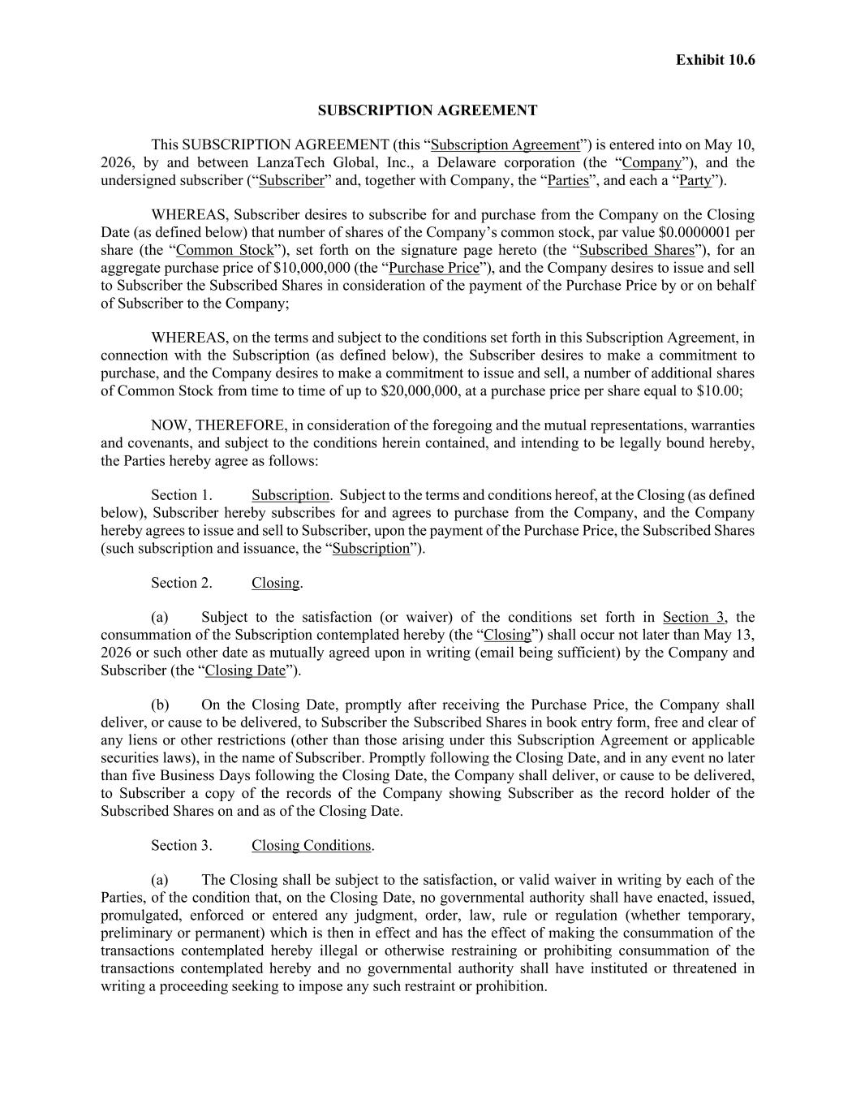
57
Exhibit 10.6 SUBSCRIPTION AGREEMENT This SUBSCRIPTION AGREEMENT (this “Subscription Agreement”) is entered into on May 10, 2026, by and between LanzaTech Global, Inc., a Delaware corporation (the “Company”), and the undersigned subscriber (“Subscriber” and, together with Company, the “Parties”, and each a “Party”). WHEREAS, Subscriber desires to subscribe for and purchase from the Company on the Closing Date (as defined below) that number of shares of the Company’s common stock, par value $0.0000001 per share (the “Common Stock”), set forth on the signature page hereto (the “Subscribed Shares”), for an aggregate purchase price of $10,000,000 (the “Purchase Price”), and the Company desires to issue and sell to Subscriber the Subscribed Shares in consideration of the payment of the Purchase Price by or on behalf of Subscriber to the Company; WHEREAS, on the terms and subject to the conditions set forth in this Subscription Agreement, in connection with the Subscription (as defined below), the Subscriber desires to make a commitment to purchase, and the Company desires to make a commitment to issue and sell, a number of additional shares of Common Stock from time to time of up to $20,000,000, at a purchase price per share equal to $10.00; NOW, THEREFORE, in consideration of the foregoing and the mutual representations, warranties and covenants, and subject to the conditions herein contained, and intending to be legally bound hereby, the Parties hereby agree as follows: Section 1. Subscription. Subject to the terms and conditions hereof, at the Closing (as defined below), Subscriber hereby subscribes for and agrees to purchase from the Company, and the Company hereby agrees to issue and sell to Subscriber, upon the payment of the Purchase Price, the Subscribed Shares (such subscription and issuance, the “Subscription”). Section 2. Closing. (a) Subject to the satisfaction (or waiver) of the conditions set forth in Section 3, the consummation of the Subscription contemplated hereby (the “Closing”) shall occur not later than May 13, 2026 or such other date as mutually agreed upon in writing (email being sufficient) by the Company and Subscriber (the “Closing Date”). (b) On the Closing Date, promptly after receiving the Purchase Price, the Company shall deliver, or cause to be delivered, to Subscriber the Subscribed Shares in book entry form, free and clear of any liens or other restrictions (other than those arising under this Subscription Agreement or applicable securities laws), in the name of Subscriber. Promptly following the Closing Date, and in any event no later than five Business Days following the Closing Date, the Company shall deliver, or cause to be delivered, to Subscriber a copy of the records of the Company showing Subscriber as the record holder of the Subscribed Shares on and as of the Closing Date. Section 3. Closing Conditions. (a) The Closing shall be subject to the satisfaction, or valid waiver in writing by each of the Parties, of the condition that, on the Closing Date, no governmental authority shall have enacted, issued, promulgated, enforced or entered any judgment, order, law, rule or regulation (whether temporary, preliminary or permanent) which is then in effect and has the effect of making the consummation of the transactions contemplated hereby illegal or otherwise restraining or prohibiting consummation of the transactions contemplated hereby and no governmental authority shall have instituted or threatened in writing a proceeding seeking to impose any such restraint or prohibition.

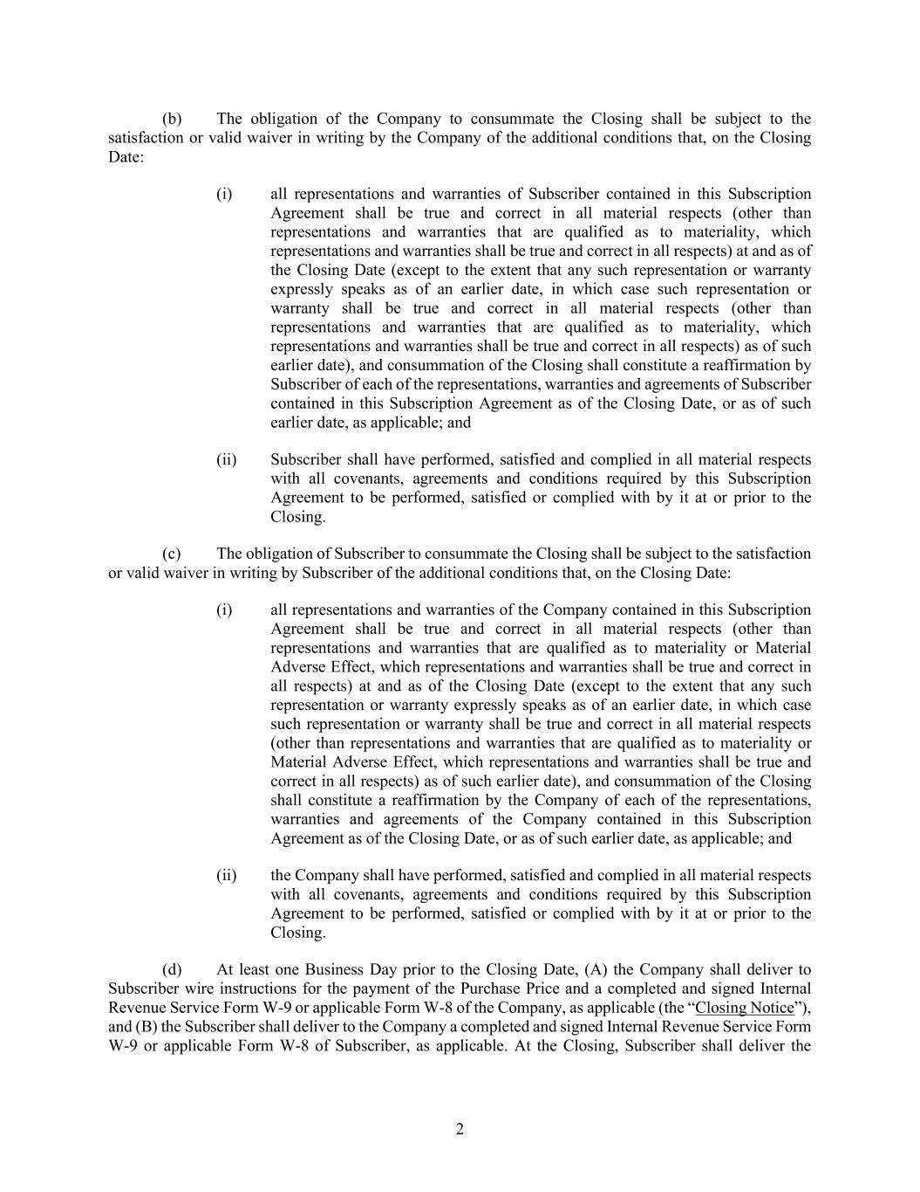
2 (b) The obligation of the Company to consummate the Closing shall be subject to the satisfaction or valid waiver in writing by the Company of the additional conditions that, on the Closing Date: (i) all representations and warranties of Subscriber contained in this Subscription Agreement shall be true and correct in all material respects (other than representations and warranties that are qualified as to materiality, which representations and warranties shall be true and correct in all respects) at and as of the Closing Date (except to the extent that any such representation or warranty expressly speaks as of an earlier date, in which case such representation or warranty shall be true and correct in all material respects (other than representations and warranties that are qualified as to materiality, which representations and warranties shall be true and correct in all respects) as of such earlier date), and consummation of the Closing shall constitute a reaffirmation by Subscriber of each of the representations, warranties and agreements of Subscriber contained in this Subscription Agreement as of the Closing Date, or as of such earlier date, as applicable; and (ii) Subscriber shall have performed, satisfied and complied in all material respects with all covenants, agreements and conditions required by this Subscription Agreement to be performed, satisfied or complied with by it at or prior to the Closing. (c) The obligation of Subscriber to consummate the Closing shall be subject to the satisfaction or valid waiver in writing by Subscriber of the additional conditions that, on the Closing Date: (i) all representations and warranties of the Company contained in this Subscription Agreement shall be true and correct in all material respects (other than representations and warranties that are qualified as to materiality or Material Adverse Effect, which representations and warranties shall be true and correct in all respects) at and as of the Closing Date (except to the extent that any such representation or warranty expressly speaks as of an earlier date, in which case such representation or warranty shall be true and correct in all material respects (other than representations and warranties that are qualified as to materiality or Material Adverse Effect, which representations and warranties shall be true and correct in all respects) as of such earlier date), and consummation of the Closing shall constitute a reaffirmation by the Company of each of the representations, warranties and agreements of the Company contained in this Subscription Agreement as of the Closing Date, or as of such earlier date, as applicable; and (ii) the Company shall have performed, satisfied and complied in all material respects with all covenants, agreements and conditions required by this Subscription Agreement to be performed, satisfied or complied with by it at or prior to the Closing. (d) At least one Business Day prior to the Closing Date, (A) the Company shall deliver to Subscriber wire instructions for the payment of the Purchase Price and a completed and signed Internal Revenue Service Form W-9 or applicable Form W-8 of the Company, as applicable (the “Closing Notice”), and (B) the Subscriber shall deliver to the Company a completed and signed Internal Revenue Service Form W-9 or applicable Form W-8 of Subscriber, as applicable. At the Closing, Subscriber shall deliver the

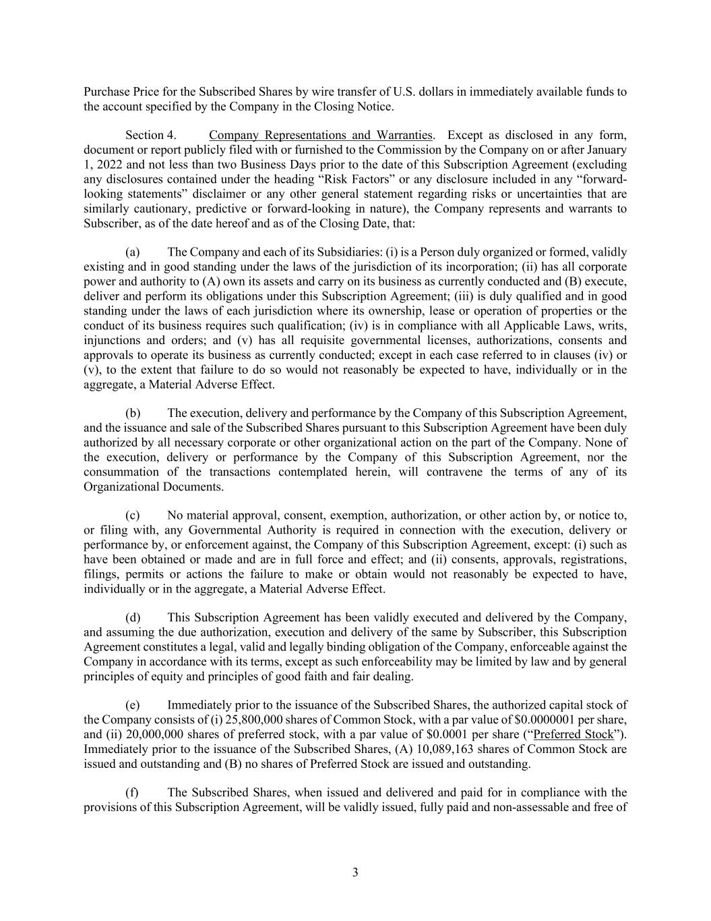
3 Purchase Price for the Subscribed Shares by wire transfer of U.S. dollars in immediately available funds to the account specified by the Company in the Closing Notice. Section 4. Company Representations and Warranties. Except as disclosed in any form, document or report publicly filed with or furnished to the Commission by the Company on or after January 1, 2022 and not less than two Business Days prior to the date of this Subscription Agreement (excluding any disclosures contained under the heading “Risk Factors” or any disclosure included in any “forward- looking statements” disclaimer or any other general statement regarding risks or uncertainties that are similarly cautionary, predictive or forward-looking in nature), the Company represents and warrants to Subscriber, as of the date hereof and as of the Closing Date, that: (a) The Company and each of its Subsidiaries: (i) is a Person duly organized or formed, validly existing and in good standing under the laws of the jurisdiction of its incorporation; (ii) has all corporate power and authority to (A) own its assets and carry on its business as currently conducted and (B) execute, deliver and perform its obligations under this Subscription Agreement; (iii) is duly qualified and in good standing under the laws of each jurisdiction where its ownership, lease or operation of properties or the conduct of its business requires such qualification; (iv) is in compliance with all Applicable Laws, writs, injunctions and orders; and (v) has all requisite governmental licenses, authorizations, consents and approvals to operate its business as currently conducted; except in each case referred to in clauses (iv) or (v), to the extent that failure to do so would not reasonably be expected to have, individually or in the aggregate, a Material Adverse Effect. (b) The execution, delivery and performance by the Company of this Subscription Agreement, and the issuance and sale of the Subscribed Shares pursuant to this Subscription Agreement have been duly authorized by all necessary corporate or other organizational action on the part of the Company. None of the execution, delivery or performance by the Company of this Subscription Agreement, nor the consummation of the transactions contemplated herein, will contravene the terms of any of its Organizational Documents. (c) No material approval, consent, exemption, authorization, or other action by, or notice to, or filing with, any Governmental Authority is required in connection with the execution, delivery or performance by, or enforcement against, the Company of this Subscription Agreement, except: (i) such as have been obtained or made and are in full force and effect; and (ii) consents, approvals, registrations, filings, permits or actions the failure to make or obtain would not reasonably be expected to have, individually or in the aggregate, a Material Adverse Effect. (d) This Subscription Agreement has been validly executed and delivered by the Company, and assuming the due authorization, execution and delivery of the same by Subscriber, this Subscription Agreement constitutes a legal, valid and legally binding obligation of the Company, enforceable against the Company in accordance with its terms, except as such enforceability may be limited by law and by general principles of equity and principles of good faith and fair dealing. (e) Immediately prior to the issuance of the Subscribed Shares, the authorized capital stock of the Company consists of (i) 25,800,000 shares of Common Stock, with a par value of $0.0000001 per share, and (ii) 20,000,000 shares of preferred stock, with a par value of $0.0001 per share (“Preferred Stock”). Immediately prior to the issuance of the Subscribed Shares, (A) 10,089,163 shares of Common Stock are issued and outstanding and (B) no shares of Preferred Stock are issued and outstanding. (f) The Subscribed Shares, when issued and delivered and paid for in compliance with the provisions of this Subscription Agreement, will be validly issued, fully paid and non-assessable and free of

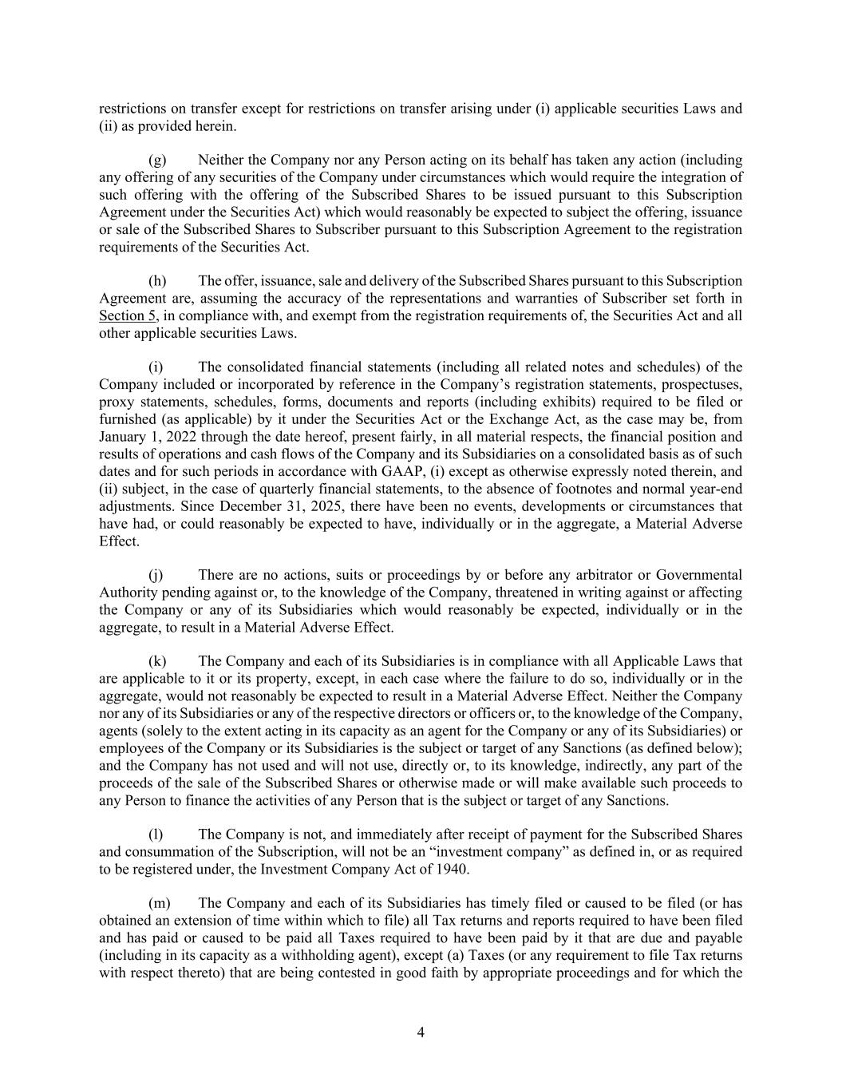
4 restrictions on transfer except for restrictions on transfer arising under (i) applicable securities Laws and (ii) as provided herein. (g) Neither the Company nor any Person acting on its behalf has taken any action (including any offering of any securities of the Company under circumstances which would require the integration of such offering with the offering of the Subscribed Shares to be issued pursuant to this Subscription Agreement under the Securities Act) which would reasonably be expected to subject the offering, issuance or sale of the Subscribed Shares to Subscriber pursuant to this Subscription Agreement to the registration requirements of the Securities Act. (h) The offer, issuance, sale and delivery of the Subscribed Shares pursuant to this Subscription Agreement are, assuming the accuracy of the representations and warranties of Subscriber set forth in Section 5, in compliance with, and exempt from the registration requirements of, the Securities Act and all other applicable securities Laws. (i) The consolidated financial statements (including all related notes and schedules) of the Company included or incorporated by reference in the Company’s registration statements, prospectuses, proxy statements, schedules, forms, documents and reports (including exhibits) required to be filed or furnished (as applicable) by it under the Securities Act or the Exchange Act, as the case may be, from January 1, 2022 through the date hereof, present fairly, in all material respects, the financial position and results of operations and cash flows of the Company and its Subsidiaries on a consolidated basis as of such dates and for such periods in accordance with GAAP, (i) except as otherwise expressly noted therein, and (ii) subject, in the case of quarterly financial statements, to the absence of footnotes and normal year-end adjustments. Since December 31, 2025, there have been no events, developments or circumstances that have had, or could reasonably be expected to have, individually or in the aggregate, a Material Adverse Effect. (j) There are no actions, suits or proceedings by or before any arbitrator or Governmental Authority pending against or, to the knowledge of the Company, threatened in writing against or affecting the Company or any of its Subsidiaries which would reasonably be expected, individually or in the aggregate, to result in a Material Adverse Effect. (k) The Company and each of its Subsidiaries is in compliance with all Applicable Laws that are applicable to it or its property, except, in each case where the failure to do so, individually or in the aggregate, would not reasonably be expected to result in a Material Adverse Effect. Neither the Company nor any of its Subsidiaries or any of the respective directors or officers or, to the knowledge of the Company, agents (solely to the extent acting in its capacity as an agent for the Company or any of its Subsidiaries) or employees of the Company or its Subsidiaries is the subject or target of any Sanctions (as defined below); and the Company has not used and will not use, directly or, to its knowledge, indirectly, any part of the proceeds of the sale of the Subscribed Shares or otherwise made or will make available such proceeds to any Person to finance the activities of any Person that is the subject or target of any Sanctions. (l) The Company is not, and immediately after receipt of payment for the Subscribed Shares and consummation of the Subscription, will not be an “investment company” as defined in, or as required to be registered under, the Investment Company Act of 1940. (m) The Company and each of its Subsidiaries has timely filed or caused to be filed (or has obtained an extension of time within which to file) all Tax returns and reports required to have been filed and has paid or caused to be paid all Taxes required to have been paid by it that are due and payable (including in its capacity as a withholding agent), except (a) Taxes (or any requirement to file Tax returns with respect thereto) that are being contested in good faith by appropriate proceedings and for which the

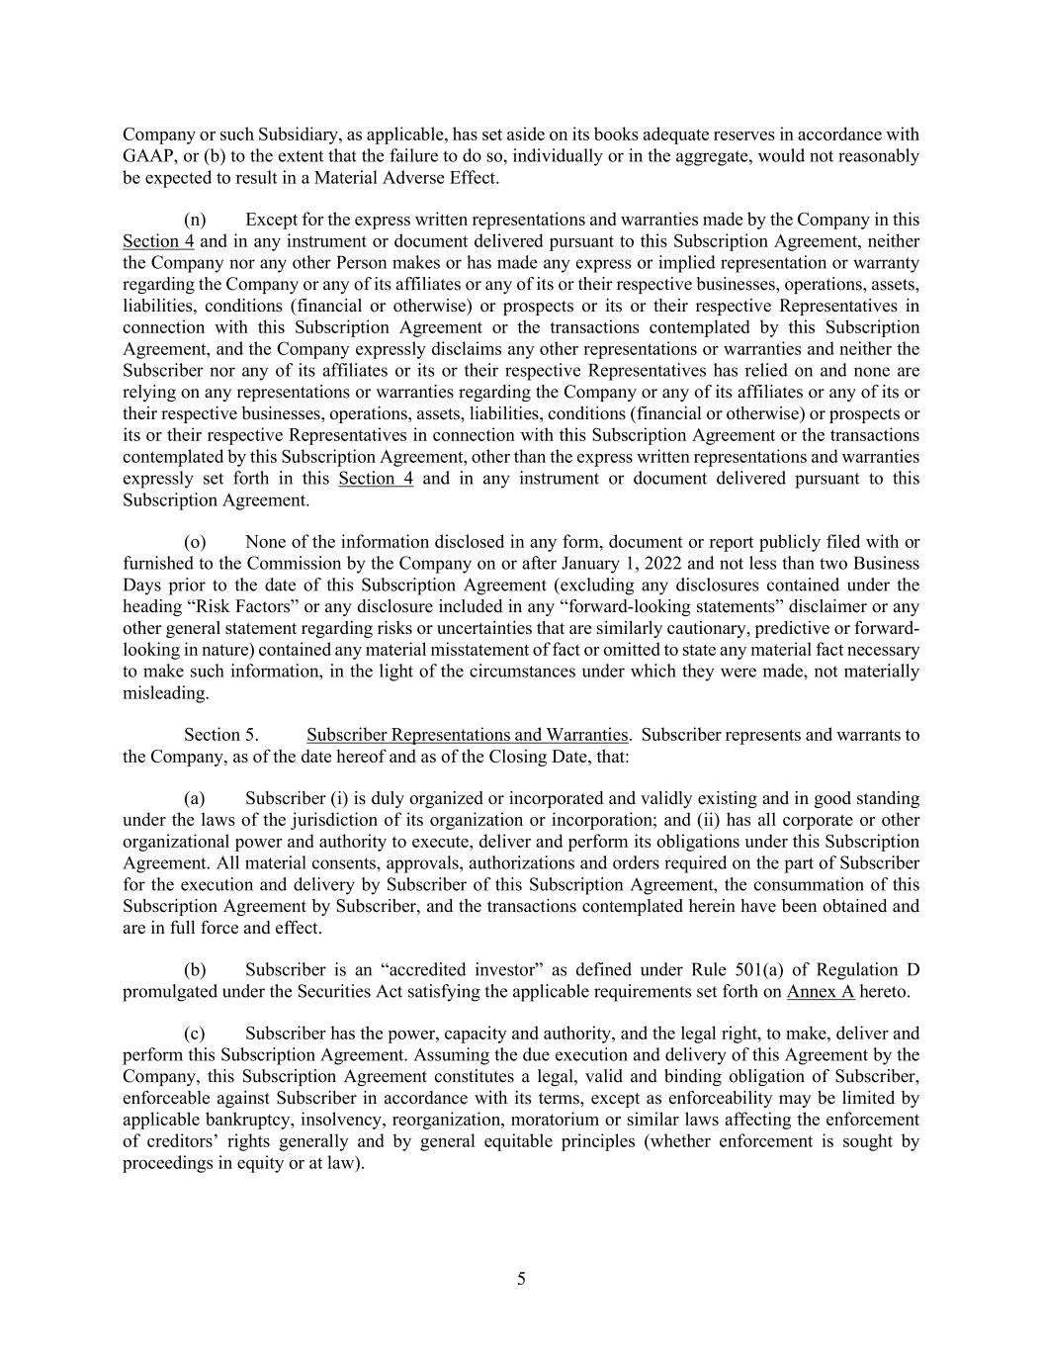
5 Company or such Subsidiary, as applicable, has set aside on its books adequate reserves in accordance with GAAP, or (b) to the extent that the failure to do so, individually or in the aggregate, would not reasonably be expected to result in a Material Adverse Effect. (n) Except for the express written representations and warranties made by the Company in this Section 4 and in any instrument or document delivered pursuant to this Subscription Agreement, neither the Company nor any other Person makes or has made any express or implied representation or warranty regarding the Company or any of its affiliates or any of its or their respective businesses, operations, assets, liabilities, conditions (financial or otherwise) or prospects or its or their respective Representatives in connection with this Subscription Agreement or the transactions contemplated by this Subscription Agreement, and the Company expressly disclaims any other representations or warranties and neither the Subscriber nor any of its affiliates or its or their respective Representatives has relied on and none are relying on any representations or warranties regarding the Company or any of its affiliates or any of its or their respective businesses, operations, assets, liabilities, conditions (financial or otherwise) or prospects or its or their respective Representatives in connection with this Subscription Agreement or the transactions contemplated by this Subscription Agreement, other than the express written representations and warranties expressly set forth in this Section 4 and in any instrument or document delivered pursuant to this Subscription Agreement. (o) None of the information disclosed in any form, document or report publicly filed with or furnished to the Commission by the Company on or after January 1, 2022 and not less than two Business Days prior to the date of this Subscription Agreement (excluding any disclosures contained under the heading “Risk Factors” or any disclosure included in any “forward-looking statements” disclaimer or any other general statement regarding risks or uncertainties that are similarly cautionary, predictive or forward- looking in nature) contained any material misstatement of fact or omitted to state any material fact necessary to make such information, in the light of the circumstances under which they were made, not materially misleading. Section 5. Subscriber Representations and Warranties. Subscriber represents and warrants to the Company, as of the date hereof and as of the Closing Date, that: (a) Subscriber (i) is duly organized or incorporated and validly existing and in good standing under the laws of the jurisdiction of its organization or incorporation; and (ii) has all corporate or other organizational power and authority to execute, deliver and perform its obligations under this Subscription Agreement. All material consents, approvals, authorizations and orders required on the part of Subscriber for the execution and delivery by Subscriber of this Subscription Agreement, the consummation of this Subscription Agreement by Subscriber, and the transactions contemplated herein have been obtained and are in full force and effect. (b) Subscriber is an “accredited investor” as defined under Rule 501(a) of Regulation D promulgated under the Securities Act satisfying the applicable requirements set forth on Annex A hereto. (c) Subscriber has the power, capacity and authority, and the legal right, to make, deliver and perform this Subscription Agreement. Assuming the due execution and delivery of this Agreement by the Company, this Subscription Agreement constitutes a legal, valid and binding obligation of Subscriber, enforceable against Subscriber in accordance with its terms, except as enforceability may be limited by applicable bankruptcy, insolvency, reorganization, moratorium or similar laws affecting the enforcement of creditors’ rights generally and by general equitable principles (whether enforcement is sought by proceedings in equity or at law).

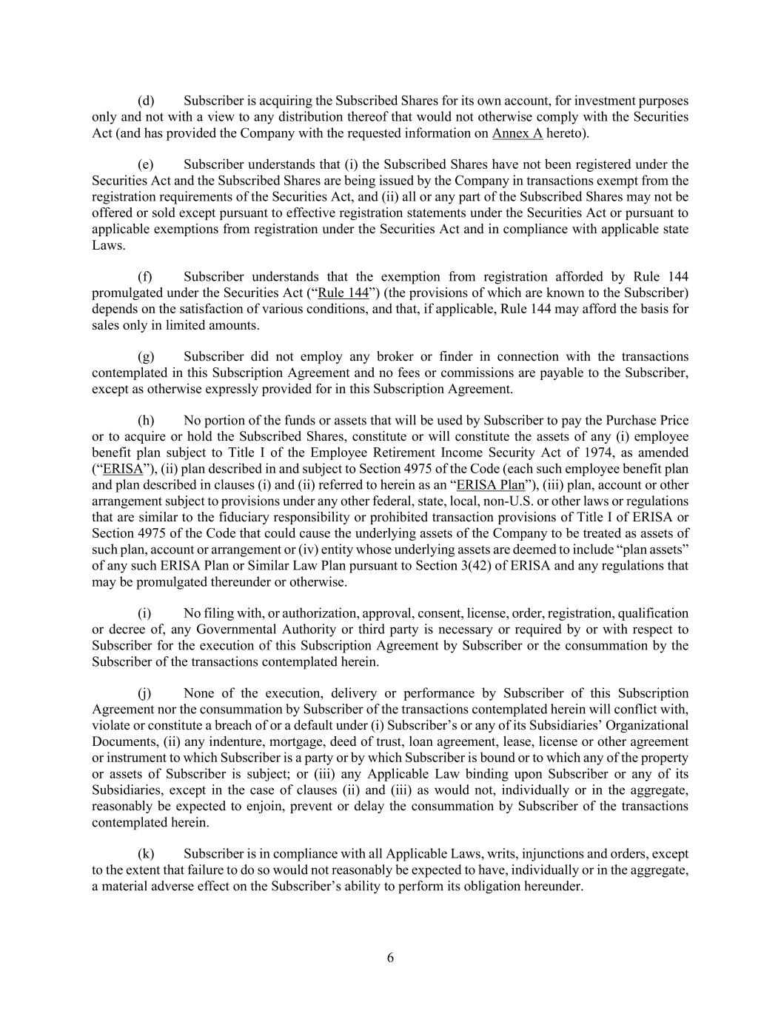
6 (d) Subscriber is acquiring the Subscribed Shares for its own account, for investment purposes only and not with a view to any distribution thereof that would not otherwise comply with the Securities Act (and has provided the Company with the requested information on Annex A hereto). (e) Subscriber understands that (i) the Subscribed Shares have not been registered under the Securities Act and the Subscribed Shares are being issued by the Company in transactions exempt from the registration requirements of the Securities Act, and (ii) all or any part of the Subscribed Shares may not be offered or sold except pursuant to effective registration statements under the Securities Act or pursuant to applicable exemptions from registration under the Securities Act and in compliance with applicable state Laws. (f) Subscriber understands that the exemption from registration afforded by Rule 144 promulgated under the Securities Act (“Rule 144”) (the provisions of which are known to the Subscriber) depends on the satisfaction of various conditions, and that, if applicable, Rule 144 may afford the basis for sales only in limited amounts. (g) Subscriber did not employ any broker or finder in connection with the transactions contemplated in this Subscription Agreement and no fees or commissions are payable to the Subscriber, except as otherwise expressly provided for in this Subscription Agreement. (h) No portion of the funds or assets that will be used by Subscriber to pay the Purchase Price or to acquire or hold the Subscribed Shares, constitute or will constitute the assets of any (i) employee benefit plan subject to Title I of the Employee Retirement Income Security Act of 1974, as amended (“ERISA”), (ii) plan described in and subject to Section 4975 of the Code (each such employee benefit plan and plan described in clauses (i) and (ii) referred to herein as an “ERISA Plan”), (iii) plan, account or other arrangement subject to provisions under any other federal, state, local, non-U.S. or other laws or regulations that are similar to the fiduciary responsibility or prohibited transaction provisions of Title I of ERISA or Section 4975 of the Code that could cause the underlying assets of the Company to be treated as assets of such plan, account or arrangement or (iv) entity whose underlying assets are deemed to include “plan assets” of any such ERISA Plan or Similar Law Plan pursuant to Section 3(42) of ERISA and any regulations that may be promulgated thereunder or otherwise. (i) No filing with, or authorization, approval, consent, license, order, registration, qualification or decree of, any Governmental Authority or third party is necessary or required by or with respect to Subscriber for the execution of this Subscription Agreement by Subscriber or the consummation by the Subscriber of the transactions contemplated herein. (j) None of the execution, delivery or performance by Subscriber of this Subscription Agreement nor the consummation by Subscriber of the transactions contemplated herein will conflict with, violate or constitute a breach of or a default under (i) Subscriber’s or any of its Subsidiaries’ Organizational Documents, (ii) any indenture, mortgage, deed of trust, loan agreement, lease, license or other agreement or instrument to which Subscriber is a party or by which Subscriber is bound or to which any of the property or assets of Subscriber is subject; or (iii) any Applicable Law binding upon Subscriber or any of its Subsidiaries, except in the case of clauses (ii) and (iii) as would not, individually or in the aggregate, reasonably be expected to enjoin, prevent or delay the consummation by Subscriber of the transactions contemplated herein. (k) Subscriber is in compliance with all Applicable Laws, writs, injunctions and orders, except to the extent that failure to do so would not reasonably be expected to have, individually or in the aggregate, a material adverse effect on the Subscriber’s ability to perform its obligation hereunder.

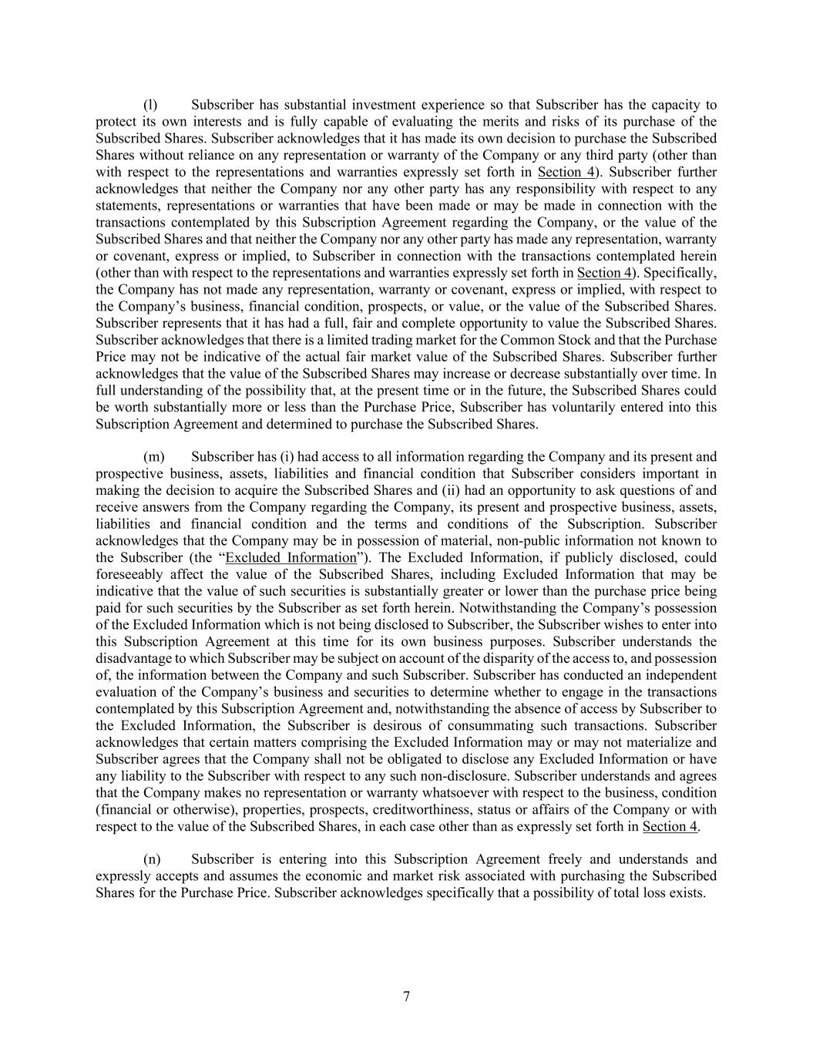
7 (l) Subscriber has substantial investment experience so that Subscriber has the capacity to protect its own interests and is fully capable of evaluating the merits and risks of its purchase of the Subscribed Shares. Subscriber acknowledges that it has made its own decision to purchase the Subscribed Shares without reliance on any representation or warranty of the Company or any third party (other than with respect to the representations and warranties expressly set forth in Section 4). Subscriber further acknowledges that neither the Company nor any other party has any responsibility with respect to any statements, representations or warranties that have been made or may be made in connection with the transactions contemplated by this Subscription Agreement regarding the Company, or the value of the Subscribed Shares and that neither the Company nor any other party has made any representation, warranty or covenant, express or implied, to Subscriber in connection with the transactions contemplated herein (other than with respect to the representations and warranties expressly set forth in Section 4). Specifically, the Company has not made any representation, warranty or covenant, express or implied, with respect to the Company’s business, financial condition, prospects, or value, or the value of the Subscribed Shares. Subscriber represents that it has had a full, fair and complete opportunity to value the Subscribed Shares. Subscriber acknowledges that there is a limited trading market for the Common Stock and that the Purchase Price may not be indicative of the actual fair market value of the Subscribed Shares. Subscriber further acknowledges that the value of the Subscribed Shares may increase or decrease substantially over time. In full understanding of the possibility that, at the present time or in the future, the Subscribed Shares could be worth substantially more or less than the Purchase Price, Subscriber has voluntarily entered into this Subscription Agreement and determined to purchase the Subscribed Shares. (m) Subscriber has (i) had access to all information regarding the Company and its present and prospective business, assets, liabilities and financial condition that Subscriber considers important in making the decision to acquire the Subscribed Shares and (ii) had an opportunity to ask questions of and receive answers from the Company regarding the Company, its present and prospective business, assets, liabilities and financial condition and the terms and conditions of the Subscription. Subscriber acknowledges that the Company may be in possession of material, non-public information not known to the Subscriber (the “Excluded Information”). The Excluded Information, if publicly disclosed, could foreseeably affect the value of the Subscribed Shares, including Excluded Information that may be indicative that the value of such securities is substantially greater or lower than the purchase price being paid for such securities by the Subscriber as set forth herein. Notwithstanding the Company’s possession of the Excluded Information which is not being disclosed to Subscriber, the Subscriber wishes to enter into this Subscription Agreement at this time for its own business purposes. Subscriber understands the disadvantage to which Subscriber may be subject on account of the disparity of the access to, and possession of, the information between the Company and such Subscriber. Subscriber has conducted an independent evaluation of the Company’s business and securities to determine whether to engage in the transactions contemplated by this Subscription Agreement and, notwithstanding the absence of access by Subscriber to the Excluded Information, the Subscriber is desirous of consummating such transactions. Subscriber acknowledges that certain matters comprising the Excluded Information may or may not materialize and Subscriber agrees that the Company shall not be obligated to disclose any Excluded Information or have any liability to the Subscriber with respect to any such non-disclosure. Subscriber understands and agrees that the Company makes no representation or warranty whatsoever with respect to the business, condition (financial or otherwise), properties, prospects, creditworthiness, status or affairs of the Company or with respect to the value of the Subscribed Shares, in each case other than as expressly set forth in Section 4. (n) Subscriber is entering into this Subscription Agreement freely and understands and expressly accepts and assumes the economic and market risk associated with purchasing the Subscribed Shares for the Purchase Price. Subscriber acknowledges specifically that a possibility of total loss exists.

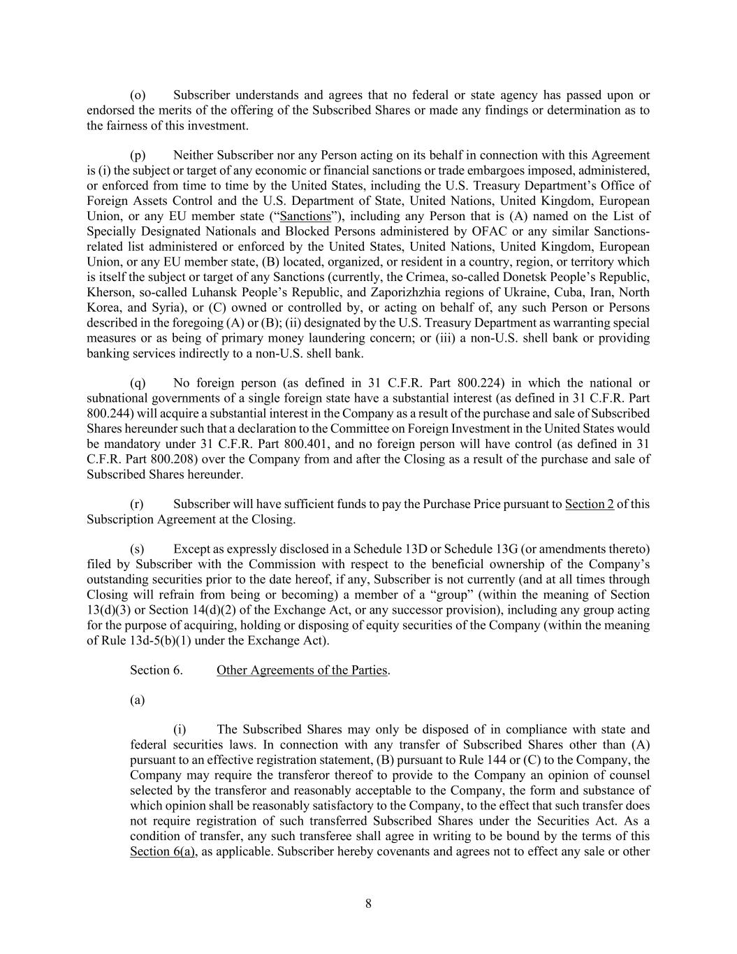
8 (o) Subscriber understands and agrees that no federal or state agency has passed upon or endorsed the merits of the offering of the Subscribed Shares or made any findings or determination as to the fairness of this investment. (p) Neither Subscriber nor any Person acting on its behalf in connection with this Agreement is (i) the subject or target of any economic or financial sanctions or trade embargoes imposed, administered, or enforced from time to time by the United States, including the U.S. Treasury Department’s Office of Foreign Assets Control and the U.S. Department of State, United Nations, United Kingdom, European Union, or any EU member state (“Sanctions”), including any Person that is (A) named on the List of Specially Designated Nationals and Blocked Persons administered by OFAC or any similar Sanctions- related list administered or enforced by the United States, United Nations, United Kingdom, European Union, or any EU member state, (B) located, organized, or resident in a country, region, or territory which is itself the subject or target of any Sanctions (currently, the Crimea, so-called Donetsk People’s Republic, Kherson, so-called Luhansk People’s Republic, and Zaporizhzhia regions of Ukraine, Cuba, Iran, North Korea, and Syria), or (C) owned or controlled by, or acting on behalf of, any such Person or Persons described in the foregoing (A) or (B); (ii) designated by the U.S. Treasury Department as warranting special measures or as being of primary money laundering concern; or (iii) a non-U.S. shell bank or providing banking services indirectly to a non-U.S. shell bank. (q) No foreign person (as defined in 31 C.F.R. Part 800.224) in which the national or subnational governments of a single foreign state have a substantial interest (as defined in 31 C.F.R. Part 800.244) will acquire a substantial interest in the Company as a result of the purchase and sale of Subscribed Shares hereunder such that a declaration to the Committee on Foreign Investment in the United States would be mandatory under 31 C.F.R. Part 800.401, and no foreign person will have control (as defined in 31 C.F.R. Part 800.208) over the Company from and after the Closing as a result of the purchase and sale of Subscribed Shares hereunder. (r) Subscriber will have sufficient funds to pay the Purchase Price pursuant to Section 2 of this Subscription Agreement at the Closing. (s) Except as expressly disclosed in a Schedule 13D or Schedule 13G (or amendments thereto) filed by Subscriber with the Commission with respect to the beneficial ownership of the Company’s outstanding securities prior to the date hereof, if any, Subscriber is not currently (and at all times through Closing will refrain from being or becoming) a member of a “group” (within the meaning of Section 13(d)(3) or Section 14(d)(2) of the Exchange Act, or any successor provision), including any group acting for the purpose of acquiring, holding or disposing of equity securities of the Company (within the meaning of Rule 13d-5(b)(1) under the Exchange Act). Section 6. Other Agreements of the Parties. (a) (i) The Subscribed Shares may only be disposed of in compliance with state and federal securities laws. In connection with any transfer of Subscribed Shares other than (A) pursuant to an effective registration statement, (B) pursuant to Rule 144 or (C) to the Company, the Company may require the transferor thereof to provide to the Company an opinion of counsel selected by the transferor and reasonably acceptable to the Company, the form and substance of which opinion shall be reasonably satisfactory to the Company, to the effect that such transfer does not require registration of such transferred Subscribed Shares under the Securities Act. As a condition of transfer, any such transferee shall agree in writing to be bound by the terms of this Section 6(a), as applicable. Subscriber hereby covenants and agrees not to effect any sale or other

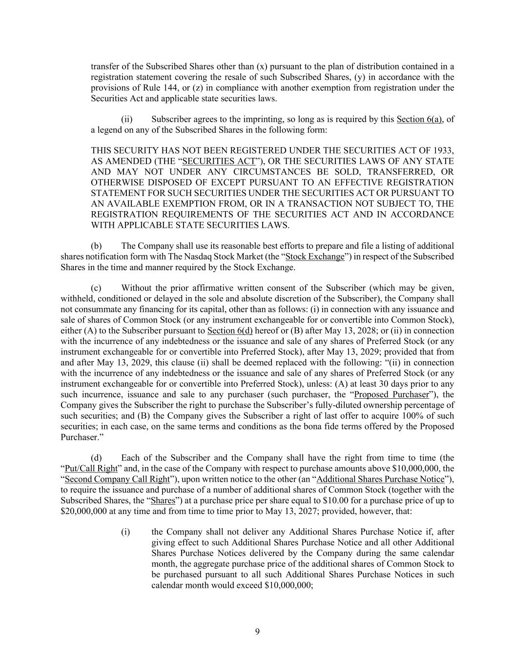
9 transfer of the Subscribed Shares other than (x) pursuant to the plan of distribution contained in a registration statement covering the resale of such Subscribed Shares, (y) in accordance with the provisions of Rule 144, or (z) in compliance with another exemption from registration under the Securities Act and applicable state securities laws. (ii) Subscriber agrees to the imprinting, so long as is required by this Section 6(a), of a legend on any of the Subscribed Shares in the following form: THIS SECURITY HAS NOT BEEN REGISTERED UNDER THE SECURITIES ACT OF 1933, AS AMENDED (THE “SECURITIES ACT”), OR THE SECURITIES LAWS OF ANY STATE AND MAY NOT UNDER ANY CIRCUMSTANCES BE SOLD, TRANSFERRED, OR OTHERWISE DISPOSED OF EXCEPT PURSUANT TO AN EFFECTIVE REGISTRATION STATEMENT FOR SUCH SECURITIES UNDER THE SECURITIES ACT OR PURSUANT TO AN AVAILABLE EXEMPTION FROM, OR IN A TRANSACTION NOT SUBJECT TO, THE REGISTRATION REQUIREMENTS OF THE SECURITIES ACT AND IN ACCORDANCE WITH APPLICABLE STATE SECURITIES LAWS. (b) The Company shall use its reasonable best efforts to prepare and file a listing of additional shares notification form with The Nasdaq Stock Market (the “Stock Exchange”) in respect of the Subscribed Shares in the time and manner required by the Stock Exchange. (c) Without the prior affirmative written consent of the Subscriber (which may be given, withheld, conditioned or delayed in the sole and absolute discretion of the Subscriber), the Company shall not consummate any financing for its capital, other than as follows: (i) in connection with any issuance and sale of shares of Common Stock (or any instrument exchangeable for or convertible into Common Stock), either (A) to the Subscriber pursuant to Section 6(d) hereof or (B) after May 13, 2028; or (ii) in connection with the incurrence of any indebtedness or the issuance and sale of any shares of Preferred Stock (or any instrument exchangeable for or convertible into Preferred Stock), after May 13, 2029; provided that from and after May 13, 2029, this clause (ii) shall be deemed replaced with the following: “(ii) in connection with the incurrence of any indebtedness or the issuance and sale of any shares of Preferred Stock (or any instrument exchangeable for or convertible into Preferred Stock), unless: (A) at least 30 days prior to any such incurrence, issuance and sale to any purchaser (such purchaser, the “Proposed Purchaser”), the Company gives the Subscriber the right to purchase the Subscriber’s fully-diluted ownership percentage of such securities; and (B) the Company gives the Subscriber a right of last offer to acquire 100% of such securities; in each case, on the same terms and conditions as the bona fide terms offered by the Proposed Purchaser.” (d) Each of the Subscriber and the Company shall have the right from time to time (the “Put/Call Right” and, in the case of the Company with respect to purchase amounts above $10,000,000, the “Second Company Call Right”), upon written notice to the other (an “Additional Shares Purchase Notice”), to require the issuance and purchase of a number of additional shares of Common Stock (together with the Subscribed Shares, the “Shares”) at a purchase price per share equal to $10.00 for a purchase price of up to $20,000,000 at any time and from time to time prior to May 13, 2027; provided, however, that: (i) the Company shall not deliver any Additional Shares Purchase Notice if, after giving effect to such Additional Shares Purchase Notice and all other Additional Shares Purchase Notices delivered by the Company during the same calendar month, the aggregate purchase price of the additional shares of Common Stock to be purchased pursuant to all such Additional Shares Purchase Notices in such calendar month would exceed $10,000,000;

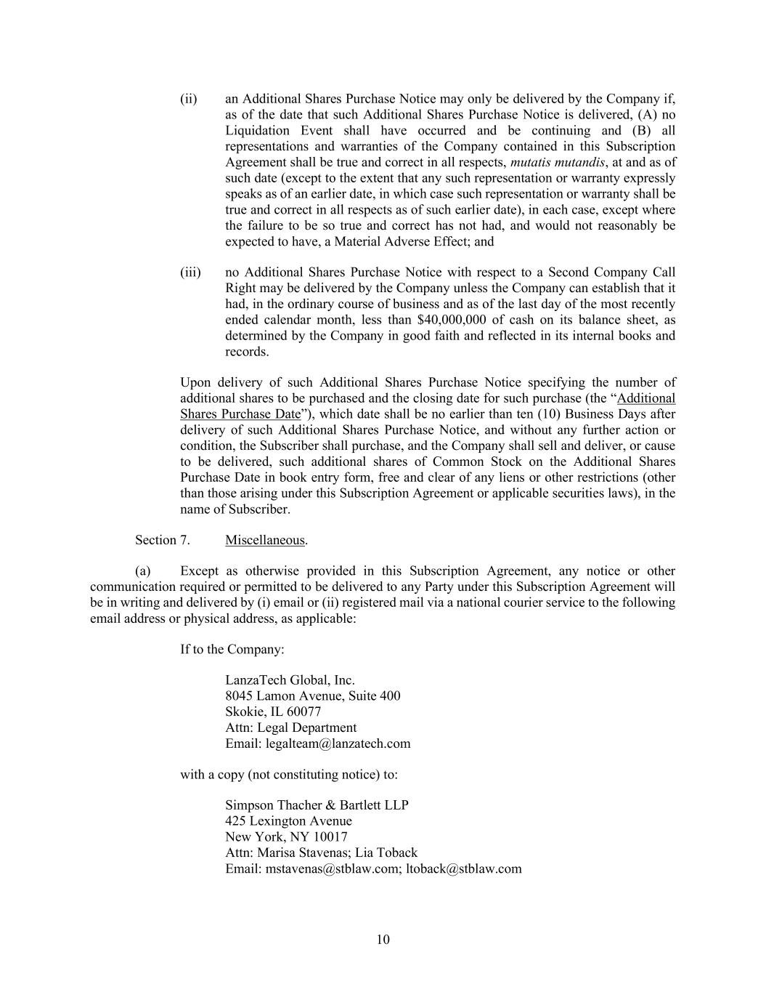
10 (ii) an Additional Shares Purchase Notice may only be delivered by the Company if, as of the date that such Additional Shares Purchase Notice is delivered, (A) no Liquidation Event shall have occurred and be continuing and (B) all representations and warranties of the Company contained in this Subscription Agreement shall be true and correct in all respects, mutatis mutandis, at and as of such date (except to the extent that any such representation or warranty expressly speaks as of an earlier date, in which case such representation or warranty shall be true and correct in all respects as of such earlier date), in each case, except where the failure to be so true and correct has not had, and would not reasonably be expected to have, a Material Adverse Effect; and (iii) no Additional Shares Purchase Notice with respect to a Second Company Call Right may be delivered by the Company unless the Company can establish that it had, in the ordinary course of business and as of the last day of the most recently ended calendar month, less than $40,000,000 of cash on its balance sheet, as determined by the Company in good faith and reflected in its internal books and records. Upon delivery of such Additional Shares Purchase Notice specifying the number of additional shares to be purchased and the closing date for such purchase (the “Additional Shares Purchase Date”), which date shall be no earlier than ten (10) Business Days after delivery of such Additional Shares Purchase Notice, and without any further action or condition, the Subscriber shall purchase, and the Company shall sell and deliver, or cause to be delivered, such additional shares of Common Stock on the Additional Shares Purchase Date in book entry form, free and clear of any liens or other restrictions (other than those arising under this Subscription Agreement or applicable securities laws), in the name of Subscriber. Section 7. Miscellaneous. (a) Except as otherwise provided in this Subscription Agreement, any notice or other communication required or permitted to be delivered to any Party under this Subscription Agreement will be in writing and delivered by (i) email or (ii) registered mail via a national courier service to the following email address or physical address, as applicable: If to the Company: LanzaTech Global, Inc. 8045 Lamon Avenue, Suite 400 Skokie, IL 60077 Attn: Legal Department Email: legalteam@lanzatech.com with a copy (not constituting notice) to: Simpson Thacher & Bartlett LLP 425 Lexington Avenue New York, NY 10017 Attn: Marisa Stavenas; Lia Toback Email: mstavenas@stblaw.com; ltoback@stblaw.com

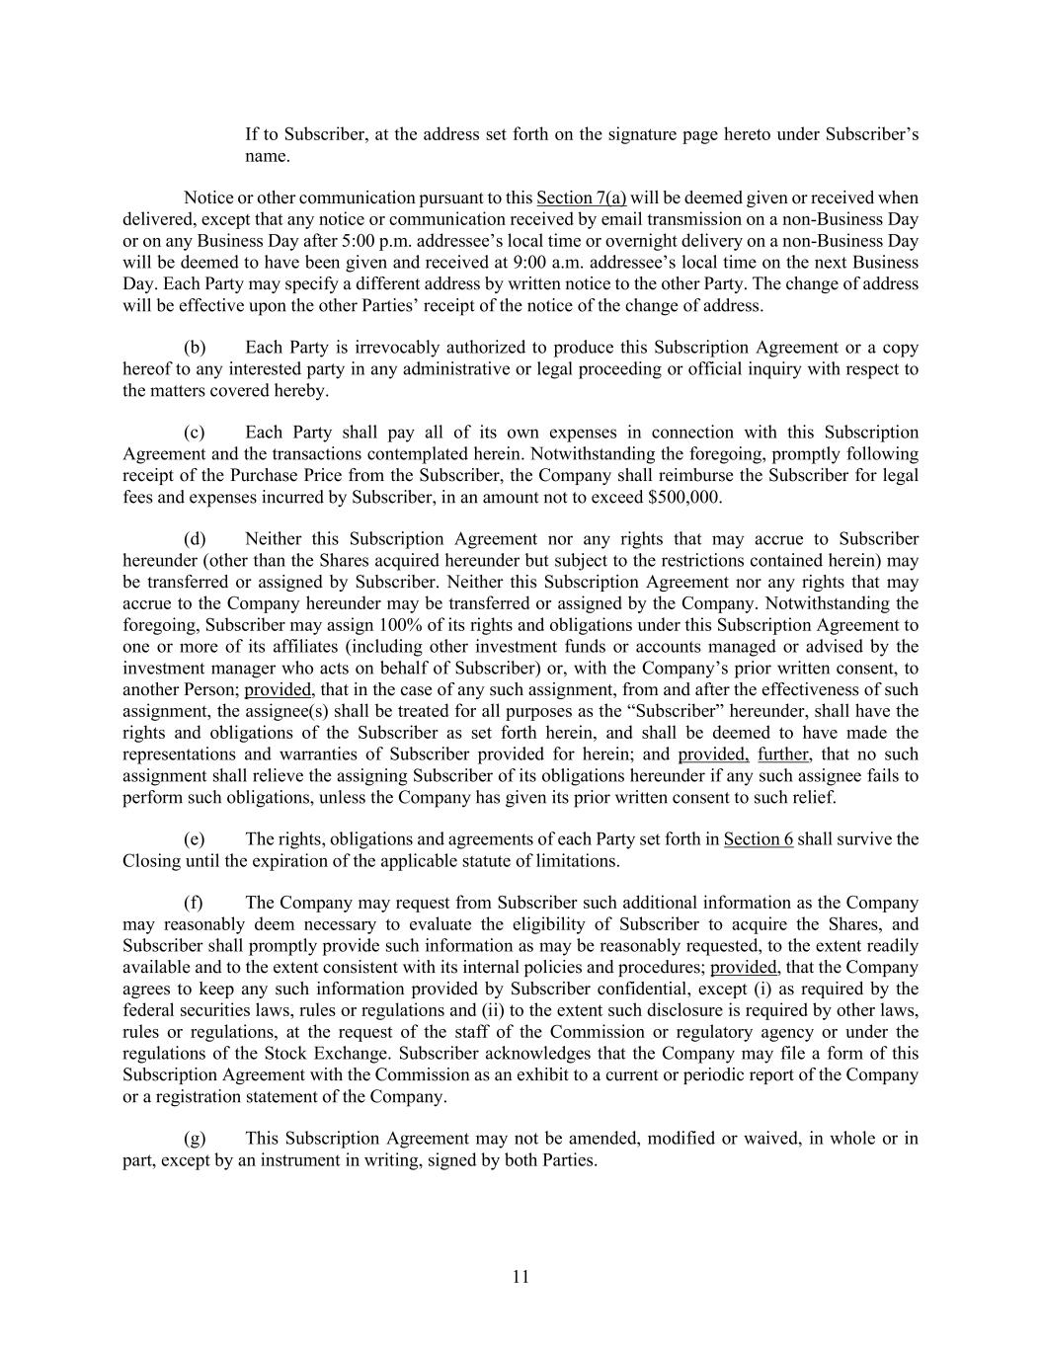
11 If to Subscriber, at the address set forth on the signature page hereto under Subscriber’s name. Notice or other communication pursuant to this Section 7(a) will be deemed given or received when delivered, except that any notice or communication received by email transmission on a non-Business Day or on any Business Day after 5:00 p.m. addressee’s local time or overnight delivery on a non-Business Day will be deemed to have been given and received at 9:00 a.m. addressee’s local time on the next Business Day. Each Party may specify a different address by written notice to the other Party. The change of address will be effective upon the other Parties’ receipt of the notice of the change of address. (b) Each Party is irrevocably authorized to produce this Subscription Agreement or a copy hereof to any interested party in any administrative or legal proceeding or official inquiry with respect to the matters covered hereby. (c) Each Party shall pay all of its own expenses in connection with this Subscription Agreement and the transactions contemplated herein. Notwithstanding the foregoing, promptly following receipt of the Purchase Price from the Subscriber, the Company shall reimburse the Subscriber for legal fees and expenses incurred by Subscriber, in an amount not to exceed $500,000. (d) Neither this Subscription Agreement nor any rights that may accrue to Subscriber hereunder (other than the Shares acquired hereunder but subject to the restrictions contained herein) may be transferred or assigned by Subscriber. Neither this Subscription Agreement nor any rights that may accrue to the Company hereunder may be transferred or assigned by the Company. Notwithstanding the foregoing, Subscriber may assign 100% of its rights and obligations under this Subscription Agreement to one or more of its affiliates (including other investment funds or accounts managed or advised by the investment manager who acts on behalf of Subscriber) or, with the Company’s prior written consent, to another Person; provided, that in the case of any such assignment, from and after the effectiveness of such assignment, the assignee(s) shall be treated for all purposes as the “Subscriber” hereunder, shall have the rights and obligations of the Subscriber as set forth herein, and shall be deemed to have made the representations and warranties of Subscriber provided for herein; and provided, further, that no such assignment shall relieve the assigning Subscriber of its obligations hereunder if any such assignee fails to perform such obligations, unless the Company has given its prior written consent to such relief. (e) The rights, obligations and agreements of each Party set forth in Section 6 shall survive the Closing until the expiration of the applicable statute of limitations. (f) The Company may request from Subscriber such additional information as the Company may reasonably deem necessary to evaluate the eligibility of Subscriber to acquire the Shares, and Subscriber shall promptly provide such information as may be reasonably requested, to the extent readily available and to the extent consistent with its internal policies and procedures; provided, that the Company agrees to keep any such information provided by Subscriber confidential, except (i) as required by the federal securities laws, rules or regulations and (ii) to the extent such disclosure is required by other laws, rules or regulations, at the request of the staff of the Commission or regulatory agency or under the regulations of the Stock Exchange. Subscriber acknowledges that the Company may file a form of this Subscription Agreement with the Commission as an exhibit to a current or periodic report of the Company or a registration statement of the Company. (g) This Subscription Agreement may not be amended, modified or waived, in whole or in part, except by an instrument in writing, signed by both Parties.

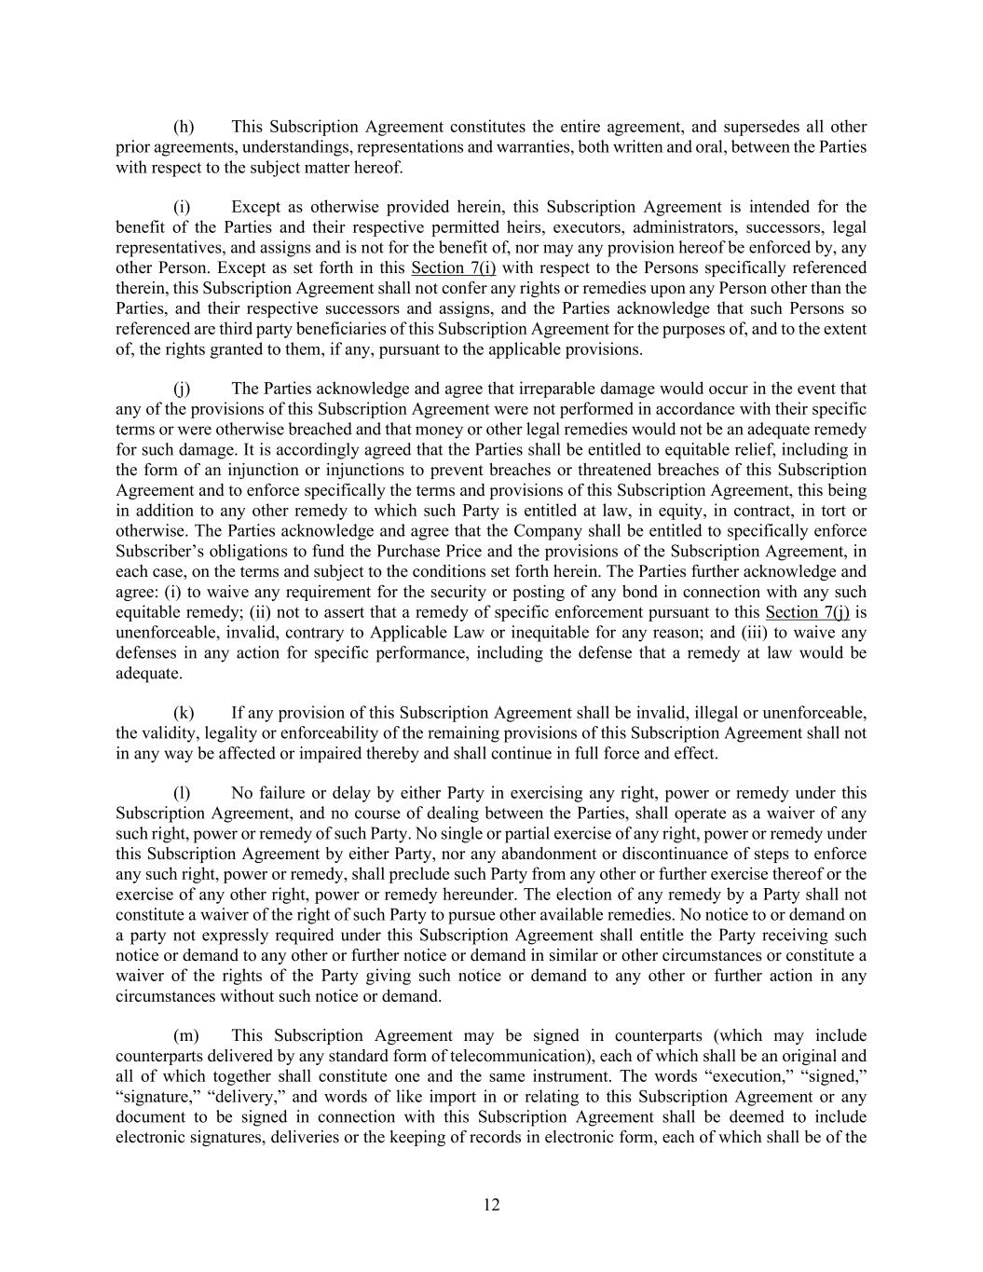
12 (h) This Subscription Agreement constitutes the entire agreement, and supersedes all other prior agreements, understandings, representations and warranties, both written and oral, between the Parties with respect to the subject matter hereof. (i) Except as otherwise provided herein, this Subscription Agreement is intended for the benefit of the Parties and their respective permitted heirs, executors, administrators, successors, legal representatives, and assigns and is not for the benefit of, nor may any provision hereof be enforced by, any other Person. Except as set forth in this Section 7(i) with respect to the Persons specifically referenced therein, this Subscription Agreement shall not confer any rights or remedies upon any Person other than the Parties, and their respective successors and assigns, and the Parties acknowledge that such Persons so referenced are third party beneficiaries of this Subscription Agreement for the purposes of, and to the extent of, the rights granted to them, if any, pursuant to the applicable provisions. (j) The Parties acknowledge and agree that irreparable damage would occur in the event that any of the provisions of this Subscription Agreement were not performed in accordance with their specific terms or were otherwise breached and that money or other legal remedies would not be an adequate remedy for such damage. It is accordingly agreed that the Parties shall be entitled to equitable relief, including in the form of an injunction or injunctions to prevent breaches or threatened breaches of this Subscription Agreement and to enforce specifically the terms and provisions of this Subscription Agreement, this being in addition to any other remedy to which such Party is entitled at law, in equity, in contract, in tort or otherwise. The Parties acknowledge and agree that the Company shall be entitled to specifically enforce Subscriber’s obligations to fund the Purchase Price and the provisions of the Subscription Agreement, in each case, on the terms and subject to the conditions set forth herein. The Parties further acknowledge and agree: (i) to waive any requirement for the security or posting of any bond in connection with any such equitable remedy; (ii) not to assert that a remedy of specific enforcement pursuant to this Section 7(j) is unenforceable, invalid, contrary to Applicable Law or inequitable for any reason; and (iii) to waive any defenses in any action for specific performance, including the defense that a remedy at law would be adequate. (k) If any provision of this Subscription Agreement shall be invalid, illegal or unenforceable, the validity, legality or enforceability of the remaining provisions of this Subscription Agreement shall not in any way be affected or impaired thereby and shall continue in full force and effect. (l) No failure or delay by either Party in exercising any right, power or remedy under this Subscription Agreement, and no course of dealing between the Parties, shall operate as a waiver of any such right, power or remedy of such Party. No single or partial exercise of any right, power or remedy under this Subscription Agreement by either Party, nor any abandonment or discontinuance of steps to enforce any such right, power or remedy, shall preclude such Party from any other or further exercise thereof or the exercise of any other right, power or remedy hereunder. The election of any remedy by a Party shall not constitute a waiver of the right of such Party to pursue other available remedies. No notice to or demand on a party not expressly required under this Subscription Agreement shall entitle the Party receiving such notice or demand to any other or further notice or demand in similar or other circumstances or constitute a waiver of the rights of the Party giving such notice or demand to any other or further action in any circumstances without such notice or demand. (m) This Subscription Agreement may be signed in counterparts (which may include counterparts delivered by any standard form of telecommunication), each of which shall be an original and all of which together shall constitute one and the same instrument. The words “execution,” “signed,” “signature,” “delivery,” and words of like import in or relating to this Subscription Agreement or any document to be signed in connection with this Subscription Agreement shall be deemed to include electronic signatures, deliveries or the keeping of records in electronic form, each of which shall be of the

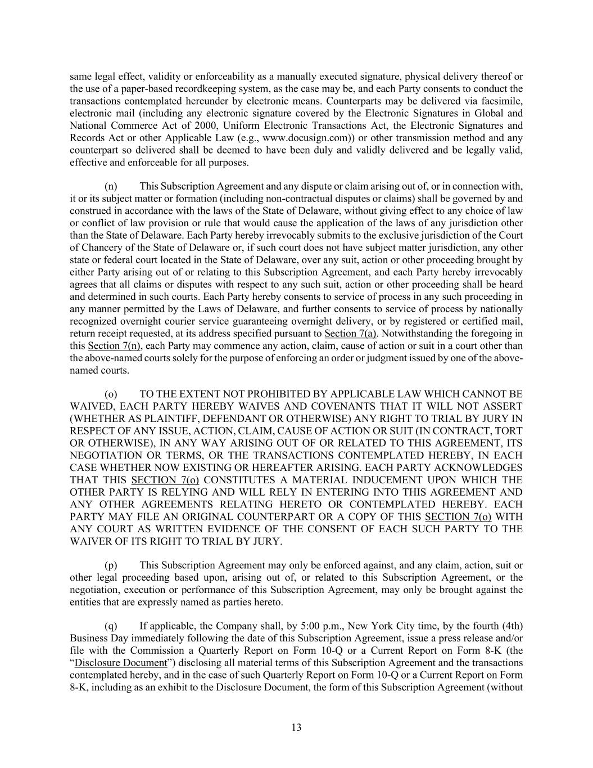
13 same legal effect, validity or enforceability as a manually executed signature, physical delivery thereof or the use of a paper-based recordkeeping system, as the case may be, and each Party consents to conduct the transactions contemplated hereunder by electronic means. Counterparts may be delivered via facsimile, electronic mail (including any electronic signature covered by the Electronic Signatures in Global and National Commerce Act of 2000, Uniform Electronic Transactions Act, the Electronic Signatures and Records Act or other Applicable Law (e.g., www.docusign.com)) or other transmission method and any counterpart so delivered shall be deemed to have been duly and validly delivered and be legally valid, effective and enforceable for all purposes. (n) This Subscription Agreement and any dispute or claim arising out of, or in connection with, it or its subject matter or formation (including non-contractual disputes or claims) shall be governed by and construed in accordance with the laws of the State of Delaware, without giving effect to any choice of law or conflict of law provision or rule that would cause the application of the laws of any jurisdiction other than the State of Delaware. Each Party hereby irrevocably submits to the exclusive jurisdiction of the Court of Chancery of the State of Delaware or, if such court does not have subject matter jurisdiction, any other state or federal court located in the State of Delaware, over any suit, action or other proceeding brought by either Party arising out of or relating to this Subscription Agreement, and each Party hereby irrevocably agrees that all claims or disputes with respect to any such suit, action or other proceeding shall be heard and determined in such courts. Each Party hereby consents to service of process in any such proceeding in any manner permitted by the Laws of Delaware, and further consents to service of process by nationally recognized overnight courier service guaranteeing overnight delivery, or by registered or certified mail, return receipt requested, at its address specified pursuant to Section 7(a). Notwithstanding the foregoing in this Section 7(n), each Party may commence any action, claim, cause of action or suit in a court other than the above-named courts solely for the purpose of enforcing an order or judgment issued by one of the above- named courts. (o) TO THE EXTENT NOT PROHIBITED BY APPLICABLE LAW WHICH CANNOT BE WAIVED, EACH PARTY HEREBY WAIVES AND COVENANTS THAT IT WILL NOT ASSERT (WHETHER AS PLAINTIFF, DEFENDANT OR OTHERWISE) ANY RIGHT TO TRIAL BY JURY IN RESPECT OF ANY ISSUE, ACTION, CLAIM, CAUSE OF ACTION OR SUIT (IN CONTRACT, TORT OR OTHERWISE), IN ANY WAY ARISING OUT OF OR RELATED TO THIS AGREEMENT, ITS NEGOTIATION OR TERMS, OR THE TRANSACTIONS CONTEMPLATED HEREBY, IN EACH CASE WHETHER NOW EXISTING OR HEREAFTER ARISING. EACH PARTY ACKNOWLEDGES THAT THIS SECTION 7(o) CONSTITUTES A MATERIAL INDUCEMENT UPON WHICH THE OTHER PARTY IS RELYING AND WILL RELY IN ENTERING INTO THIS AGREEMENT AND ANY OTHER AGREEMENTS RELATING HERETO OR CONTEMPLATED HEREBY. EACH PARTY MAY FILE AN ORIGINAL COUNTERPART OR A COPY OF THIS SECTION 7(o) WITH ANY COURT AS WRITTEN EVIDENCE OF THE CONSENT OF EACH SUCH PARTY TO THE WAIVER OF ITS RIGHT TO TRIAL BY JURY. (p) This Subscription Agreement may only be enforced against, and any claim, action, suit or other legal proceeding based upon, arising out of, or related to this Subscription Agreement, or the negotiation, execution or performance of this Subscription Agreement, may only be brought against the entities that are expressly named as parties hereto. (q) If applicable, the Company shall, by 5:00 p.m., New York City time, by the fourth (4th) Business Day immediately following the date of this Subscription Agreement, issue a press release and/or file with the Commission a Quarterly Report on Form 10-Q or a Current Report on Form 8-K (the “Disclosure Document”) disclosing all material terms of this Subscription Agreement and the transactions contemplated hereby, and in the case of such Quarterly Report on Form 10-Q or a Current Report on Form 8-K, including as an exhibit to the Disclosure Document, the form of this Subscription Agreement (without

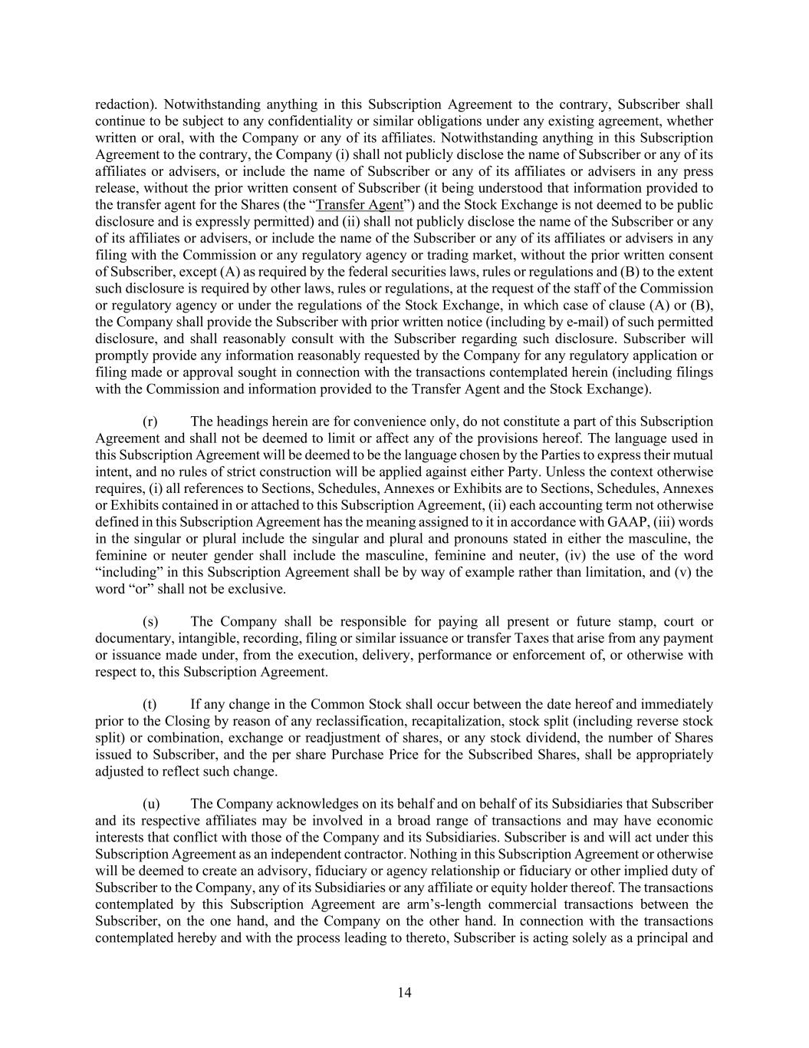
14 redaction). Notwithstanding anything in this Subscription Agreement to the contrary, Subscriber shall continue to be subject to any confidentiality or similar obligations under any existing agreement, whether written or oral, with the Company or any of its affiliates. Notwithstanding anything in this Subscription Agreement to the contrary, the Company (i) shall not publicly disclose the name of Subscriber or any of its affiliates or advisers, or include the name of Subscriber or any of its affiliates or advisers in any press release, without the prior written consent of Subscriber (it being understood that information provided to the transfer agent for the Shares (the “Transfer Agent”) and the Stock Exchange is not deemed to be public disclosure and is expressly permitted) and (ii) shall not publicly disclose the name of the Subscriber or any of its affiliates or advisers, or include the name of the Subscriber or any of its affiliates or advisers in any filing with the Commission or any regulatory agency or trading market, without the prior written consent of Subscriber, except (A) as required by the federal securities laws, rules or regulations and (B) to the extent such disclosure is required by other laws, rules or regulations, at the request of the staff of the Commission or regulatory agency or under the regulations of the Stock Exchange, in which case of clause (A) or (B), the Company shall provide the Subscriber with prior written notice (including by e-mail) of such permitted disclosure, and shall reasonably consult with the Subscriber regarding such disclosure. Subscriber will promptly provide any information reasonably requested by the Company for any regulatory application or filing made or approval sought in connection with the transactions contemplated herein (including filings with the Commission and information provided to the Transfer Agent and the Stock Exchange). (r) The headings herein are for convenience only, do not constitute a part of this Subscription Agreement and shall not be deemed to limit or affect any of the provisions hereof. The language used in this Subscription Agreement will be deemed to be the language chosen by the Parties to express their mutual intent, and no rules of strict construction will be applied against either Party. Unless the context otherwise requires, (i) all references to Sections, Schedules, Annexes or Exhibits are to Sections, Schedules, Annexes or Exhibits contained in or attached to this Subscription Agreement, (ii) each accounting term not otherwise defined in this Subscription Agreement has the meaning assigned to it in accordance with GAAP, (iii) words in the singular or plural include the singular and plural and pronouns stated in either the masculine, the feminine or neuter gender shall include the masculine, feminine and neuter, (iv) the use of the word “including” in this Subscription Agreement shall be by way of example rather than limitation, and (v) the word “or” shall not be exclusive. (s) The Company shall be responsible for paying all present or future stamp, court or documentary, intangible, recording, filing or similar issuance or transfer Taxes that arise from any payment or issuance made under, from the execution, delivery, performance or enforcement of, or otherwise with respect to, this Subscription Agreement. (t) If any change in the Common Stock shall occur between the date hereof and immediately prior to the Closing by reason of any reclassification, recapitalization, stock split (including reverse stock split) or combination, exchange or readjustment of shares, or any stock dividend, the number of Shares issued to Subscriber, and the per share Purchase Price for the Subscribed Shares, shall be appropriately adjusted to reflect such change. (u) The Company acknowledges on its behalf and on behalf of its Subsidiaries that Subscriber and its respective affiliates may be involved in a broad range of transactions and may have economic interests that conflict with those of the Company and its Subsidiaries. Subscriber is and will act under this Subscription Agreement as an independent contractor. Nothing in this Subscription Agreement or otherwise will be deemed to create an advisory, fiduciary or agency relationship or fiduciary or other implied duty of Subscriber to the Company, any of its Subsidiaries or any affiliate or equity holder thereof. The transactions contemplated by this Subscription Agreement are arm’s-length commercial transactions between the Subscriber, on the one hand, and the Company on the other hand. In connection with the transactions contemplated hereby and with the process leading to thereto, Subscriber is acting solely as a principal and

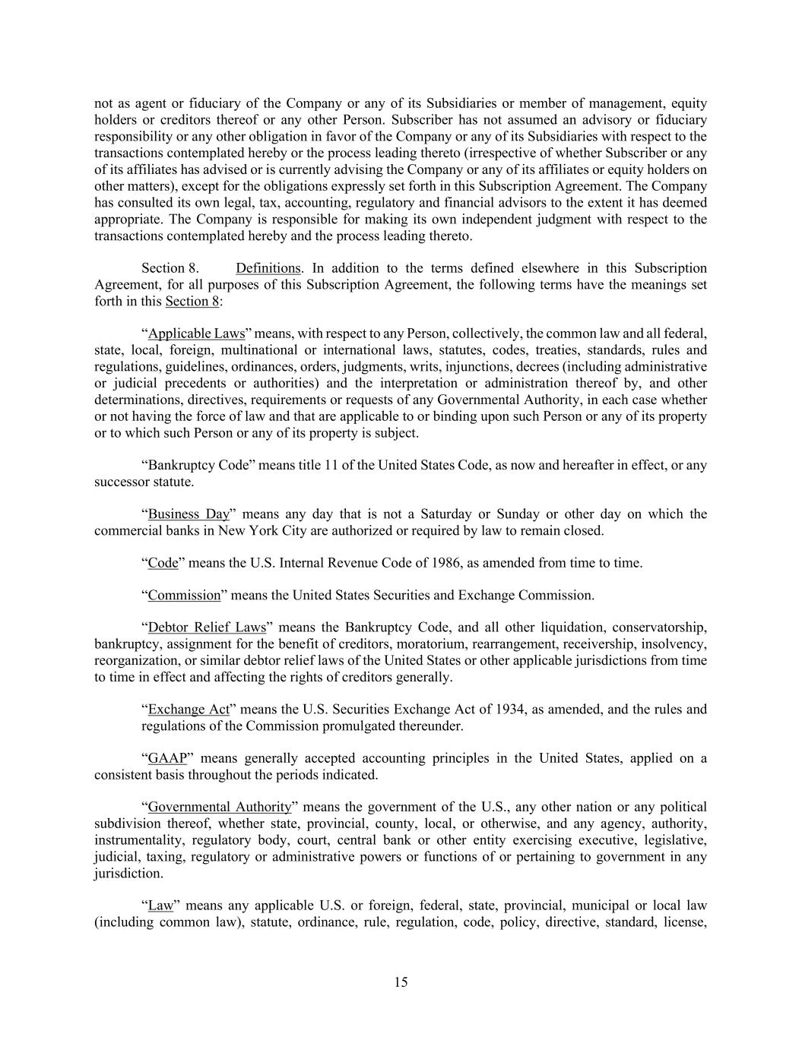
15 not as agent or fiduciary of the Company or any of its Subsidiaries or member of management, equity holders or creditors thereof or any other Person. Subscriber has not assumed an advisory or fiduciary responsibility or any other obligation in favor of the Company or any of its Subsidiaries with respect to the transactions contemplated hereby or the process leading thereto (irrespective of whether Subscriber or any of its affiliates has advised or is currently advising the Company or any of its affiliates or equity holders on other matters), except for the obligations expressly set forth in this Subscription Agreement. The Company has consulted its own legal, tax, accounting, regulatory and financial advisors to the extent it has deemed appropriate. The Company is responsible for making its own independent judgment with respect to the transactions contemplated hereby and the process leading thereto. Section 8. Definitions. In addition to the terms defined elsewhere in this Subscription Agreement, for all purposes of this Subscription Agreement, the following terms have the meanings set forth in this Section 8: “Applicable Laws” means, with respect to any Person, collectively, the common law and all federal, state, local, foreign, multinational or international laws, statutes, codes, treaties, standards, rules and regulations, guidelines, ordinances, orders, judgments, writs, injunctions, decrees (including administrative or judicial precedents or authorities) and the interpretation or administration thereof by, and other determinations, directives, requirements or requests of any Governmental Authority, in each case whether or not having the force of law and that are applicable to or binding upon such Person or any of its property or to which such Person or any of its property is subject. “Bankruptcy Code” means title 11 of the United States Code, as now and hereafter in effect, or any successor statute. “Business Day” means any day that is not a Saturday or Sunday or other day on which the commercial banks in New York City are authorized or required by law to remain closed. “Code” means the U.S. Internal Revenue Code of 1986, as amended from time to time. “Commission” means the United States Securities and Exchange Commission. “Debtor Relief Laws” means the Bankruptcy Code, and all other liquidation, conservatorship, bankruptcy, assignment for the benefit of creditors, moratorium, rearrangement, receivership, insolvency, reorganization, or similar debtor relief laws of the United States or other applicable jurisdictions from time to time in effect and affecting the rights of creditors generally. “Exchange Act” means the U.S. Securities Exchange Act of 1934, as amended, and the rules and regulations of the Commission promulgated thereunder. “GAAP” means generally accepted accounting principles in the United States, applied on a consistent basis throughout the periods indicated. “Governmental Authority” means the government of the U.S., any other nation or any political subdivision thereof, whether state, provincial, county, local, or otherwise, and any agency, authority, instrumentality, regulatory body, court, central bank or other entity exercising executive, legislative, judicial, taxing, regulatory or administrative powers or functions of or pertaining to government in any jurisdiction. “Law” means any applicable U.S. or foreign, federal, state, provincial, municipal or local law (including common law), statute, ordinance, rule, regulation, code, policy, directive, standard, license,

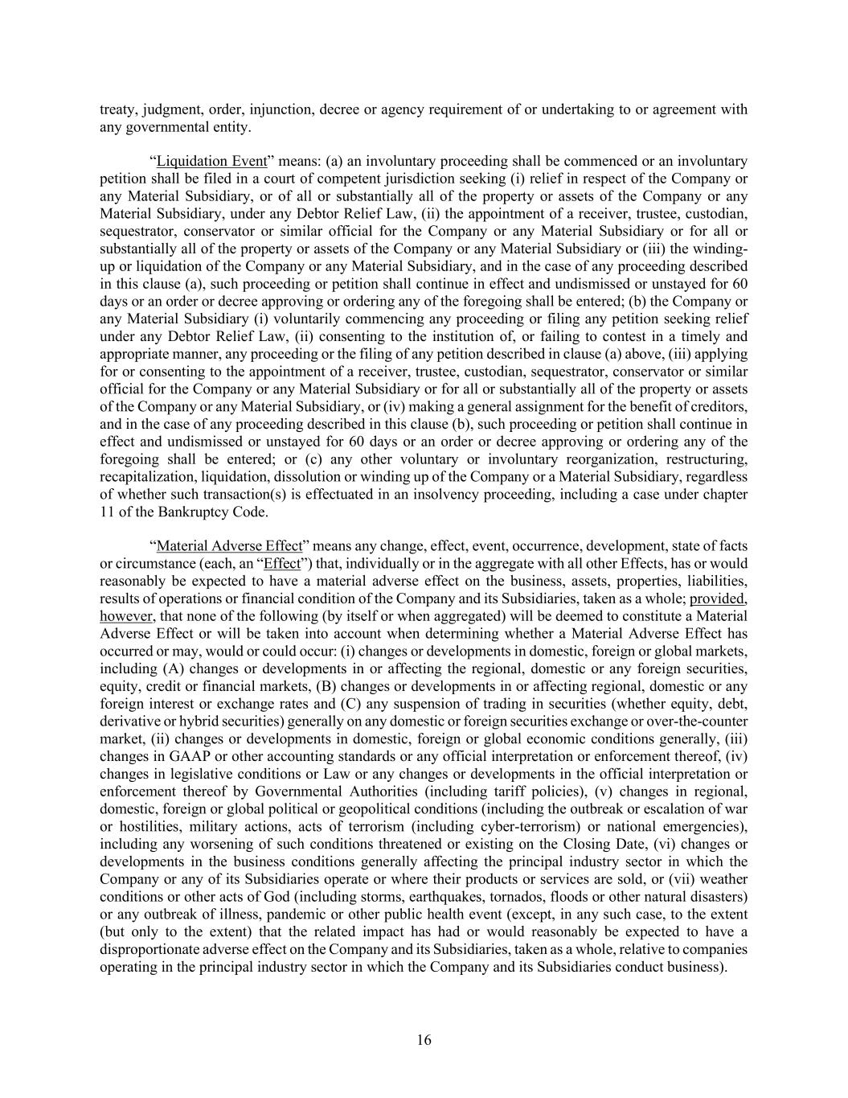
16 treaty, judgment, order, injunction, decree or agency requirement of or undertaking to or agreement with any governmental entity. “Liquidation Event” means: (a) an involuntary proceeding shall be commenced or an involuntary petition shall be filed in a court of competent jurisdiction seeking (i) relief in respect of the Company or any Material Subsidiary, or of all or substantially all of the property or assets of the Company or any Material Subsidiary, under any Debtor Relief Law, (ii) the appointment of a receiver, trustee, custodian, sequestrator, conservator or similar official for the Company or any Material Subsidiary or for all or substantially all of the property or assets of the Company or any Material Subsidiary or (iii) the winding- up or liquidation of the Company or any Material Subsidiary, and in the case of any proceeding described in this clause (a), such proceeding or petition shall continue in effect and undismissed or unstayed for 60 days or an order or decree approving or ordering any of the foregoing shall be entered; (b) the Company or any Material Subsidiary (i) voluntarily commencing any proceeding or filing any petition seeking relief under any Debtor Relief Law, (ii) consenting to the institution of, or failing to contest in a timely and appropriate manner, any proceeding or the filing of any petition described in clause (a) above, (iii) applying for or consenting to the appointment of a receiver, trustee, custodian, sequestrator, conservator or similar official for the Company or any Material Subsidiary or for all or substantially all of the property or assets of the Company or any Material Subsidiary, or (iv) making a general assignment for the benefit of creditors, and in the case of any proceeding described in this clause (b), such proceeding or petition shall continue in effect and undismissed or unstayed for 60 days or an order or decree approving or ordering any of the foregoing shall be entered; or (c) any other voluntary or involuntary reorganization, restructuring, recapitalization, liquidation, dissolution or winding up of the Company or a Material Subsidiary, regardless of whether such transaction(s) is effectuated in an insolvency proceeding, including a case under chapter 11 of the Bankruptcy Code. “Material Adverse Effect” means any change, effect, event, occurrence, development, state of facts or circumstance (each, an “Effect”) that, individually or in the aggregate with all other Effects, has or would reasonably be expected to have a material adverse effect on the business, assets, properties, liabilities, results of operations or financial condition of the Company and its Subsidiaries, taken as a whole; provided, however, that none of the following (by itself or when aggregated) will be deemed to constitute a Material Adverse Effect or will be taken into account when determining whether a Material Adverse Effect has occurred or may, would or could occur: (i) changes or developments in domestic, foreign or global markets, including (A) changes or developments in or affecting the regional, domestic or any foreign securities, equity, credit or financial markets, (B) changes or developments in or affecting regional, domestic or any foreign interest or exchange rates and (C) any suspension of trading in securities (whether equity, debt, derivative or hybrid securities) generally on any domestic or foreign securities exchange or over-the-counter market, (ii) changes or developments in domestic, foreign or global economic conditions generally, (iii) changes in GAAP or other accounting standards or any official interpretation or enforcement thereof, (iv) changes in legislative conditions or Law or any changes or developments in the official interpretation or enforcement thereof by Governmental Authorities (including tariff policies), (v) changes in regional, domestic, foreign or global political or geopolitical conditions (including the outbreak or escalation of war or hostilities, military actions, acts of terrorism (including cyber-terrorism) or national emergencies), including any worsening of such conditions threatened or existing on the Closing Date, (vi) changes or developments in the business conditions generally affecting the principal industry sector in which the Company or any of its Subsidiaries operate or where their products or services are sold, or (vii) weather conditions or other acts of God (including storms, earthquakes, tornados, floods or other natural disasters) or any outbreak of illness, pandemic or other public health event (except, in any such case, to the extent (but only to the extent) that the related impact has had or would reasonably be expected to have a disproportionate adverse effect on the Company and its Subsidiaries, taken as a whole, relative to companies operating in the principal industry sector in which the Company and its Subsidiaries conduct business).

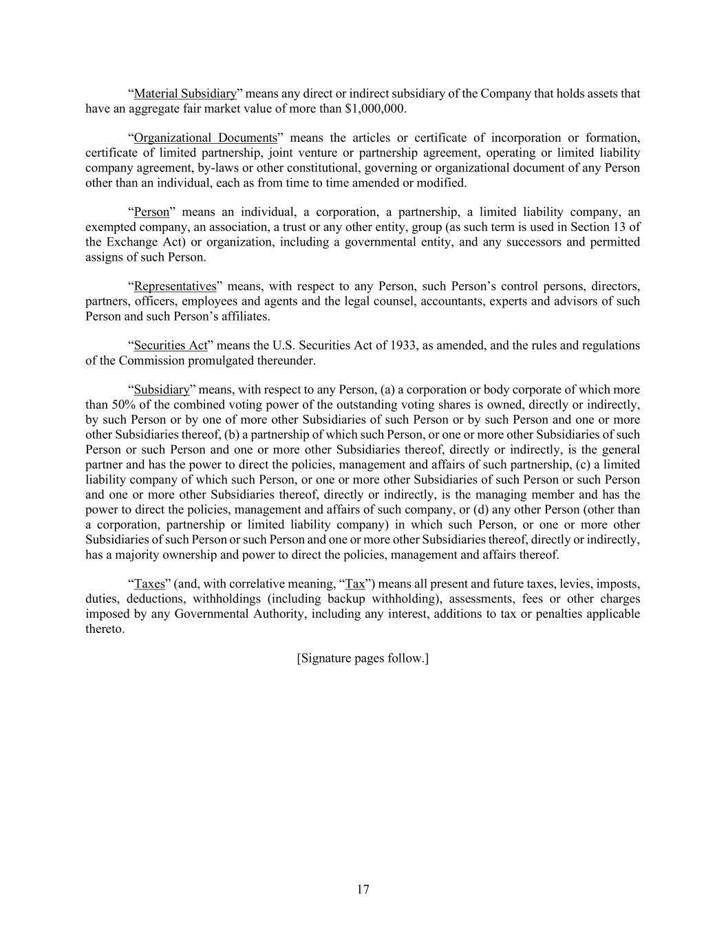
17 “Material Subsidiary” means any direct or indirect subsidiary of the Company that holds assets that have an aggregate fair market value of more than $1,000,000. “Organizational Documents” means the articles or certificate of incorporation or formation, certificate of limited partnership, joint venture or partnership agreement, operating or limited liability company agreement, by-laws or other constitutional, governing or organizational document of any Person other than an individual, each as from time to time amended or modified. “Person” means an individual, a corporation, a partnership, a limited liability company, an exempted company, an association, a trust or any other entity, group (as such term is used in Section 13 of the Exchange Act) or organization, including a governmental entity, and any successors and permitted assigns of such Person. “Representatives” means, with respect to any Person, such Person’s control persons, directors, partners, officers, employees and agents and the legal counsel, accountants, experts and advisors of such Person and such Person’s affiliates. “Securities Act” means the U.S. Securities Act of 1933, as amended, and the rules and regulations of the Commission promulgated thereunder. “Subsidiary” means, with respect to any Person, (a) a corporation or body corporate of which more than 50% of the combined voting power of the outstanding voting shares is owned, directly or indirectly, by such Person or by one of more other Subsidiaries of such Person or by such Person and one or more other Subsidiaries thereof, (b) a partnership of which such Person, or one or more other Subsidiaries of such Person or such Person and one or more other Subsidiaries thereof, directly or indirectly, is the general partner and has the power to direct the policies, management and affairs of such partnership, (c) a limited liability company of which such Person, or one or more other Subsidiaries of such Person or such Person and one or more other Subsidiaries thereof, directly or indirectly, is the managing member and has the power to direct the policies, management and affairs of such company, or (d) any other Person (other than a corporation, partnership or limited liability company) in which such Person, or one or more other Subsidiaries of such Person or such Person and one or more other Subsidiaries thereof, directly or indirectly, has a majority ownership and power to direct the policies, management and affairs thereof. “Taxes” (and, with correlative meaning, “Tax”) means all present and future taxes, levies, imposts, duties, deductions, withholdings (including backup withholding), assessments, fees or other charges imposed by any Governmental Authority, including any interest, additions to tax or penalties applicable thereto. [Signature pages follow.]

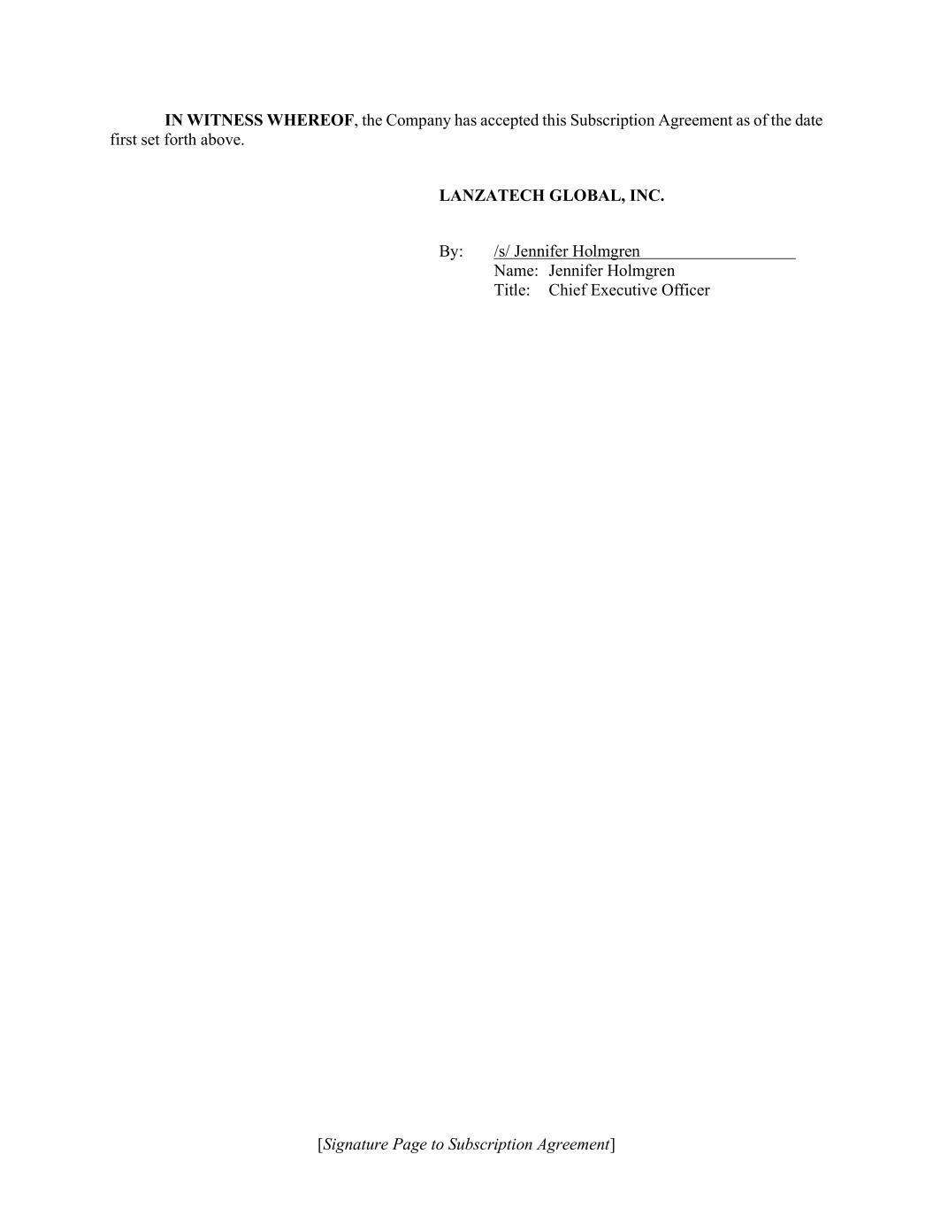
[Signature Page to Subscription Agreement] IN WITNESS WHEREOF, the Company has accepted this Subscription Agreement as of the date first set forth above. LANZATECH GLOBAL, INC. By: /s/ Jennifer Holmgren Name: Jennifer Holmgren Title: Chief Executive Officer

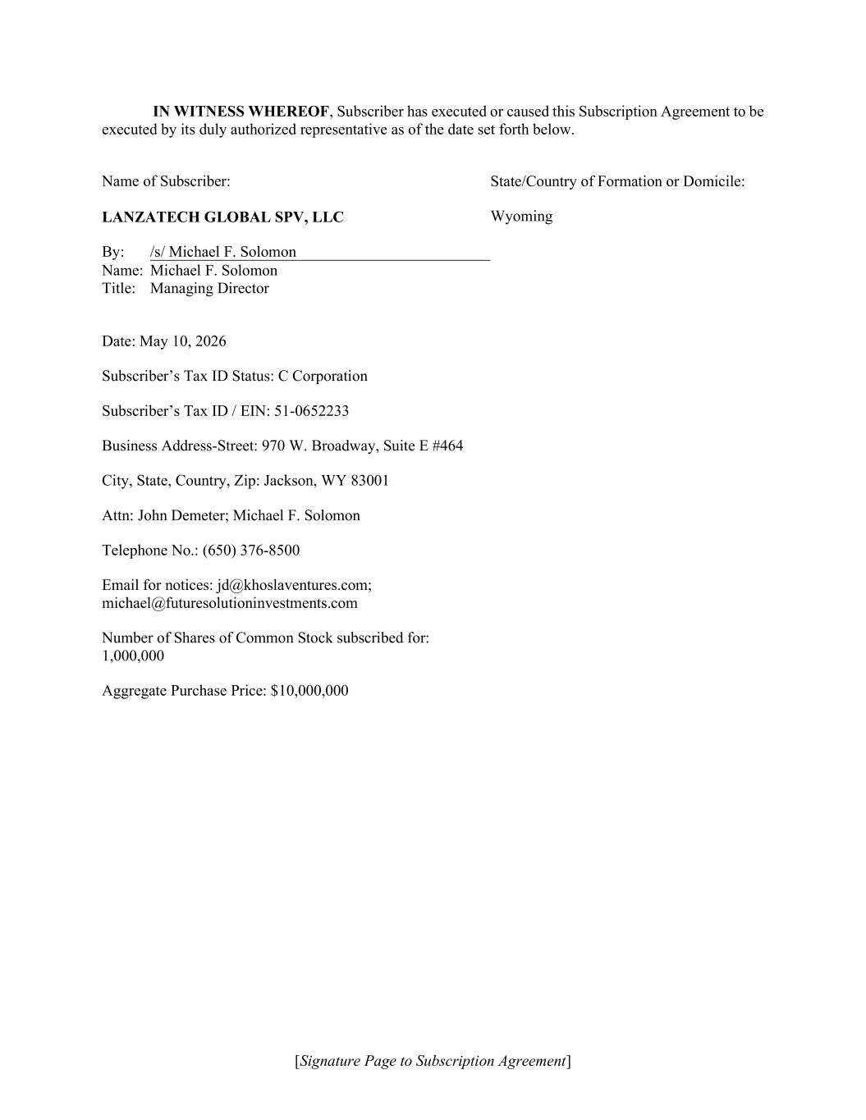
[Signature Page to Subscription Agreement] IN WITNESS WHEREOF, Subscriber has executed or caused this Subscription Agreement to be executed by its duly authorized representative as of the date set forth below. Name of Subscriber: LANZATECH GLOBAL SPV, LLC State/Country of Formation or Domicile: Wyoming By: /s/ Michael F. Solomon Name: Michael F. Solomon Title: Managing Director Date: May 10, 2026 Subscriber’s Tax ID Status: C Corporation Subscriber’s Tax ID / EIN: 51-0652233 Business Address-Street: 970 W. Broadway, Suite E #464 City, State, Country, Zip: Jackson, WY 83001 Attn: John Demeter; Michael F. Solomon Telephone No.: (650) 376-8500 Email for notices: jd@khoslaventures.com; michael@futuresolutioninvestments.com Number of Shares of Common Stock subscribed for: 1,000,000 Aggregate Purchase Price: $10,000,000


ANNEX A ELIGIBILITY REPRESENTATIONS OF SUBSCRIBER

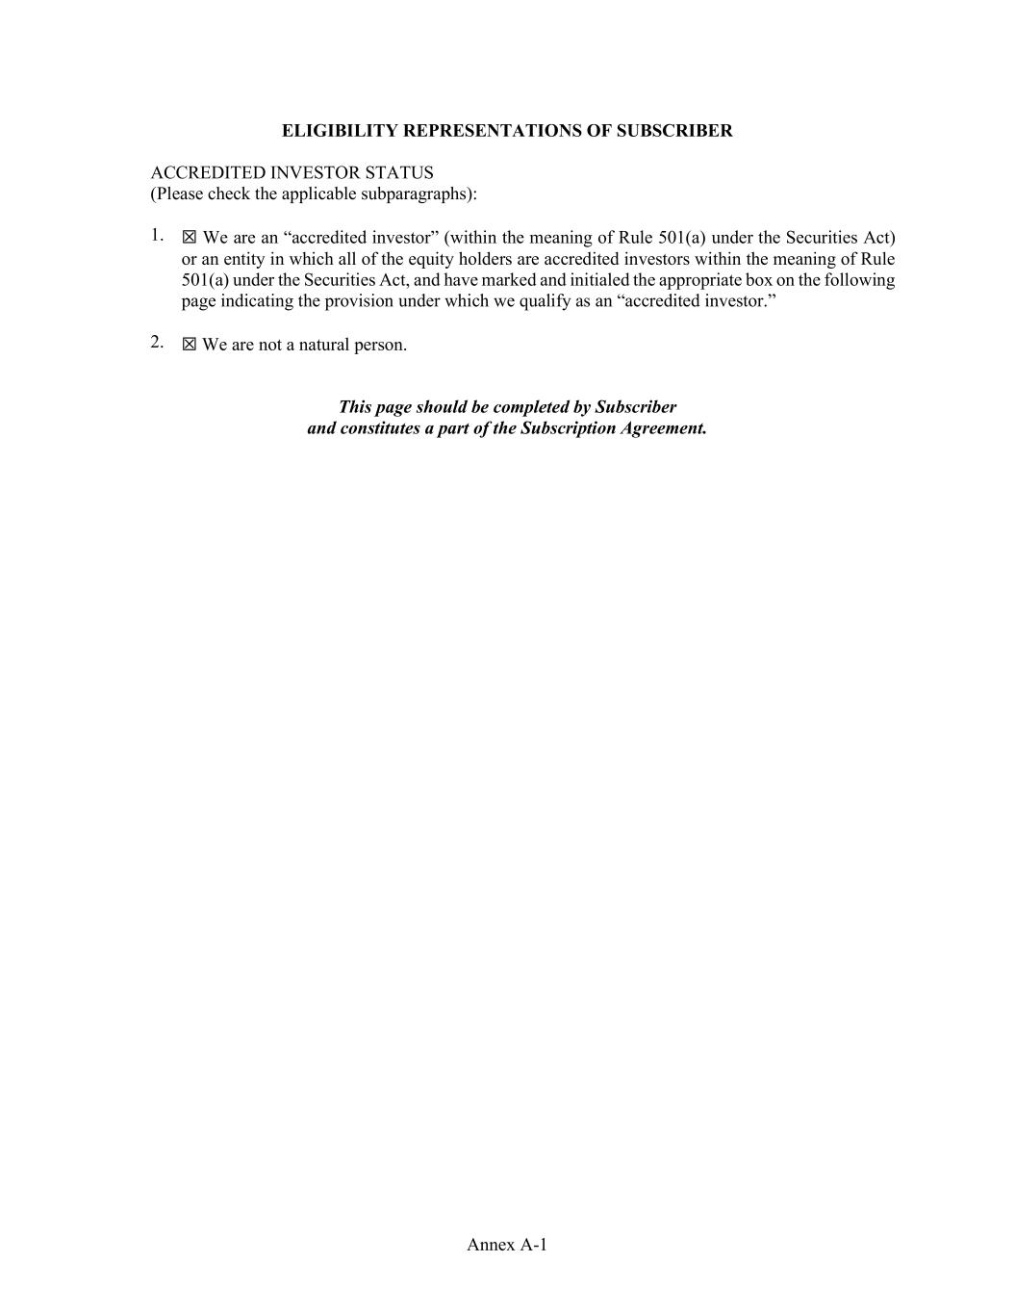
Annex A-1 ELIGIBILITY REPRESENTATIONS OF SUBSCRIBER ACCREDITED INVESTOR STATUS (Please check the applicable subparagraphs): 1. ☒ We are an “accredited investor” (within the meaning of Rule 501(a) under the Securities Act) or an entity in which all of the equity holders are accredited investors within the meaning of Rule 501(a) under the Securities Act, and have marked and initialed the appropriate box on the following page indicating the provision under which we qualify as an “accredited investor.” 2. ☒ We are not a natural person. This page should be completed by Subscriber and constitutes a part of the Subscription Agreement.

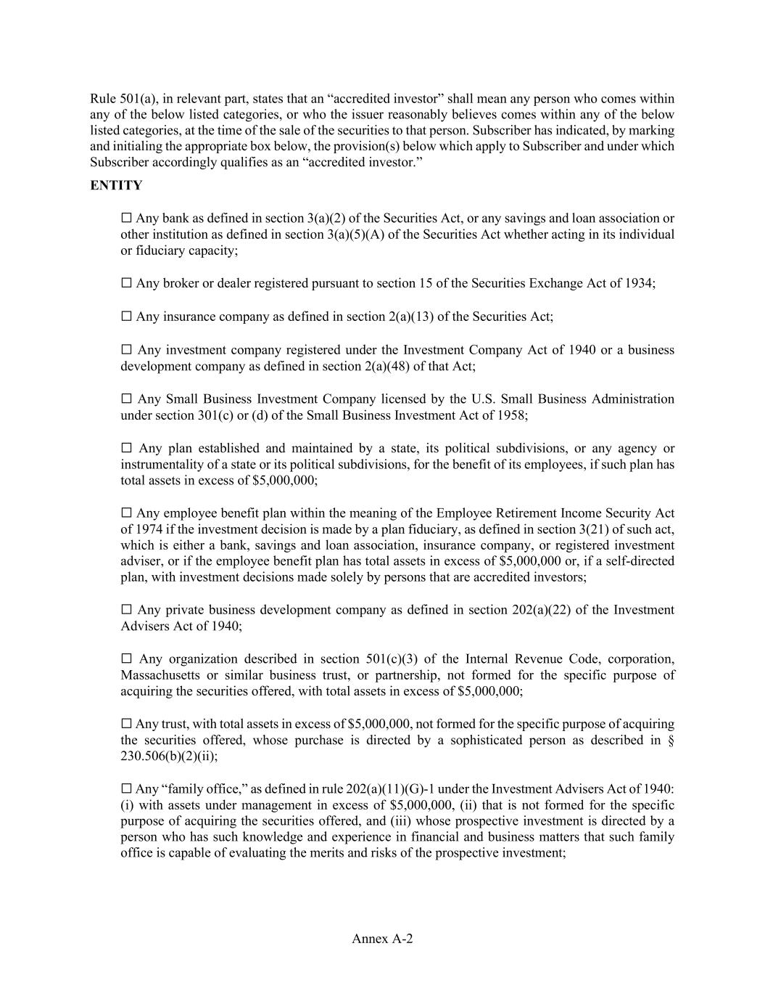
Annex A-2 Rule 501(a), in relevant part, states that an “accredited investor” shall mean any person who comes within any of the below listed categories, or who the issuer reasonably believes comes within any of the below listed categories, at the time of the sale of the securities to that person. Subscriber has indicated, by marking and initialing the appropriate box below, the provision(s) below which apply to Subscriber and under which Subscriber accordingly qualifies as an “accredited investor.” ENTITY ☐ Any bank as defined in section 3(a)(2) of the Securities Act, or any savings and loan association or other institution as defined in section 3(a)(5)(A) of the Securities Act whether acting in its individual or fiduciary capacity; ☐ Any broker or dealer registered pursuant to section 15 of the Securities Exchange Act of 1934; ☐ Any insurance company as defined in section 2(a)(13) of the Securities Act; ☐ Any investment company registered under the Investment Company Act of 1940 or a business development company as defined in section 2(a)(48) of that Act; ☐ Any Small Business Investment Company licensed by the U.S. Small Business Administration under section 301(c) or (d) of the Small Business Investment Act of 1958; ☐ Any plan established and maintained by a state, its political subdivisions, or any agency or instrumentality of a state or its political subdivisions, for the benefit of its employees, if such plan has total assets in excess of $5,000,000; ☐ Any employee benefit plan within the meaning of the Employee Retirement Income Security Act of 1974 if the investment decision is made by a plan fiduciary, as defined in section 3(21) of such act, which is either a bank, savings and loan association, insurance company, or registered investment adviser, or if the employee benefit plan has total assets in excess of $5,000,000 or, if a self-directed plan, with investment decisions made solely by persons that are accredited investors; ☐ Any private business development company as defined in section 202(a)(22) of the Investment Advisers Act of 1940; ☐ Any organization described in section 501(c)(3) of the Internal Revenue Code, corporation, Massachusetts or similar business trust, or partnership, not formed for the specific purpose of acquiring the securities offered, with total assets in excess of $5,000,000; ☐ Any trust, with total assets in excess of $5,000,000, not formed for the specific purpose of acquiring the securities offered, whose purchase is directed by a sophisticated person as described in § 230.506(b)(2)(ii); ☐ Any “family office,” as defined in rule 202(a)(11)(G)-1 under the Investment Advisers Act of 1940: (i) with assets under management in excess of $5,000,000, (ii) that is not formed for the specific purpose of acquiring the securities offered, and (iii) whose prospective investment is directed by a person who has such knowledge and experience in financial and business matters that such family office is capable of evaluating the merits and risks of the prospective investment;

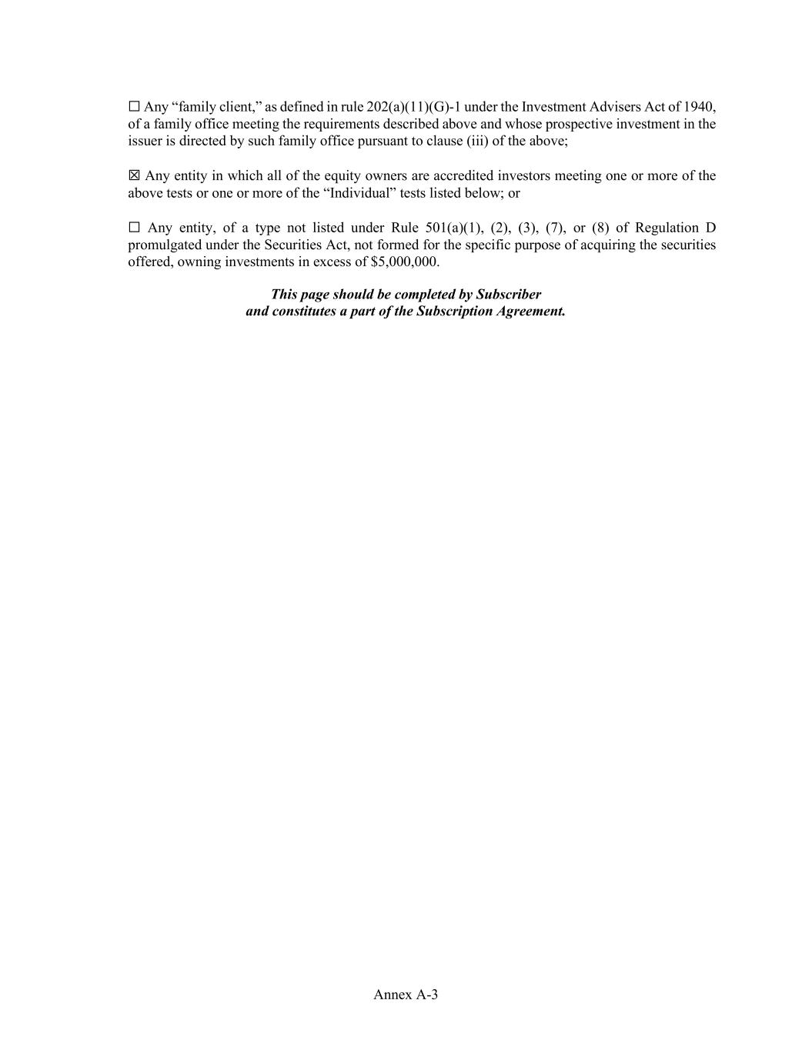
Annex A-3 ☐ Any “family client,” as defined in rule 202(a)(11)(G)-1 under the Investment Advisers Act of 1940, of a family office meeting the requirements described above and whose prospective investment in the issuer is directed by such family office pursuant to clause (iii) of the above; ☒ Any entity in which all of the equity owners are accredited investors meeting one or more of the above tests or one or more of the “Individual” tests listed below; or ☐ Any entity, of a type not listed under Rule 501(a)(1), (2), (3), (7), or (8) of Regulation D promulgated under the Securities Act, not formed for the specific purpose of acquiring the securities offered, owning investments in excess of $5,000,000. This page should be completed by Subscriber and constitutes a part of the Subscription Agreement.

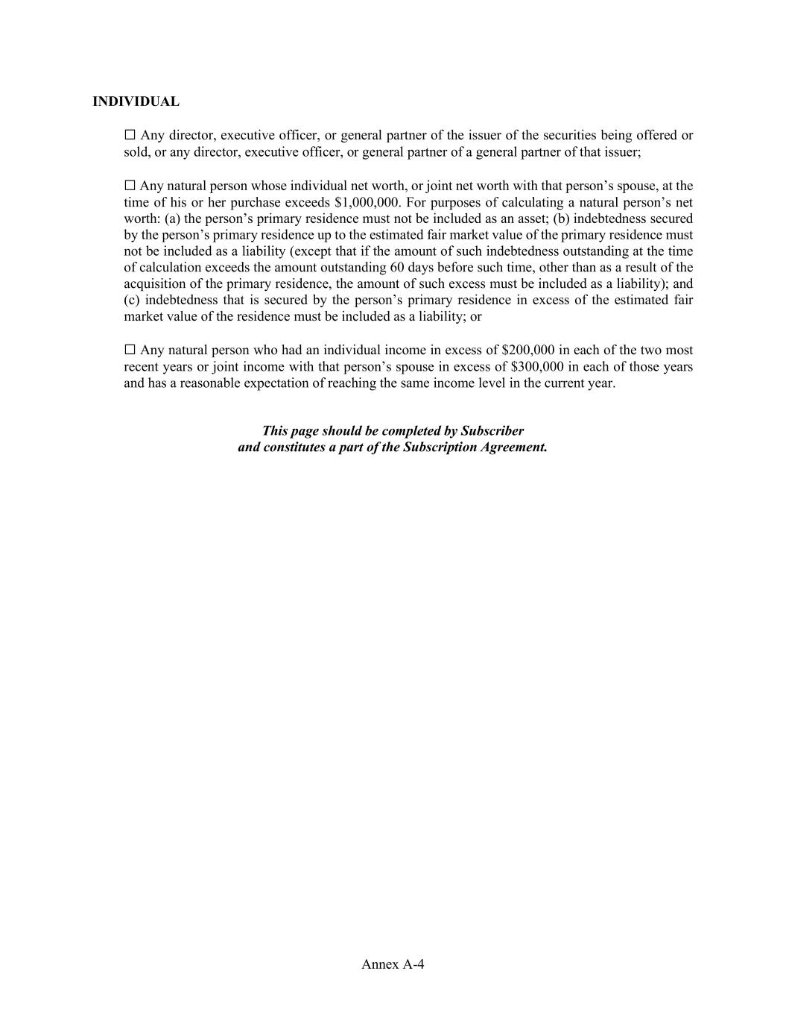
Annex A-4 INDIVIDUAL ☐ Any director, executive officer, or general partner of the issuer of the securities being offered or sold, or any director, executive officer, or general partner of a general partner of that issuer; ☐ Any natural person whose individual net worth, or joint net worth with that person’s spouse, at the time of his or her purchase exceeds $1,000,000. For purposes of calculating a natural person’s net worth: (a) the person’s primary residence must not be included as an asset; (b) indebtedness secured by the person’s primary residence up to the estimated fair market value of the primary residence must not be included as a liability (except that if the amount of such indebtedness outstanding at the time of calculation exceeds the amount outstanding 60 days before such time, other than as a result of the acquisition of the primary residence, the amount of such excess must be included as a liability); and (c) indebtedness that is secured by the person’s primary residence in excess of the estimated fair market value of the residence must be included as a liability; or ☐ Any natural person who had an individual income in excess of $200,000 in each of the two most recent years or joint income with that person’s spouse in excess of $300,000 in each of those years and has a reasonable expectation of reaching the same income level in the current year. This page should be completed by Subscriber and constitutes a part of the Subscription Agreement.

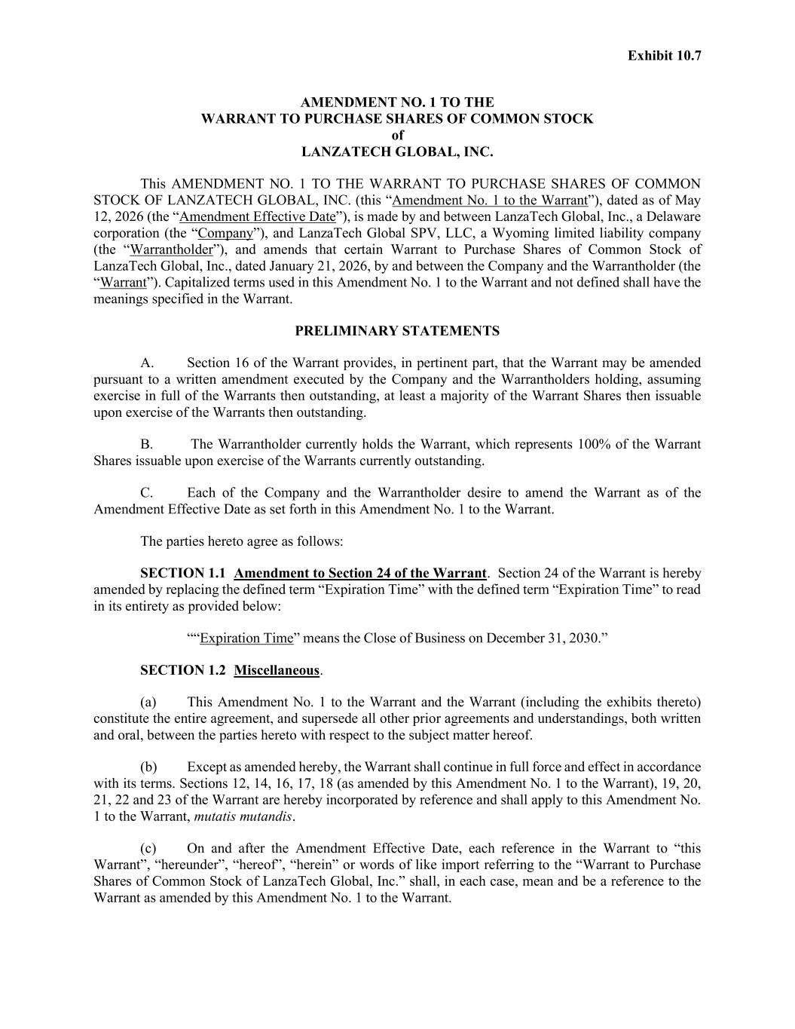
Exhibit 10.7 AMENDMENT NO. 1 TO THE WARRANT TO PURCHASE SHARES OF COMMON STOCK of LANZATECH GLOBAL, INC. This AMENDMENT NO. 1 TO THE WARRANT TO PURCHASE SHARES OF COMMON STOCK OF LANZATECH GLOBAL, INC. (this “Amendment No. 1 to the Warrant”), dated as of May 12, 2026 (the “Amendment Effective Date”), is made by and between LanzaTech Global, Inc., a Delaware corporation (the “Company”), and LanzaTech Global SPV, LLC, a Wyoming limited liability company (the “Warrantholder”), and amends that certain Warrant to Purchase Shares of Common Stock of LanzaTech Global, Inc., dated January 21, 2026, by and between the Company and the Warrantholder (the “Warrant”). Capitalized terms used in this Amendment No. 1 to the Warrant and not defined shall have the meanings specified in the Warrant. PRELIMINARY STATEMENTS A. Section 16 of the Warrant provides, in pertinent part, that the Warrant may be amended pursuant to a written amendment executed by the Company and the Warrantholders holding, assuming exercise in full of the Warrants then outstanding, at least a majority of the Warrant Shares then issuable upon exercise of the Warrants then outstanding. B. The Warrantholder currently holds the Warrant, which represents 100% of the Warrant Shares issuable upon exercise of the Warrants currently outstanding. C. Each of the Company and the Warrantholder desire to amend the Warrant as of the Amendment Effective Date as set forth in this Amendment No. 1 to the Warrant. The parties hereto agree as follows: SECTION 1.1 Amendment to Section 24 of the Warrant. Section 24 of the Warrant is hereby amended by replacing the defined term “Expiration Time” with the defined term “Expiration Time” to read in its entirety as provided below: ““Expiration Time” means the Close of Business on December 31, 2030.” SECTION 1.2 Miscellaneous. (a) This Amendment No. 1 to the Warrant and the Warrant (including the exhibits thereto) constitute the entire agreement, and supersede all other prior agreements and understandings, both written and oral, between the parties hereto with respect to the subject matter hereof. (b) Except as amended hereby, the Warrant shall continue in full force and effect in accordance with its terms. Sections 12, 14, 16, 17, 18 (as amended by this Amendment No. 1 to the Warrant), 19, 20, 21, 22 and 23 of the Warrant are hereby incorporated by reference and shall apply to this Amendment No. 1 to the Warrant, mutatis mutandis. (c) On and after the Amendment Effective Date, each reference in the Warrant to “this Warrant”, “hereunder”, “hereof”, “herein” or words of like import referring to the “Warrant to Purchase Shares of Common Stock of LanzaTech Global, Inc.” shall, in each case, mean and be a reference to the Warrant as amended by this Amendment No. 1 to the Warrant.


(d) The execution, delivery and effectiveness of this Amendment No. 1 to the Warrant shall not, except as expressly provided herein, operate as a waiver of any right, power or remedy of the Warrantholder under the Warrant. [Remainder of page intentionally left blank]

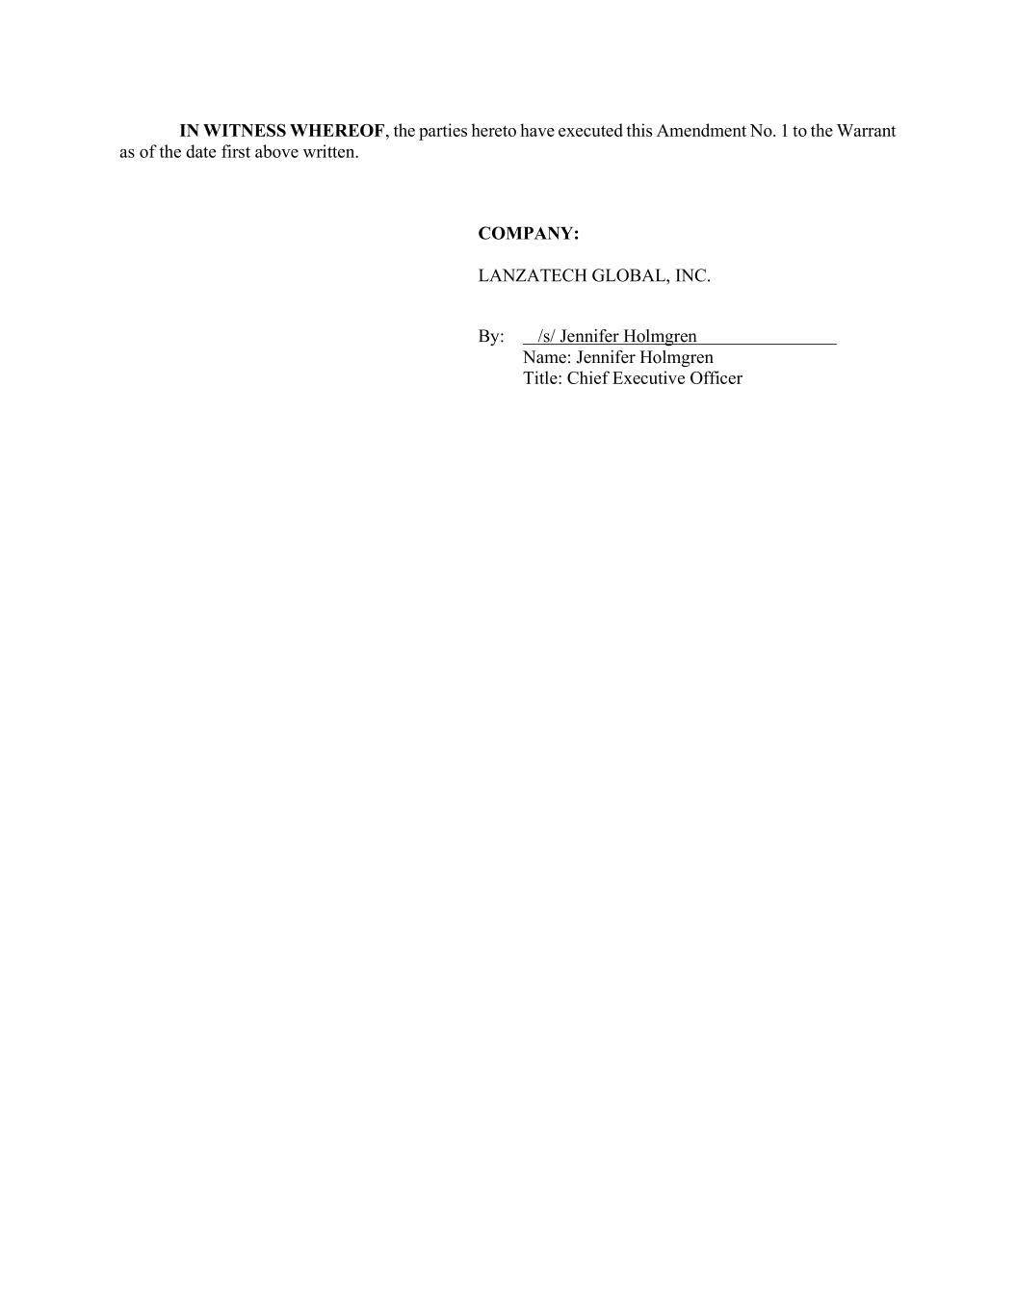
IN WITNESS WHEREOF, the parties hereto have executed this Amendment No. 1 to the Warrant as of the date first above written. COMPANY: LANZATECH GLOBAL, INC. By: /s/ Jennifer Holmgren Name: Jennifer Holmgren Title: Chief Executive Officer

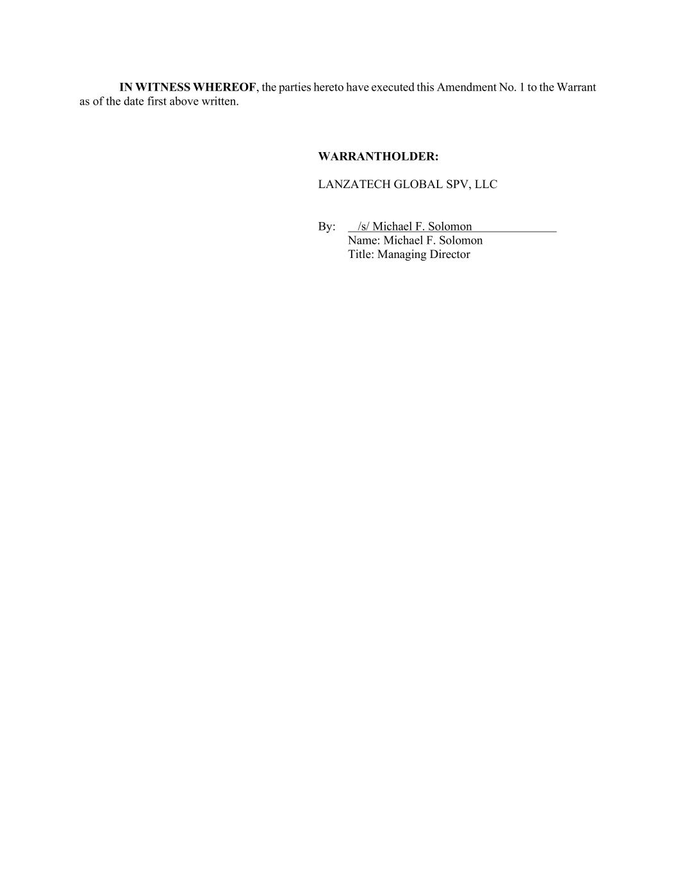
IN WITNESS WHEREOF, the parties hereto have executed this Amendment No. 1 to the Warrant as of the date first above written. WARRANTHOLDER: LANZATECH GLOBAL SPV, LLC By: /s/ Michael F. Solomon Name: Michael F. Solomon Title: Managing Director

Exhibit 31.1

CERTIFICATION PURSUANT TO

RULES 13a-14(a) AND 15d-14(a) UNDER THE SECURITIES EXCHANGE ACT OF 1934,

AS ADOPTED PURSUANT TO SECTION 302 OF THE SARBANES-OXLEY ACT OF 2002

I, Jennifer Holmgren, certify that:

1.I have reviewed this Quarterly Report on Form 10-Q of LanzaTech Global, Inc.;

2.Based on my knowledge, this report does not contain any untrue statement of a material fact or omit to state a material fact necessary to make the statements made, in light of the circumstances under which such statements were made, not misleading with respect to the period covered by this report;

3.Based on my knowledge, the financial statements, and other financial information included in this report, fairly present in all material respects the financial condition, results of operations and cash flows of the registrant as of, and for, the periods presented in this report;

4.The registrant’s other certifying officer(s) and I are responsible for establishing and maintaining disclosure controls and procedures (as defined in Exchange Act Rules 13a-15(e) and 15d-15(e)) and internal control over financial reporting (as defined in Exchange Act Rules 13a-15(f) and 15d-15(f)) for the registrant and have:

a)Designed such disclosure controls and procedures, or caused such disclosure controls and procedures to be designed under our supervision, to ensure that material information relating to the registrant, including its consolidated subsidiaries, is made known to us by others within those entities, particularly during the period in which this report is being prepared;

b)Designed such internal control over financial reporting, or caused such internal control over financial reporting to be designed under our supervision, to provide reasonable assurance regarding the reliability of financial reporting and the preparation of financial statements for external purposes in accordance with generally accepted accounting principles;

c)Evaluated the effectiveness of the registrant’s disclosure controls and procedures and presented in this report our conclusions about the effectiveness of the disclosure controls and procedures, as of the end of the period covered by this report based on such evaluation; and

d)Disclosed in this report any change in the registrant’s internal control over financial reporting that occurred during the registrant’s most recent fiscal quarter (the registrant’s fourth fiscal quarter in the case of an annual report) that has materially affected, or is reasonably likely to materially affect, the registrant’s internal control over financial reporting; and

5.The registrant’s other certifying officer(s) and I have disclosed, based on our most recent evaluation of internal control over financial reporting, to the registrant’s auditors and the audit committee of the registrant’s board of directors (or persons performing the equivalent functions):

a)All significant deficiencies and material weaknesses in the design or operation of internal control over financial reporting which are reasonably likely to adversely affect the registrant’s ability to record, process, summarize and report financial information; and

b)Any fraud, whether or not material, that involves management or other employees who have a significant role in the registrant’s internal control over financial reporting.

Date: May 14, 2026 |  |  | By: /s/ Jennifer Holmgren
 |  |  |  |  |  | Jennifer Holmgren
 |  |  |  |  |  | Chief Executive Officer
 |  |  |  |  |  | (Principal Executive Officer)

Exhibit 31.2

CERTIFICATION PURSUANT TO

RULES 13a-14(a) AND 15d-14(a) UNDER THE SECURITIES EXCHANGE ACT OF 1934,

AS ADOPTED PURSUANT TO SECTION 302 OF THE SARBANES-OXLEY ACT OF 2002

I, Sushmita Koyanagi, certify that:

1.I have reviewed this Quarterly Report on Form 10-Q of LanzaTech Global, Inc.;

2.Based on my knowledge, this report does not contain any untrue statement of a material fact or omit to state a material fact necessary to make the statements made, in light of the circumstances under which such statements were made, not misleading with respect to the period covered by this report;

3.Based on my knowledge, the financial statements, and other financial information included in this report, fairly present in all material respects the financial condition, results of operations and cash flows of the registrant as of, and for, the periods presented in this report;

4.The registrant’s other certifying officer(s) and I are responsible for establishing and maintaining disclosure controls and procedures (as defined in Exchange Act Rules 13a-15(e) and 15d-15(e)) and internal control over financial reporting (as defined in Exchange Act Rules 13a-15(f) and 15d-15(f)) for the registrant and have:

a)Designed such disclosure controls and procedures, or caused such disclosure controls and procedures to be designed under our supervision, to ensure that material information relating to the registrant, including its consolidated subsidiaries, is made known to us by others within those entities, particularly during the period in which this report is being prepared;

b)Designed such internal control over financial reporting, or caused such internal control over financial reporting to be designed under our supervision, to provide reasonable assurance regarding the reliability of financial reporting and the preparation of financial statements for external purposes in accordance with generally accepted accounting principles;

c)Evaluated the effectiveness of the registrant’s disclosure controls and procedures and presented in this report our conclusions about the effectiveness of the disclosure controls and procedures, as of the end of the period covered by this report based on such evaluation; and

d)Disclosed in this report any change in the registrant’s internal control over financial reporting that occurred during the registrant’s most recent fiscal quarter (the registrant’s fourth fiscal quarter in the case of an annual report) that has materially affected, or is reasonably likely to materially affect, the registrant’s internal control over financial reporting; and

5.The registrant’s other certifying officer(s) and I have disclosed, based on our most recent evaluation of internal control over financial reporting, to the registrant’s auditors and the audit committee of the registrant’s board of directors (or persons performing the equivalent functions):

a)All significant deficiencies and material weaknesses in the design or operation of internal control over financial reporting which are reasonably likely to adversely affect the registrant’s ability to record, process, summarize and report financial information; and

b)Any fraud, whether or not material, that involves management or other employees who have a significant role in the registrant’s internal control over financial reporting.

Date: May 14, 2026 |  |  | By: /s/ Sushmita Koyanagi
 |  |  |  |  |  | Sushmita Koyanagi
 |  |  |  |  |  | Chief Financial Officer
 |  |  |  |  |  | (Principal Financial & Accounting Officer)

Exhibit 32.1

CERTIFICATION PURSUANT TO

18 U.S.C. SECTION 1350, AS ADOPTED PURSUANT TO

SECTION 906 OF THE SARBANES-OXLEY ACT OF 2002

Pursuant to the requirement set forth in Rule 13a-14(b) of the Securities Exchange Act of 1934, as amended (the “Exchange Act”) and Section 1350 of Chapter 63 of Title 18 of the United States Code (18 U.S.C. § 1350), Jennifer Holmgren, Chief Executive Officer of LanzaTech Global, Inc. (the “Company”), and Sushmita Koyanagi, Chief Financial Officer of the Company, each hereby certifies that, to the best of their knowledge:

1.The Company’s Quarterly Report on Form 10-Q for the year ended March 31, 2026, to which this Certification is attached as Exhibit 32 (the “Report”), fully complies with the requirements of Section 13(a) or Section 15(d) of the Exchange Act; and

2.The information contained in the Report fairly presents, in all material respects, the financial condition and results of operations of the Company.

Date: May 14, 2026 |  |  | By: |  |  | /s/ Jennifer Holmgren
 |  |  |  |  |  | Jennifer Holmgren
 |  |  |  |  |  | Chief Executive Officer
 |  |  |  |  |  | (Principal Executive Officer)
 |  |  | By: |  |  | /s/ Sushmita Koyanagi
 |  |  |  |  |  | Sushmita Koyanagi
 |  |  |  |  |  | Chief Financial Officer
 |  |  |  |  |  | (Principal Financial & Accounting Officer)

This certification accompanies the Form 10-Q to which it relates, is not deemed filed with the Securities and Exchange Commission and is not to be incorporated by reference into any filing of LanzaTech Global, Inc. under the Securities Act of 1933, as amended, or the Securities Exchange Act of 1934, as amended (whether made before or after the date of the Form 10-Q), irrespective of any general incorporation language contained in such filing.

