UNITED STATES
SECURITIES AND EXCHANGE COMMISSION
Washington, D.C. 20549
FORM 8-K
CURRENT REPORT
PURSUANT TO SECTION 13 OR 15(D) OF THE
SECURITIES EXCHANGE ACT OF 1934
Date of Report (Date of earliest event reported): May 4, 2026
LanzaTech Global, Inc.
(Exact name of registrant as specified in its charter)
Delaware |  |  |  |  |  | 001-40282 |  |  |  |  |  | 92-2018969
(State or other jurisdiction  of incorporation) |  |  |  |  |  | (Commission File Number) |  |  |  |  |  | (I.R.S. Employer  Identification No.)
8045 Lamon Avenue, Suite 400  Skokie, Illinois |  |  |  |  |  | 60077
(Address of principal executive offices) |  |  |  |  |  | (Zip Code)
(847) 324-2400
(Registrant’s telephone number, including area code)
Not Applicable
(Former name or former address, if changed since last report)
Check the appropriate box below if the Form 8-K is intended to simultaneously satisfy the filing obligation of the registrant under any of the following provisions:
☐ |  |  | Written communication pursuant to Rule 425 under the Securities Act (17 CFR 230.425)
☐ |  |  | Soliciting material pursuant to Rule 14a-12 under the Exchange Act (17 CFR 240.14a-12)
☐ |  |  | Pre-commencement communications pursuant to Rule 14d-2(b) under the Exchange Act (17 CFR 240.14d-2(b))
☐ |  |  | Pre-commencements communications pursuant to Rule 13e-4(c) under the Exchange Act (17 CFR 240.13e-4(c))
Securities registered pursuant to Section 12(b) of the Act:
Title of each class |  |  |  |  |  | Trading Symbols |  |  |  |  |  | Name of each exchange on which registered
Common Stock, par value $0.0000001 per share |  |  |  |  |  | LNZA |  |  |  |  |  | The Nasdaq Stock Market LLC
Warrants to purchase Common Stock |  |  |  |  |  | LNZAW |  |  |  |  |  | The Nasdaq Stock Market LLC
☐ |  |  | Indicate by check mark whether the registrant is an emerging growth company as defined in Rule 405 of the Securities Act of 1933 (§230.405 of this chapter) or Rule 12b-2 of the Securities Exchange Act of 1934 (§240.12b-2 of this chapter).
☐ |  |  | If an emerging growth company, indicate by check mark if the registrant has elected not to use the extended transition period for complying with any new or revised financial accounting standards provided pursuant to Section 13(a) of the Exchange Act.

Item 7.01 Regulation FD Disclosure.
On May 4, 2026, LanzaTech Global, Inc. (the “Company”) made available an investor presentation (the “Presentation”) that the Company intends to use in communications with investors and other stakeholders.
A copy of the Presentation is furnished as Exhibit 99.1 to this Current Report on Form 8-K.
The Presentation provides an update on the Company’s business, liquidity-related actions and strategic initiatives. The information contained in the Presentation is summary in nature and should be read in conjunction with the Company’s filings with the U.S. Securities and Exchange Commission (the “SEC”) and other public disclosures.
The Presentation contains forward-looking statements within the meaning of the Private Securities Litigation Reform Act of 1995. These statements are based on the Company’s current expectations and assumptions and are subject to risks and uncertainties that could cause actual results to differ materially. These risks and uncertainties are described in the Presentation, the Company’s filings with the SEC, including its most recent Annual Report on Form 10-K and subsequent reports. The Company undertakes no obligation to update any forward-looking statements, except as required by law.
The information in this Item 7.01, including Exhibit 99.1, is being furnished and shall not be deemed “filed” for purposes of Section 18 of the Securities Exchange Act of 1934, as amended, or otherwise subject to the liabilities of that section, nor shall it be deemed incorporated by reference into any filing under the Securities Act of 1933, as amended, or the Securities Exchange Act of 1934, as amended, except as expressly set forth by specific reference in such filing.

2

Item 9.01 Financial Statements and Exhibits.
(d) Exhibits

Exhibit No. |  |  |  |  |  | Description
99.1 |  |  |  |  |  | Exhibit 99.1 – Investor Presentation dated May 4, 2026.
104 |  |  |  |  |  | Cover Page Interactive Data File (formatted as Inline XBRL)

3

SIGNATURES
Pursuant to the requirements of the Securities Exchange Act of 1934, the registrant has duly caused this report to be signed on its behalf by the undersigned hereunto duly authorized.

 |  |  | LANZATECH GLOBAL, INC.
Dated: May 4, 2026 |  |  | By: |  |  |  |  |  | /s/ Maryann Maas
 |  |  | Name: |  |  |  |  |  | Maryann Maas
 |  |  | Title: |  |  |  |  |  | Interim General Counsel
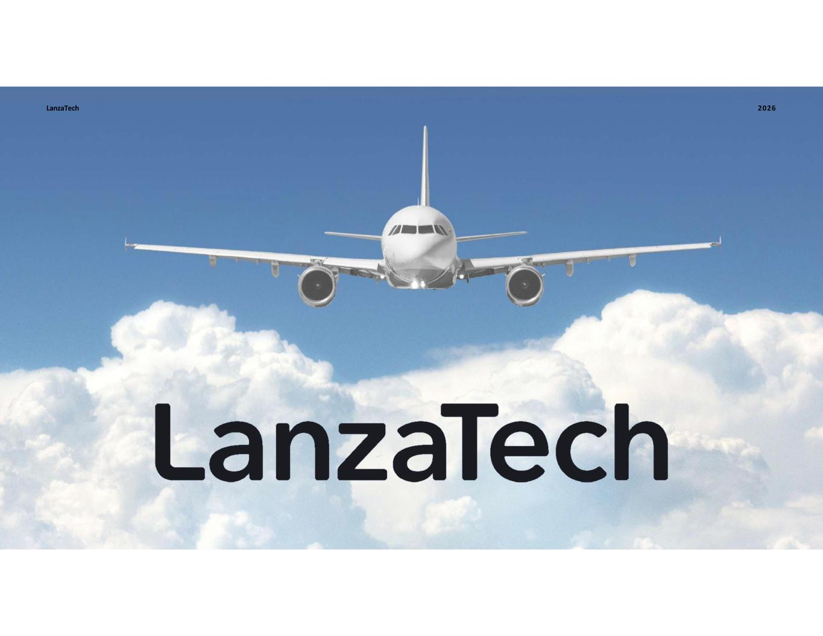
4
LanzaTech 2026

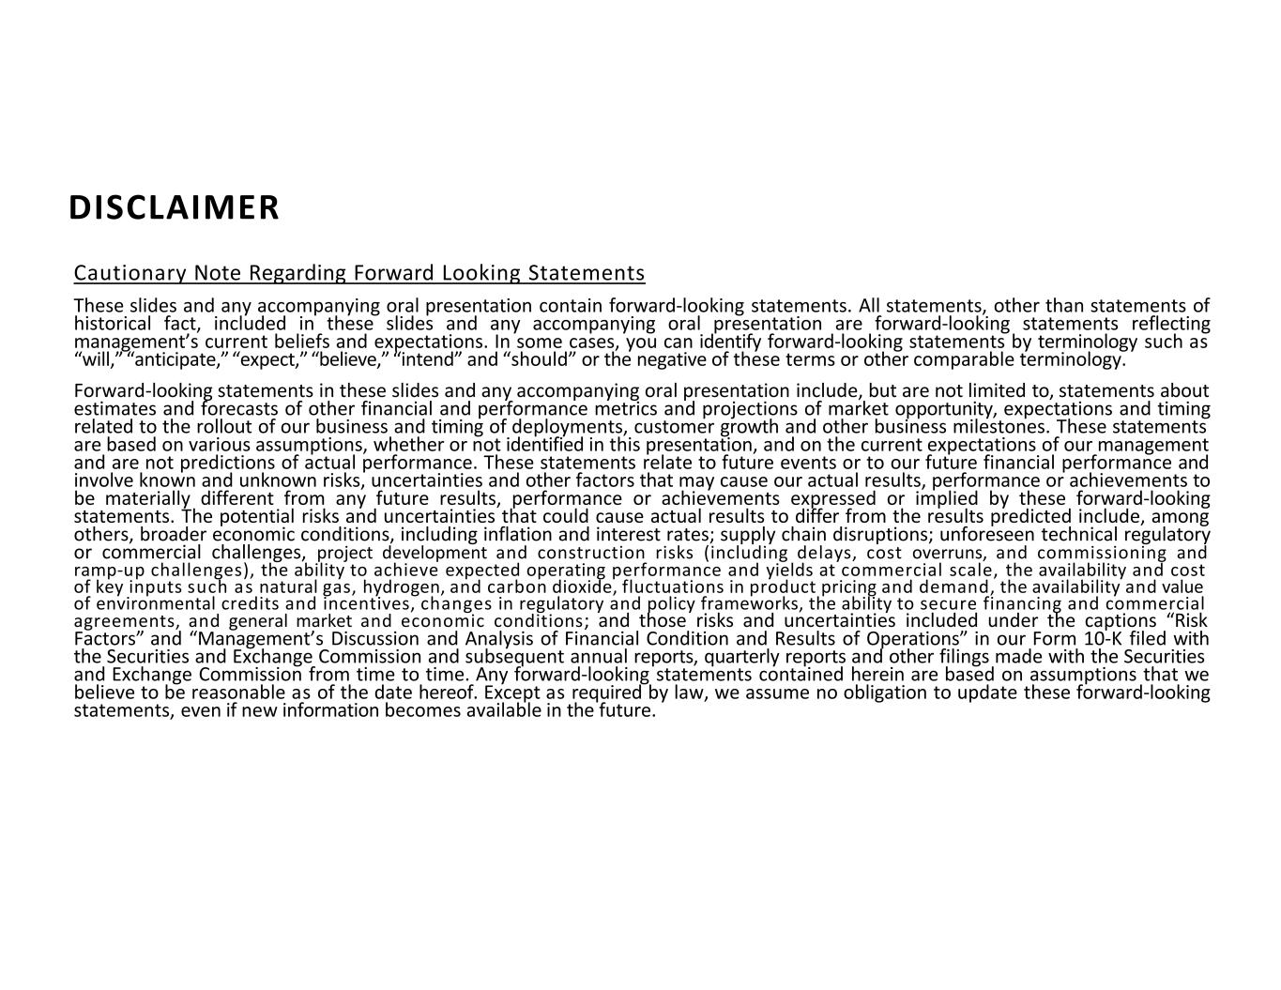
Cautionary Note Regarding Forward Looking Statements These slides and any accompanying oral presentation contain forward-looking statements. All statements, other than statements of historical fact, included in these slides and any accompanying oral presentation are forward-looking statements reflecting management’s current beliefs and expectations. In some cases, you can identify forward-looking statements by terminology such as “will,” “anticipate,” “expect,” “believe,” “intend” and “should” or the negative of these terms or other comparable terminology. Forward-looking statements in these slides and any accompanying oral presentation include, but are not limited to, statements about estimates and forecasts of other financial and performance metrics and projections of market opportunity, expectations and timing related to the rollout of our business and timing of deployments, customer growth and other business milestones. These statements are based on various assumptions, whether or not identified in this presentation, and on the current expectations of our management and are not predictions of actual performance. These statements relate to future events or to our future financial performance and involve known and unknown risks, uncertainties and other factors that may cause our actual results, performance or achievements to be materially different from any future results, performance or achievements expressed or implied by these forward-looking statements. The potential risks and uncertainties that could cause actual results to differ from the results predicted include, among others, broader economic conditions, including inflation and interest rates; supply chain disruptions; unforeseen technical regulatory or commercial challenges, project development and construction risks (including delays, cost overruns, and commissioning and ramp-up challenges), the ability to achieve expected operating performance and yields at commercial scale, the availability and cost of key inputs such as natural gas, hydrogen, and carbon dioxide, fluctuations in product pricing and demand, the availability and value of environmental credits and incentives, changes in regulatory and policy frameworks, the ability to secure financing and commercial agreements, and general market and economic conditions; and those risks and uncertainties included under the captions “Risk Factors” and “Management’s Discussion and Analysis of Financial Condition and Results of Operations” in our Form 10-K filed with the Securities and Exchange Commission and subsequent annual reports, quarterly reports and other filings made with the Securities and Exchange Commission from time to time. Any forward-looking statements contained herein are based on assumptions that we believe to be reasonable as of the date hereof. Except as required by law, we assume no obligation to update these forward-looking statements, even if new information becomes available in the future. DISCLAIMER DISCLAIMER

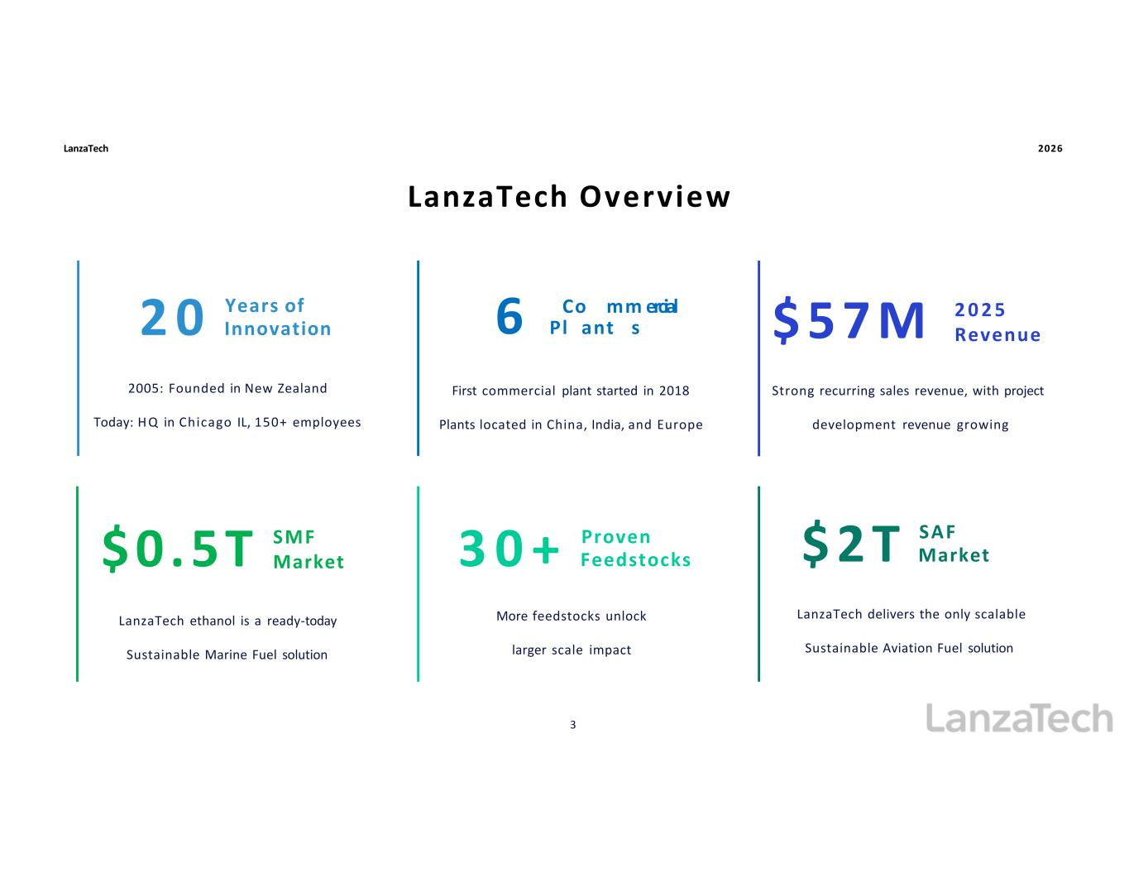
LanzaTech 2026 LanzaTech Overview 2005: Founded in New Zealand Today: H Q in Chicago IL, 150+ employees Years of2 0 Innovation First commercial plant started in 2018 Plants located in China, India, and Europe 6 Pl Co ant mm s ercial LanzaTech ethanol is a ready-today Sustainable Marine Fuel solution $0.5T SMF Market Strong recurring sales revenue, with project development revenue growing $ 5 7 M 2 0 2 5 Revenue Proven3 0 + Feedstocks More feedstocks unlock larger scale impact LanzaTech delivers the only scalable Sustainable Aviation Fuel solution SAF$ 2 T Market 3

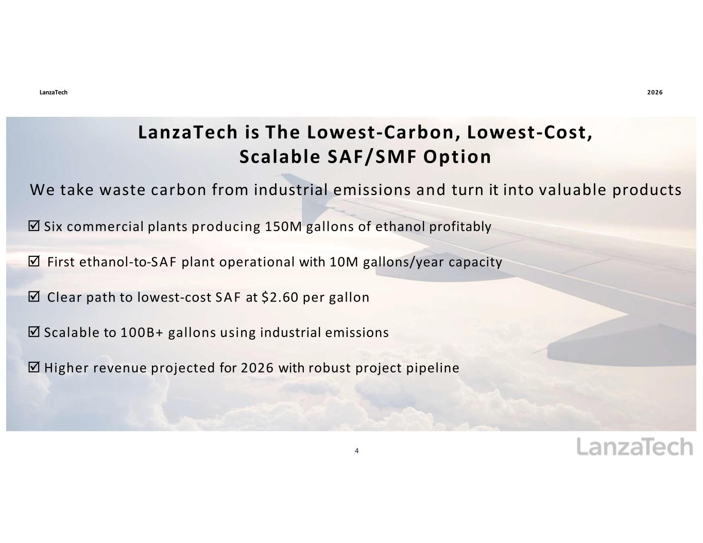
LanzaTech 4 2026 LanzaTech is The Lowest-Carbon, Lowest-Cost, Scalable SAF/SMF Option LanzaTech is The Lowest-Carbon, Lowest-Cost, Scalable SAF/SMF Option We take waste carbon from industrial emissions and turn it into valuable products ☑ Six commercial plants producing 150M gallons of ethanol profitably ☑ First ethanol-to-SAF plant operational with 10M gallons/year capacity ☑ Clear path to lowest-cost SAF at $2.60 per gallon ☑ Scalable to 100B+ gallons using industrial emissions ☑ Higher revenue projected for 2026 with robust project pipeline

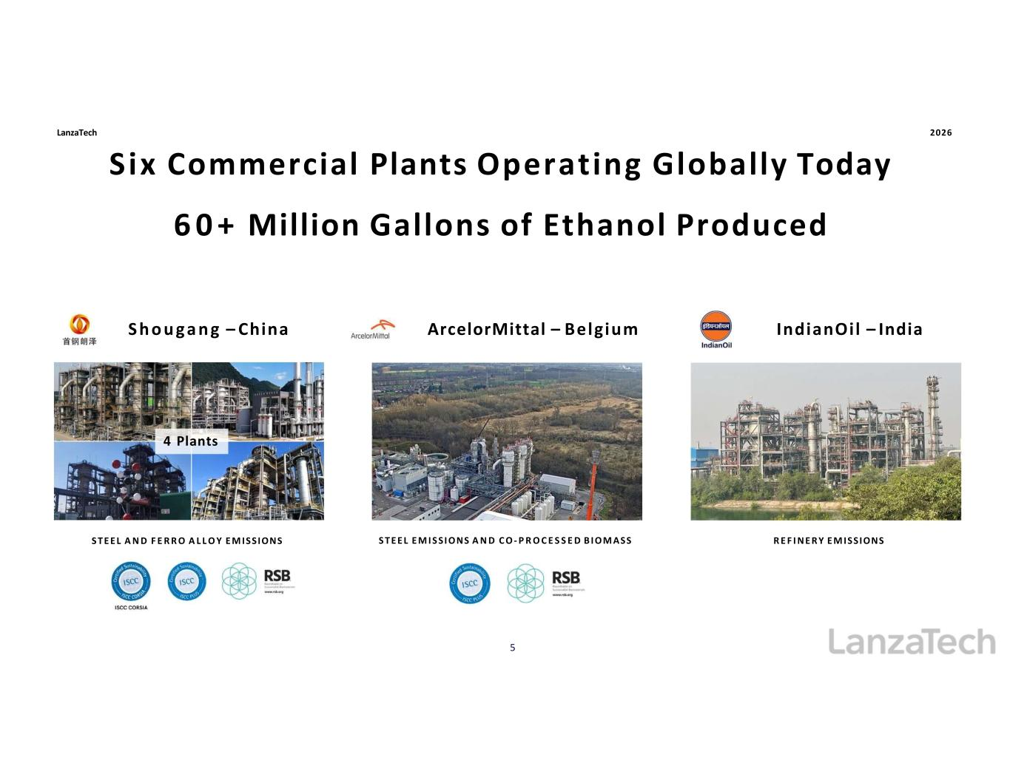
R E F I N E R Y E M ISSIONSS T E E L E M I S SI O NS A N D C O - P R O C E S S E D B I O M ASSS T E E L A N D F E R R O A L L O Y E M ISSIONS IndianOil – IndiaS h o u g a n g – China ArcelorMittal – Belgium Six Commercial Plants Operating Globally Today 60+ Million Gallons of Ethanol Produced Six Commercial Plants Operating Globally Today 6 0 + Million Gallons of Ethanol Produced 4 Plants LanzaTech 2026 5

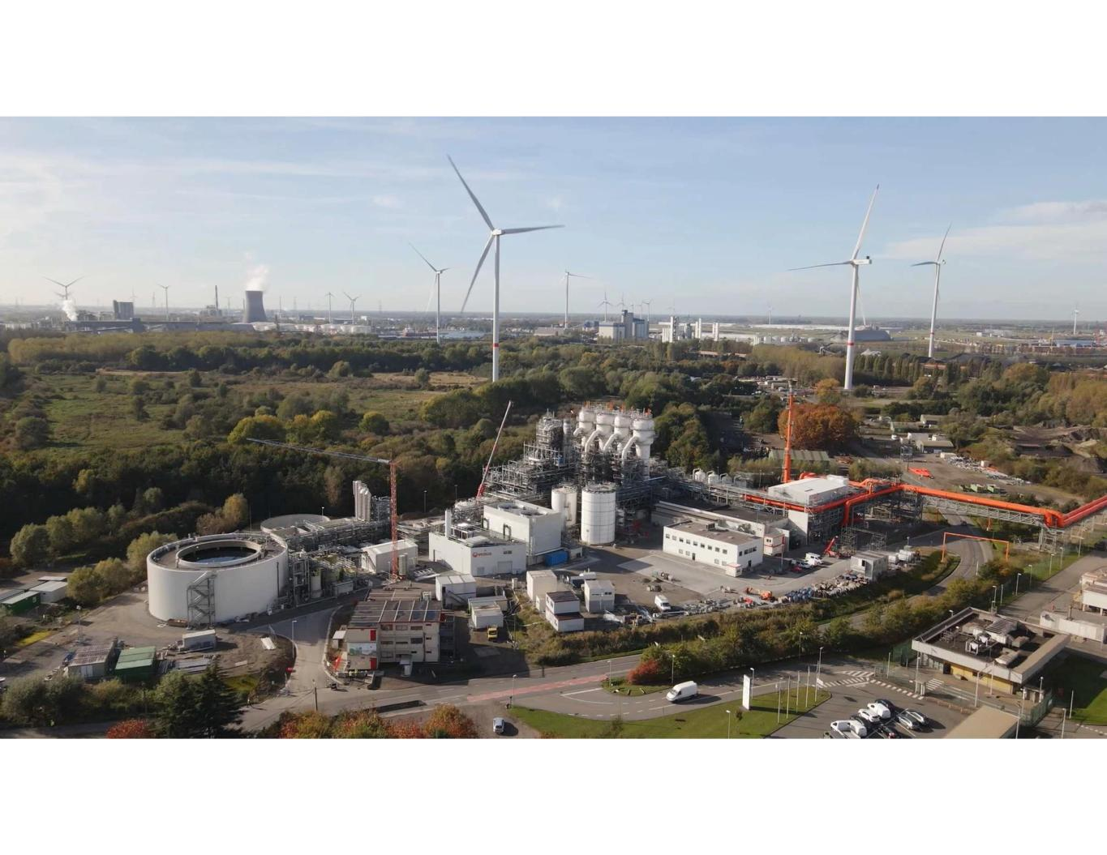
Confidential

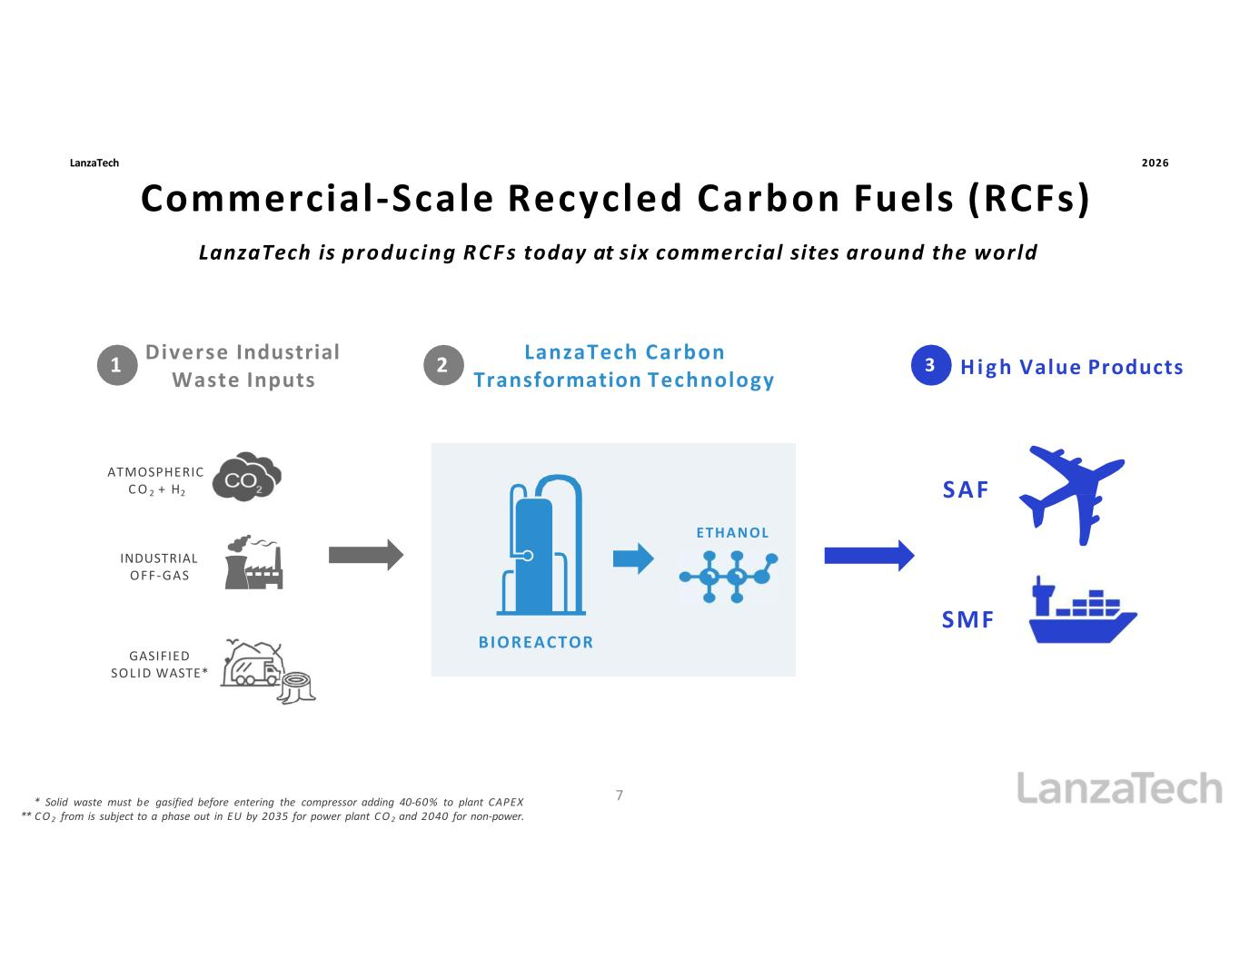
Commercial-Scale Recycled Carbon Fuels (RCFs) Commercial-Scale Recycled Carbon Fuels (RCFs) INDUSTRIAL OFF-GAS 21 ATMOSPHERIC C O 2 + H2 ETHANOL BIOREACTOR 3 * Solid waste must be gasified before entering the compressor adding 40-60% to plant CAPEX ** C O 2 from is subject to a phase out in EU by 2035 for power plant C O 2 and 2040 for non-power. LanzaTech Carbon Transformation Technology GASIFIED SOL ID WASTE* H i g h Value Products Diverse Industrial Waste Inputs SAF LanzaTech is producing R C F s today at six commercial sites around the world SMF LanzaTech 2026 7

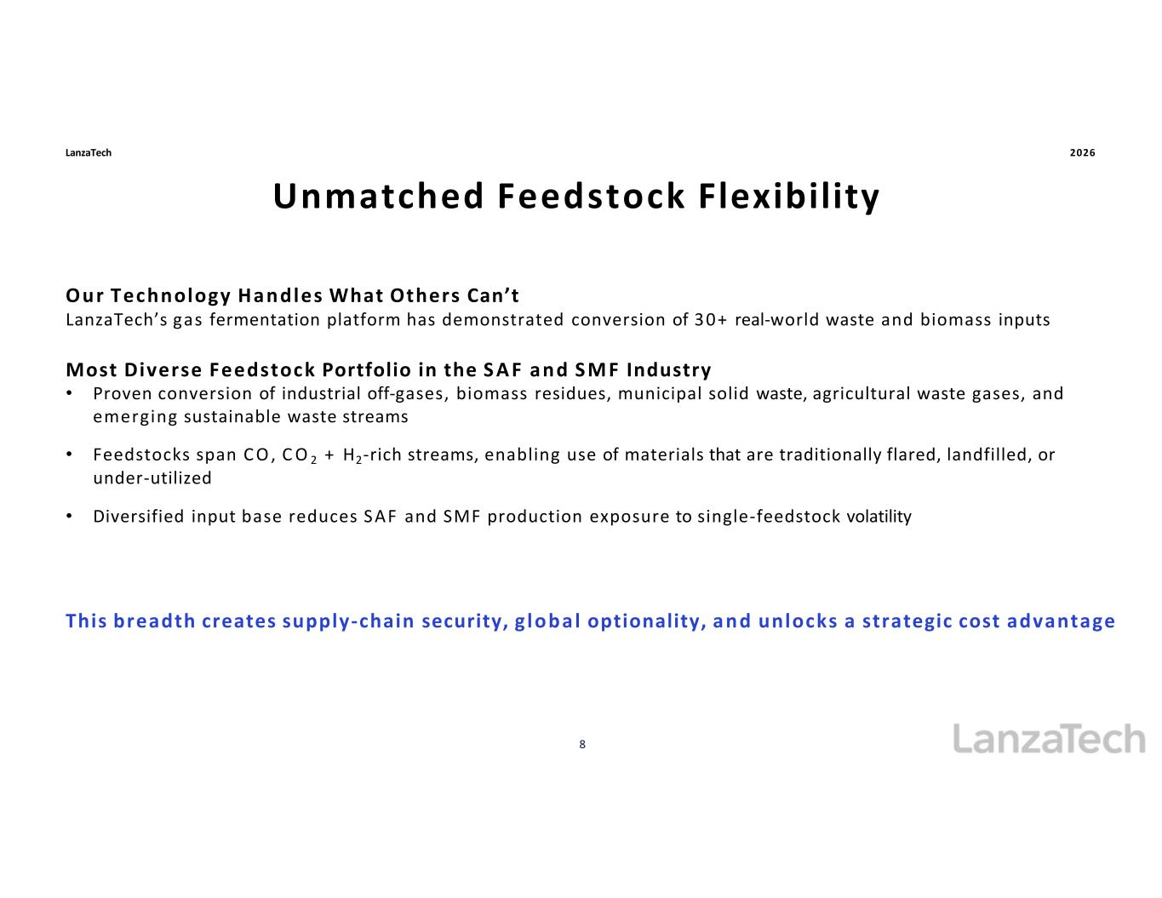
Unmatched Feedstock Flexibility Unmatched Feedstock Flexibility LanzaTech 2026 Our Technology Handles What Others Can’t LanzaTech’s gas fermentation platform has demonstrated conversion of 30+ real-world waste and biomass inputs Most Diverse Feedstock Portfolio in the S A F and S M F Industry • Proven conversion of industrial off-gases, biomass residues, municipal solid waste, agricultural waste gases, and emerging sustainable waste streams • Feedstocks span C O , C O 2 + H2-rich streams, enabling use of materials that are traditionally flared, landfilled, or under-utilized • Diversified input base reduces S AF and SMF production exposure to single-feedstock volatility 8 This breadth creates supply-chain security, g lobal optionality, and unlocks a strategic cost advantage

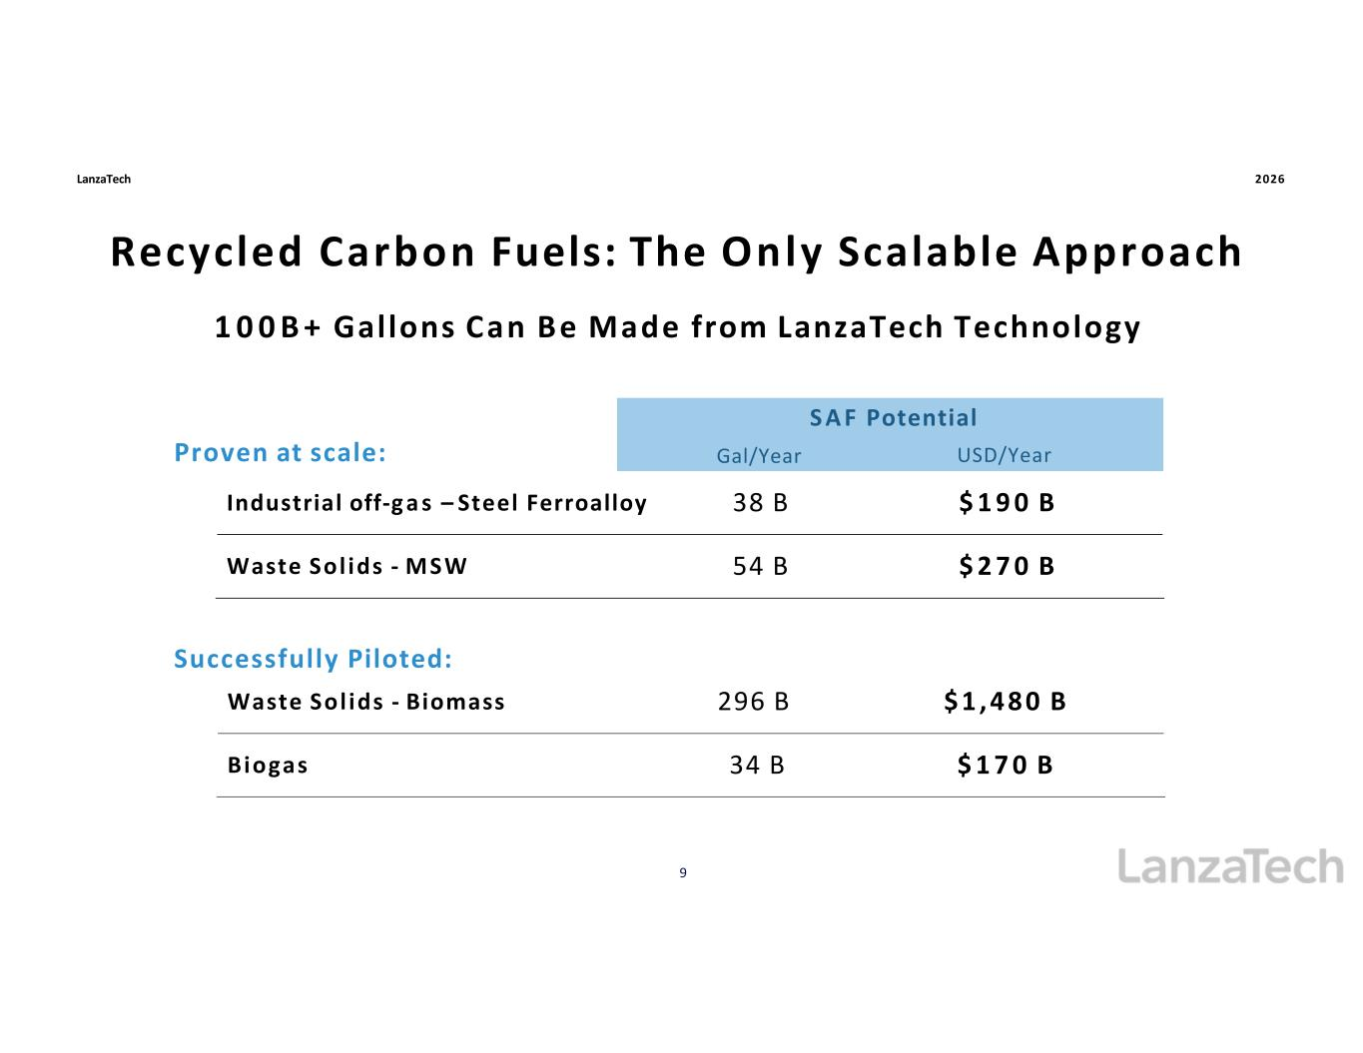
Recycled Carbon Fuels: The Only Scalable Approach Recycled Carbon Fuels: The Only Scalable Approach 1 0 0 B + Gallons Can Be Made from LanzaTech Technology LanzaTech 2026 Gal/Year S A F Potential USD/Year Industrial off-g a s – Steel Ferroalloy 38 B $ 1 9 0 B Waste Sol ids - MSW 54 B $ 2 7 0 B $ 1 , 4 8 0 B 9 296 BWaste Sol ids - Biomass $ 1 7 0 B34 BBiogas Proven at scale: Successfully Piloted:

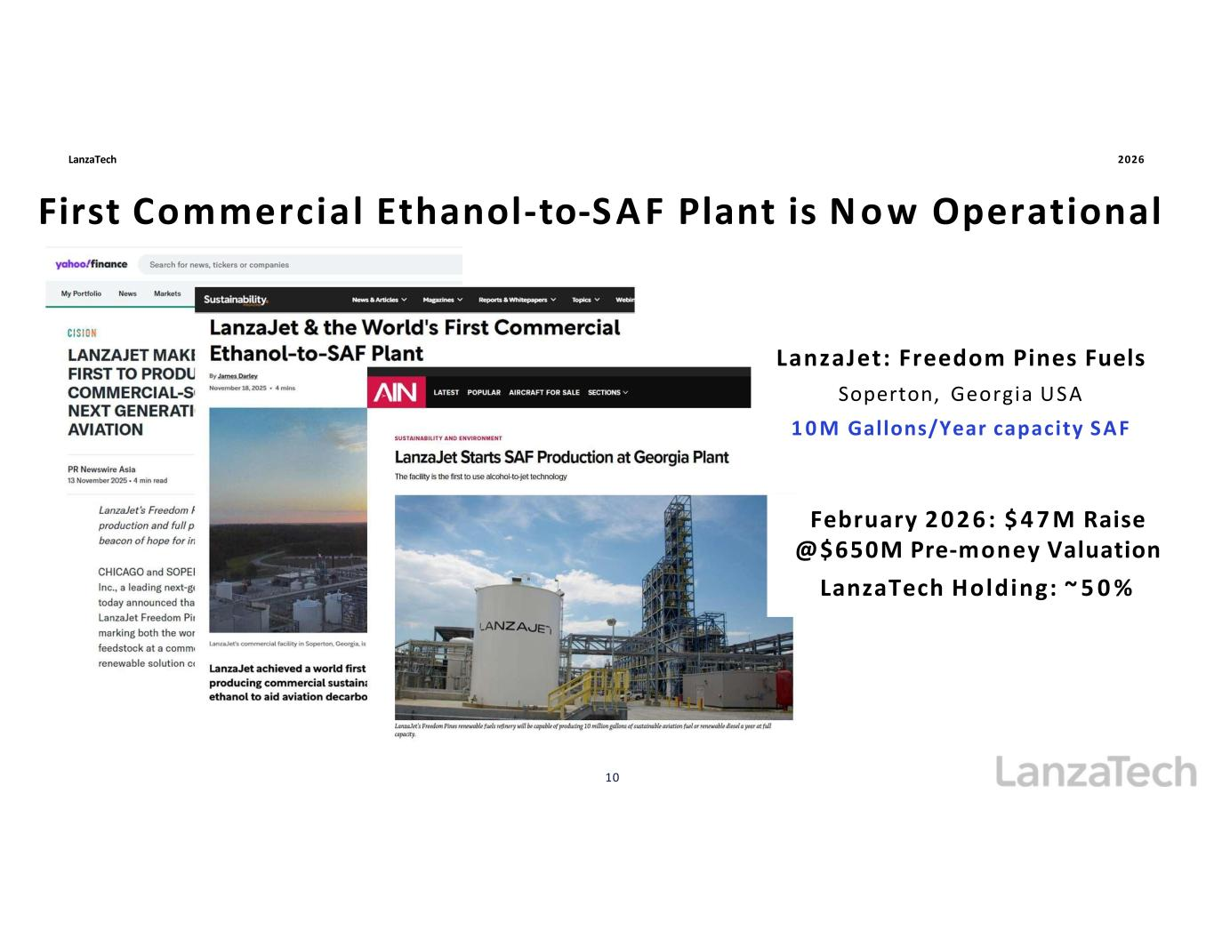
First Commercial Ethanol-to-SAF Plant is Now Operational First Commercial Ethanol-to-SAF Plant is N ow Operational LanzaTech 2026 February 2 0 2 6 : $ 4 7 M Raise @$650M Pre-money Valuation LanzaTech Holding: ~ 5 0 % LanzaJet: Freedom Pines Fuels Soperton, Georgia USA 1 0 M Gallons/Year capacity SAF i l i 10

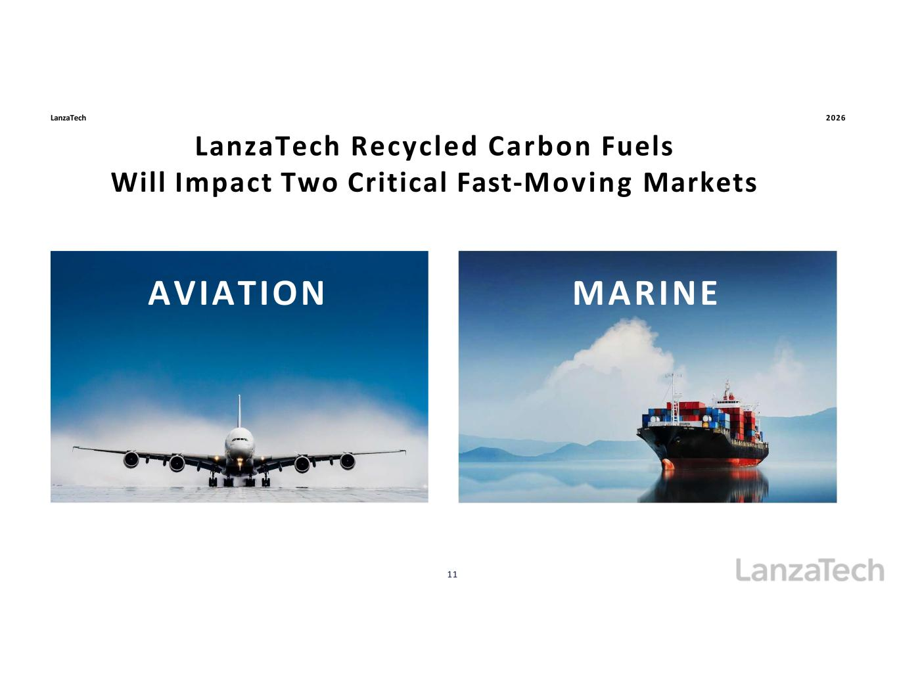
LanzaTech Recycled Carbon Fuels Will Impact Two Critical Fast-Moving Markets LanzaTech 2026 AVIATION 11 MARINE

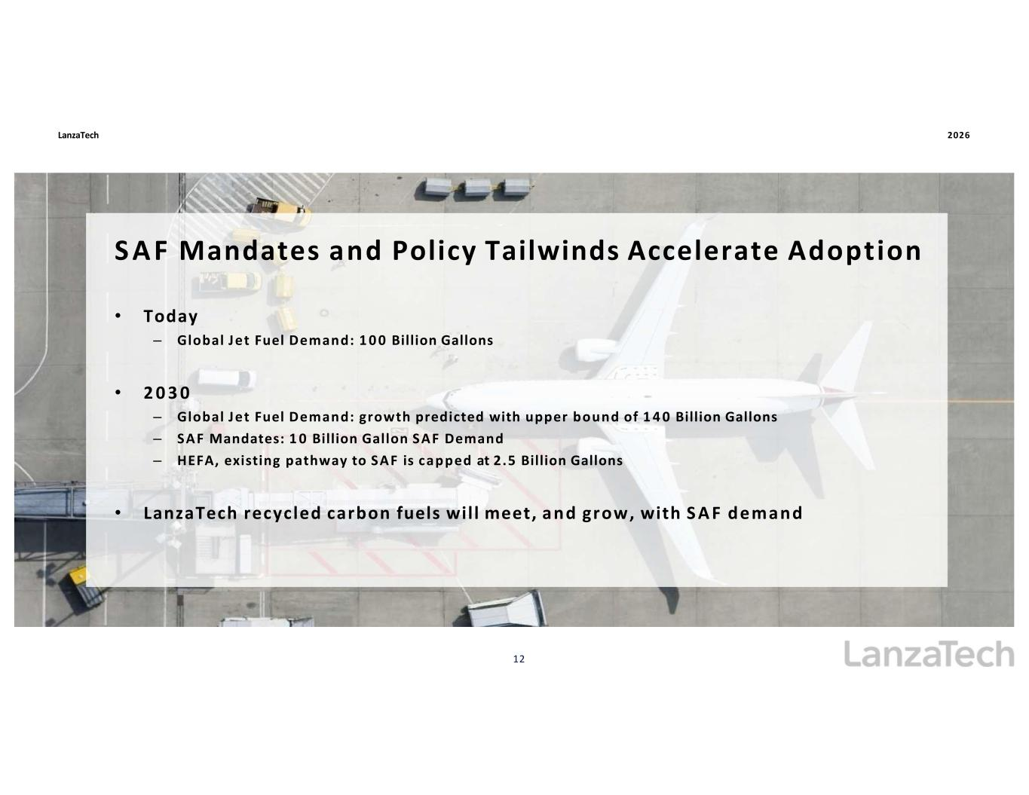
SAF Mandates and Policy Tailwinds Accelerate Adoption S A F Mandates and Policy Tailwinds Accelerate Adoption • Today – Global Jet Fuel Demand: 1 0 0 Billion Gallons • 2 0 3 0 – Global Jet Fuel Demand: growth predicted with upper bound of 1 4 0 Billion Gallons – SAF Mandates: 1 0 Billion Gallon SAF Demand – HEFA, existing pathway to SAF is capped at 2.5 Billion Gallons • LanzaTech recycled carbon fuels will meet, and grow, with S A F demand LanzaTech 2026 12

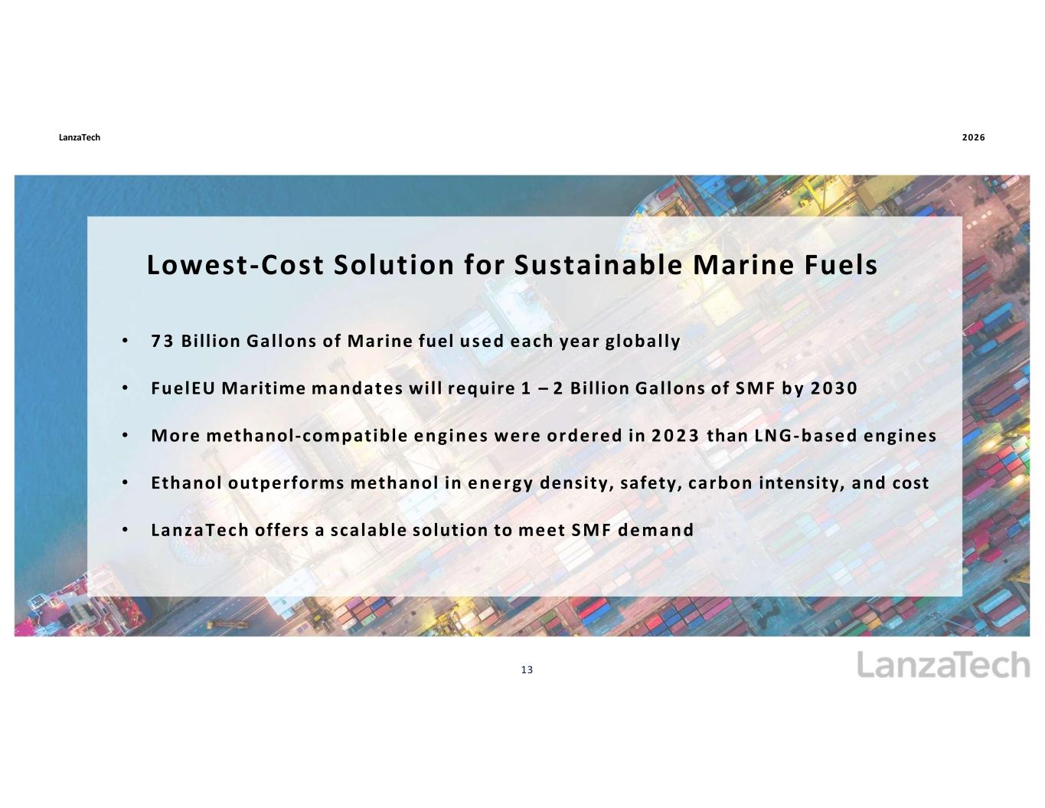
LanzaTech 2026 • 7 3 Billion Gallons of Marine fuel used each year globally • FuelEU Maritime mandates will require 1 – 2 Billion Gallons of SM F b y 2 0 3 0 • More methanol-compatible engines were ordered in 2 0 2 3 than LNG-based engines • Ethanol outperforms methanol in energy density, safety, carbon intensity, and cost • LanzaTech offers a scalable solution to meet SM F demand 13 Lowest-Cost Solution for Sustainable Marine Fuels Lowest-Cost Solution for Sustainable Marine Fuels

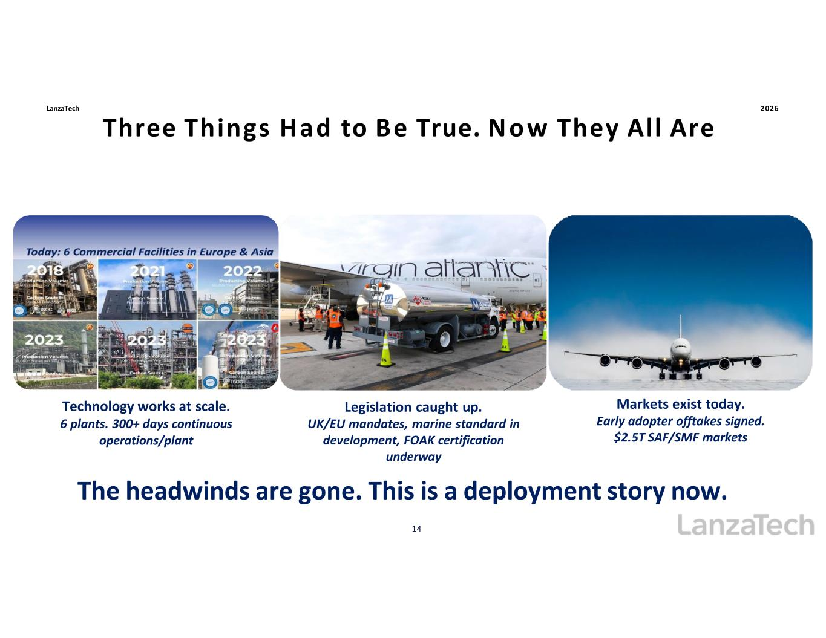
LanzaTech 2026 Three Things Had to Be True. Now They All Are Three Things Had to Be True. Now They All Are Technology works at scale. 6 plants. 300+ days continuous operations/plant 14 Legislation caught up. UK/EU mandates, marine standard in development, FOAK certification underway Markets exist today. Early adopter offtakes signed. $2.5T SAF/SMF markets The headwinds are gone. This is a deployment story now.

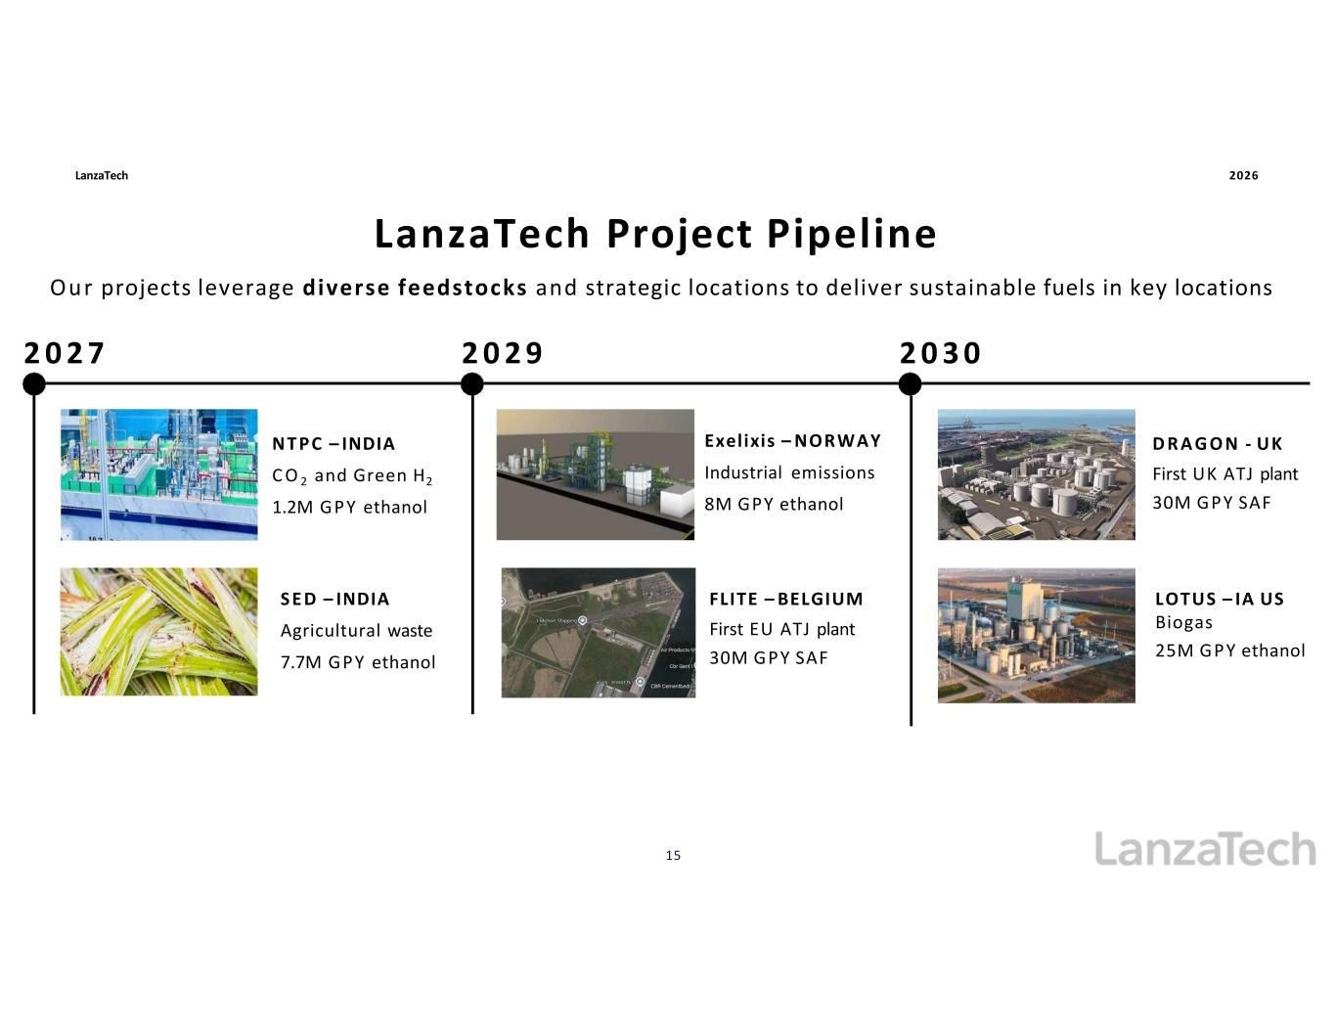
NT PC – INDIA C O 2 and Green H2 1.2M GPY ethanol Exelixis – NORWAY Industrial emissions 8M GPY ethanol S E D – INDIA Agricultural waste 7.7M GPY ethanol LanzaTech Project Pipeline LanzaTech Project Pipeline FLITE – BELGIUM First EU ATJ plant 30M GPY SAF Our projects leverage diverse feedstocks and strategic locations to deliver sustainable fuels in key locations 2 0 2 7 2 0 2 9 2 0 3 0 LanzaTech 2026 D R A G O N - UK First UK ATJ plant 30M GPY SAF LOTUS – IA US Biogas 25M GPY ethanol 15

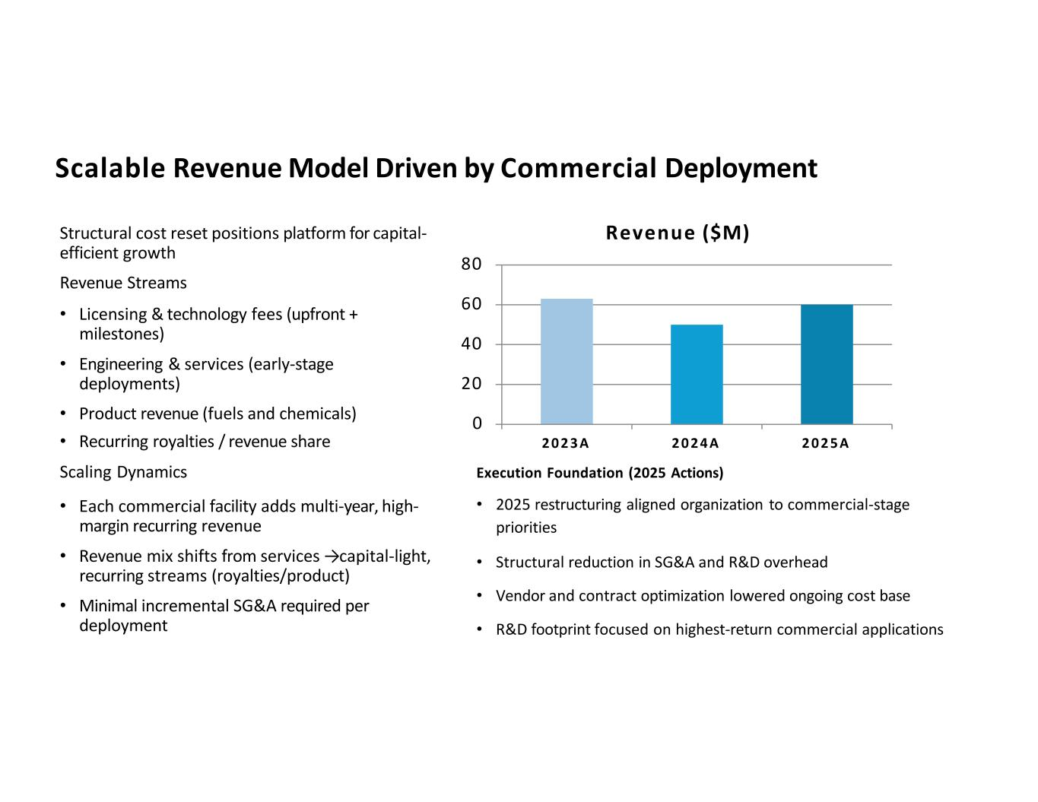
Structural cost reset positions platform for capital- efficient growth Revenue Streams • Licensing & technology fees (upfront + milestones) • Engineering & services (early-stage deployments) • Product revenue (fuels and chemicals) • Recurring royalties / revenue share Scaling Dynamics • Each commercial facility adds multi-year, high- margin recurring revenue • Revenue mix shifts from services → capital-light, recurring streams (royalties/product) • Minimal incremental SG&A required per deployment 80 60 40 20 0 2 0 2 3 A 2 0 2 4 A 2 0 2 5 A Revenue ($M) Scalable Revenue Model Driven by Commercial Deployment Scalable Revenue Model Driven by Commercial Deployment Execution Foundation (2025 Actions) • 2025 restructuring aligned organization to commercial-stage priorities • Structural reduction in SG&A and R&D overhead • Vendor and contract optimization lowered ongoing cost base • R&D footprint focused on highest-return commercial applications

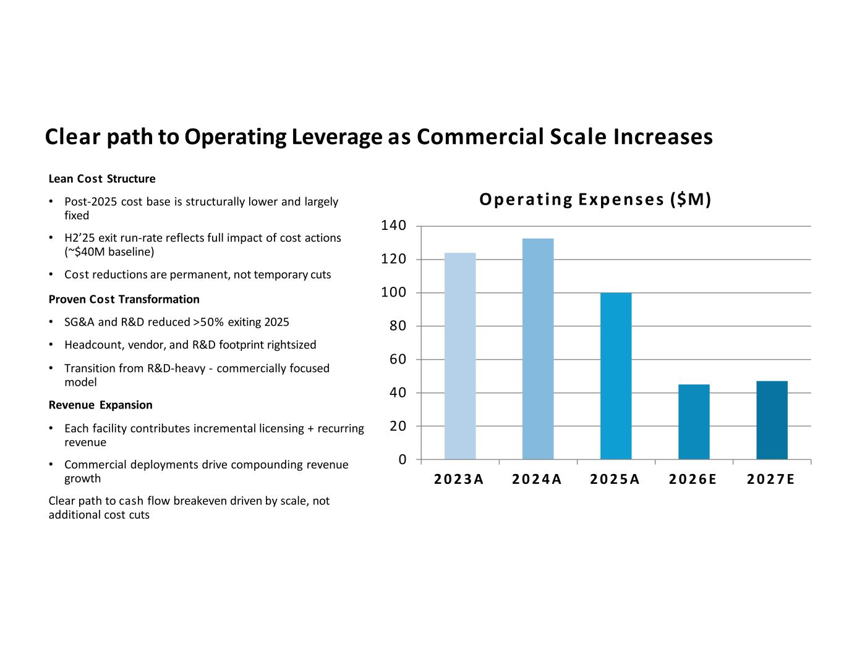
Lean Cost Structure • Post-2025 cost base is structurally lower and largely fixed • H2’25 exit run-rate reflects full impact of cost actions (~$40M baseline) • Cost reductions are permanent, not temporary cuts Proven Cost Transformation • SG&A and R&D reduced >50% exiting 2025 • Headcount, vendor, and R&D footprint rightsized • Transition from R&D-heavy - commercially focused model Revenue Expansion • Each facility contributes incremental licensing + recurring revenue • Commercial deployments drive compounding revenue growth Clear path to cash flow breakeven driven by scale, not additional cost cuts 140 120 100 80 60 40 20 0 2 0 2 3 A 2 0 2 4 A 2 0 2 5 A 2 0 2 6 E 2 0 2 7 E Operating Expenses ($M) Clear path to Operating Leverage as Commercial Scale Increases Clear path to Operating Leverage as Commercial Scale Increases

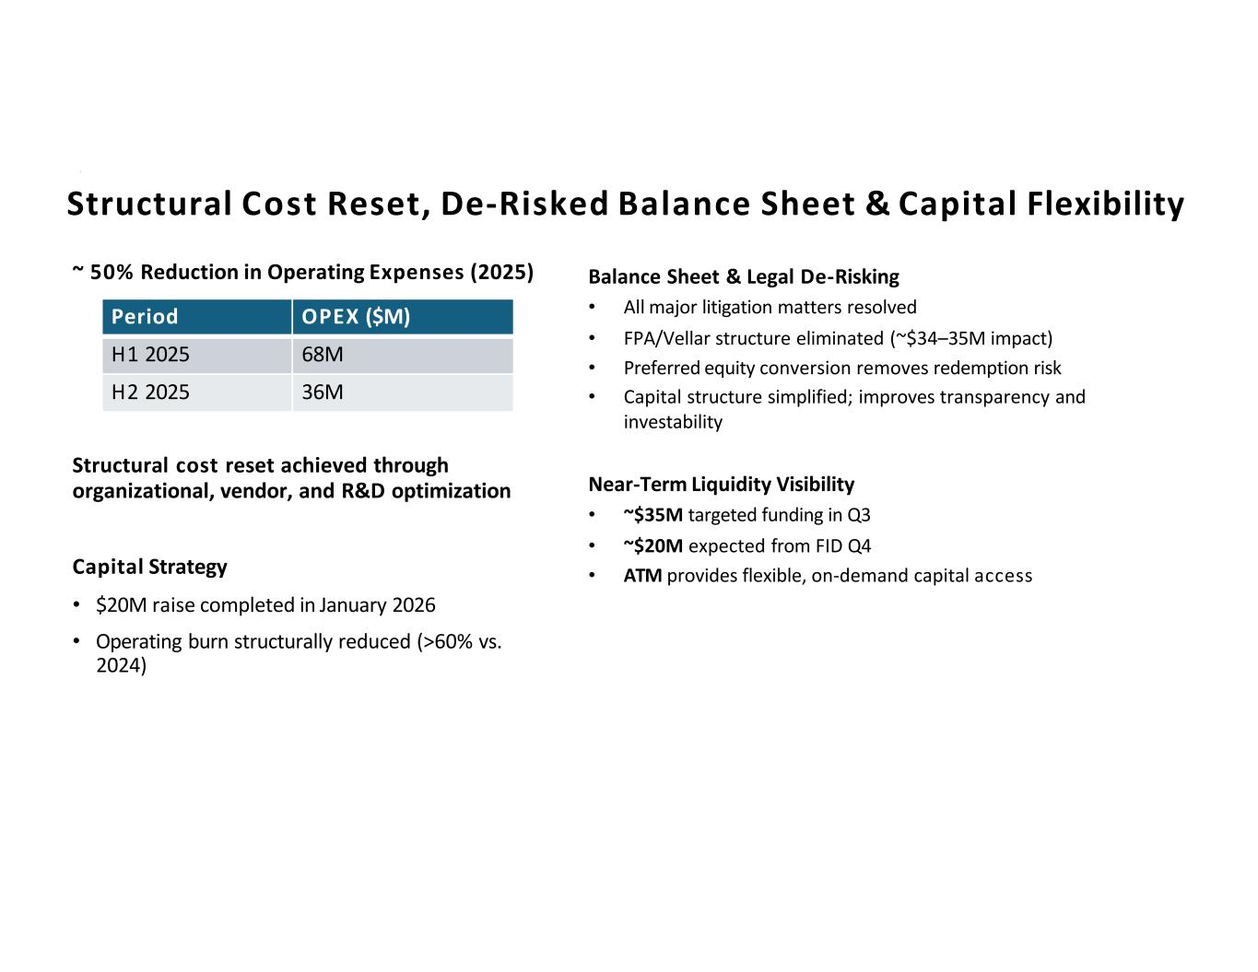
~ 50% Reduction in Operating Expenses (2025) Structural cost reset achieved through organizational, vendor, and R&D optimization Capital Strategy • $20M raise completed in January 2026 • Operating burn structurally reduced (>60% vs. 2024) Balance Sheet & Legal De-Risking • All major litigation matters resolved • FPA/Vellar structure eliminated (~$34–35M impact) • Preferred equity conversion removes redemption risk • Capital structure simplified; improves transparency and investability Near-Term Liquidity Visibility • ~$35M targeted funding in Q3 • ~$20M expected from FID Q4 • ATM provides flexible, on-demand capital access Period OPEX ($M) H1 2025 68M H2 2025 36M Structural Cost Reset, De-Risked Balance Sheet Capital Flexibility Structural Cost Reset, De-Risked Balance Sheet & Capital Flexibility



